**The Idiot's Guide to Taoist Alchemy Qigong, Enlightenment,**

**Neidan, Nei Kung, Neigong training for males**

[**voidisyinyang.blogspot.com**/2016/07/the-idiots-guide-to-taoist-alchemy.html](https://voidisyinyang.blogspot.com/2016/07/the-idiots-guide-to-taoist-alchemy.html)



*The Idiot's Guide to Taoist Alchemy Qigong Neidan training for males*

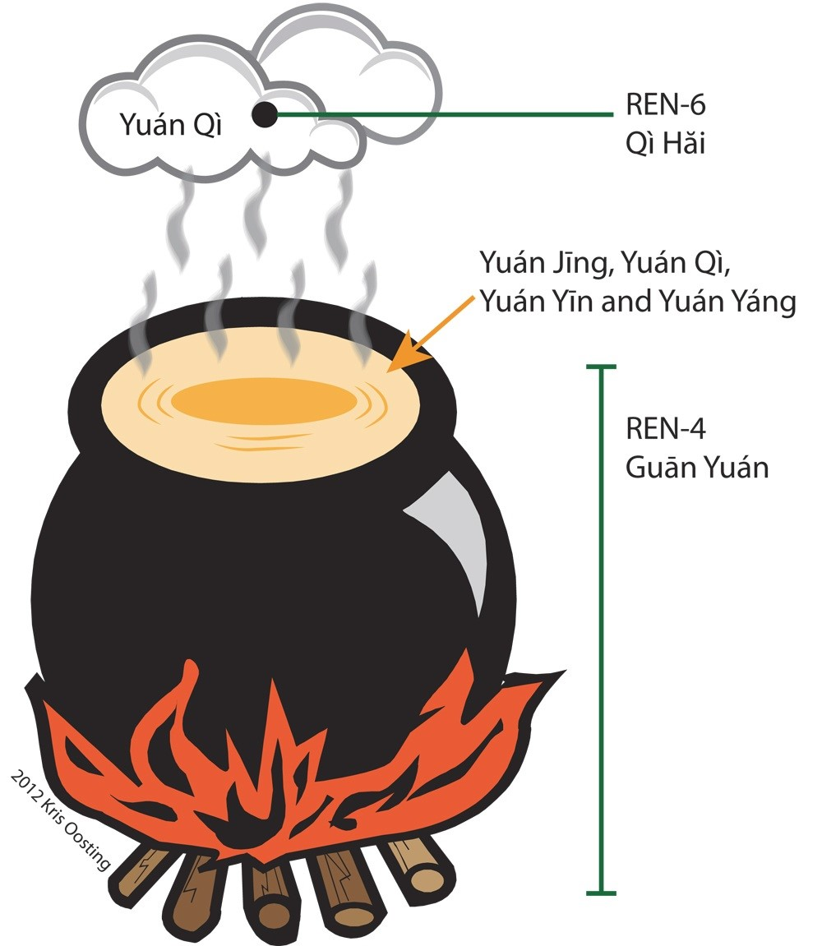Now we know from history that the training has been done by rote, the explanations mired in alchemical secrecy, and then if someone does achieve the rare status of qigong master it's only because they've been able to store up their energy sufficiently. In which case for real qigong masters they then need to protect their energy, dole it out carefully, build up a base of students, etc. It's obviously *not easy* especially considering this shamanic training goes against the grain of the modern world.

*“Your language-focused mind is an idiot; only spirit has wisdom. No matter how much book knowledge or street smarts you have, it won’t help with spiritual affairs. Spiritual wisdom is only voiced by spirit. You may be its instrument, but you don’t know jack squat. Get over yourself and allow spirit to take over. Easier said than done. And it’s never done.” Dr. Bradford Keeney*

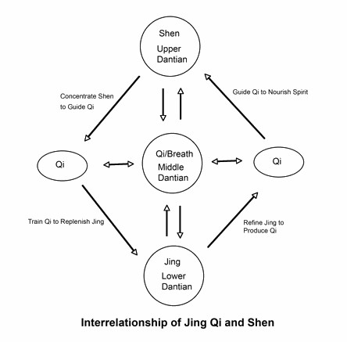So then the basic principle of enlightenment training is to visualize, with the eyes closed, spirit-light or shen, beneath the life force or jing energy (see the first image above). Spirit or shen turns generative force (jing) into yuan qi. "Since it is the undivided yin-yang it is called the One vitality." p. 122, *Taoist Yoga: Alchemy and Immortality*. As the *Tao Te Ching* states [on alchemy (works link):](https://www.google.com/url?sa=t&rct=j&q=&esrc=s&source=web&cd=10&cad=rja&uact=8&ved=0ahUKEwirirD6oq7SAhXHsFQKHSCaAJ4QFgg9MAk&url=http%3A%2F%2Fwww.lingqidao.com%2Fwp-content%2Fuploads%2F2013%2F05%2FDaoist-Inner-Alchemy-readings.doc&usg=AFQjCNGbpb3KryVaEVsFZDLC0UJWeyE6LQ&sig2=w9NN7QDLPgwTKP9DNZVQ7g),

*“empty the mind and fill the belly” which are reminiscent of later Daoist inner alchemy breathing practices meant to tonify the energy center in the lower abdomen. Chapter 40’s passage “the movement of Dao is reversal”*

Alchemically this means we visualize and focus our fire or

[spirit qi underneath our water or life force qi, in order to bring out the qi hidden within spirit and life force. Professor William Clarke Hudson II, University of Virginia provides the Neidan alchemy commentaries on the Tao Te Ching:](https://www.academia.edu/1727544/The_Alchemists_Daode_jing)

|  |
| --- |
|  |
| [Once the Yin Qi is built up then the real lower dantian also opens the third eye](http://sygz2012.blogspot.com/2013/02/chakras-nadis-and-meridians-dao-tantric.html) |

The alchemical bellows as the harmony of heaven and earth is based on the heart as the furnace of spirit-fire with the kidneys as the cauldron of life force water. So it is a combination of the bellows as the lungs, using the deep breathing, and proper intention to then both raise the water and lower the fire to activate the alchemical process. So only by closing the eyes will the furnace fire of the heart stop going out of the eyes as spirit and then by visualized below the water of the life force hormones. Above the navel, deep in the body, is the "zhonggong" and below the navel is the lower tan tien or lower dantian. So then straight behind the navel is considered the "wuji point" of the body:

*Taoist Yoga: Alchemy and Immortality*: "nature and life [spirit and vitality or shen and qi] change place during the shutting and opening process [of the bellows]." So life (yuan qi) goes above nature (yuan shen) on the in breath - the shutting of the bellows and nature (yuan shen) goes below life (yuan qi) on the out breath - the opening of the bellows.

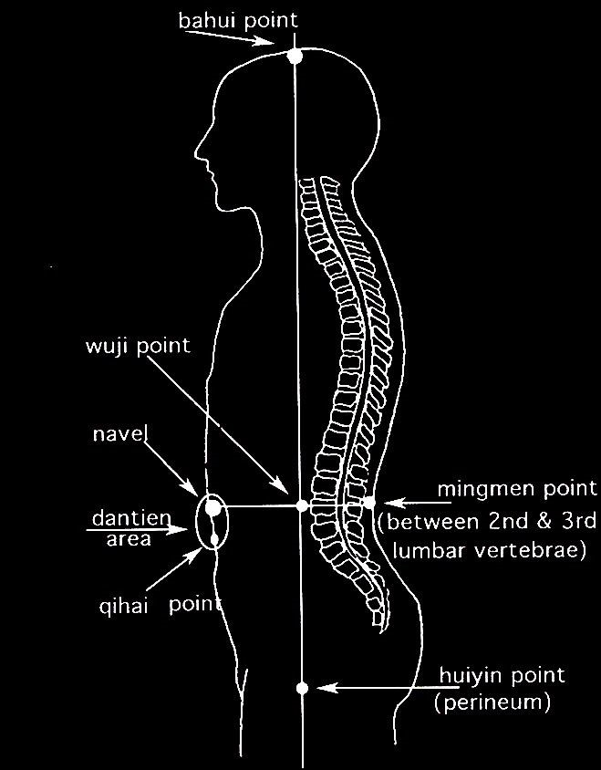 *Taoist Yoga: Alchemy and Immortality*: "Prenatal vitality [yuan qi] is produced and stored up by this process while the [heart and lower abdomen mingle." As we can see from this youtube video, the alchemical Small Universe focused at the navel.](https://www.youtube.com/watch?v=7UfaiOXv3tQ&feature=youtu.be)

The symbol as the back image for this blog is the oldest symbol of Wuji or Wu Chi, and originally it was with the Chinese characters for alchemical fire and water (but contrary to the below quote claims - the red/black color was not added till the Ming Dynasty. ( *The Genesis of an* [*Icon: The "Taiji" Diagram's Early History* by François Louis, 2003 pdf link)](https://www.google.com/url?sa=t&rct=j&q=&esrc=s&source=web&cd=1&cad=rja&uact=8&ved=0ahUKEwiNrb-86JfTAhUl9YMKHQcaD50QFggcMAA&url=https%3A%2F%2Fwww.biroco.com%2Fyijing%2Flouis_taiji_diagram.pdf&usg=AFQjCNEX63phrtjHOQ2e0Y4HGmVh9sjnWw&sig2=oIMEdVl_OpbLdOr3yeVZCg)

*This older symbol is attributed to the Buddhist scholar,* [*Zong Mi*](http://en.wikipedia.org/wiki/Guifeng_Zongmi)*, of the Tang dynasty, who used the symbol to denote a balanced consciousness in which “the true and the false” are blended (Louis, p. 177).... Furthermore, since this diagram was a product of the Tang dynasty, the Daoist ideas of nèi dān (*内丹*) or inner alchemy, were already established (Robinet & Wissing, 1990).*

As Professor Hudson points out, this alchemical aperture or bellows, is then this fire below water, as the Valley of the Spirit that alchemically creates the yuan qi. [For example](http://www.pathgate.org/index.php/dharma-qigong-and-martial-arts/introduction-to-qigong/76-how-many-types-of-human-energy-are-ther):

*There are three main types of human energy. The first type: xian tian qi (pre-natal energy), also known as yuan qi (original qi) is derived from ching (primordial essence) which is yin by nature.*

So the original qi is discovered alchemically, the qi of the universe, by putting fire underneath water to create steam [or as it's called in medical qigong: Prenatal Wu Jing Shen. This is called to "revert the yin to restore the yang" as alchemy training. But the important thing to realize is that the Wuji or Wu Chi is always already a 3 in 1 harmony](https://books.google.com/books?id=9PfdCgAAQBAJ&pg=PA54&lpg=PA54&dq=the+primal+qi%E2%80%9D+(li+yuanqi+%E7%90%86%E5%85%83%E6%B0%A3),+since+they+are+themselves+formless.&source=bl&ots=-xRtO_Dw11&sig=UUjrXUPtp8Jcdprsw381MbRQ49Y&hl=en&sa=X&ved=0ahUKEwis-c3Gj_zSAhUJYyYKHQp2Da4Q6AEIHDAA#v=onepage&q=primal qi&f=false) of the shen below the jing, as "undivided yin-yang" or Yuan Qi. [An 1871 Missionary book to China records this origin:](https://books.google.com/books?id=NF1DAQAAMAAJ)

*“When Chaos was undivided, the Yin-yang Air was chaotic and dark; and ... Hence motion and rest have no end, and the Yin-yang have' no beginning,”*

|  |
| --- |
|  |
| [In 2002, Grandmaster Lu Zijian recognized Zhang Yuanming as his lineage successor, 17th generation in the Dragon Gate Taoist Alchemy line.](http://luzijian.com/) |

Now

that is actually the Yuan Qi, the "undivided yin-yang" as the "one vitality":

*the primal qi” (li yuanqi* 理元氣*), since they are themselves formless.*

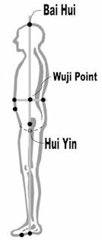[The basic circle of the Wu Chi was introduced later during the Song Dynasty in the 12th](https://www.google.com/url?sa=t&rct=j&q=&esrc=s&source=web&cd=6&ved=0ahUKEwjPteGkifzSAhVEeCYKHd-YAg4QFgg4MAU&url=http%3A%2F%2Fygmh.skku.edu%2F_custom%2Fskk%2F_common%2Fboard%2Fdownload.jsp%3Fattach_no%3D2807&usg=AFQjCNH9hXoVg_Xmt0Qx17ZDM3mxOYImKg&sig2=0m2H7OB4TQ10IaHjK_RMXw&bvm=bv.150729734,d.eWE&cad=rja)

[Century A.D. by Zhou Dunyi (pdf link). The *Tao Te Ching* states, "Indeterminate yet the](https://www.google.com/url?sa=t&rct=j&q=&esrc=s&source=web&cd=6&ved=0ahUKEwjPteGkifzSAhVEeCYKHd-YAg4QFgg4MAU&url=http%3A%2F%2Fygmh.skku.edu%2F_custom%2Fskk%2F_common%2Fboard%2Fdownload.jsp%3Fattach_no%3D2807&usg=AFQjCNH9hXoVg_Xmt0Qx17ZDM3mxOYImKg&sig2=0m2H7OB4TQ10IaHjK_RMXw&bvm=bv.150729734,d.eWE&cad=rja) Great Ultimate" and as that link explains the true meaning (lost by many) is that: "*wuji* is *Taiji* and *Taiji* is also *wuji*." (Italics in original). The (139 BCE) [*Huainanzi*](https://en.wikipedia.org/wiki/Huainanzi), states:

*A boundary [divided] the original qi. That which was pure and bright spread out to form Heaven; that which was heavy and turbid congealed to form Earth.*

We can see then that by meditating with the eyes closed with the shen spirit Heaven below the jing Earth we return back to the Yuan Qi and this alchemical process is the secret of eternal creation.

[The oldest Chinese character for qi is from the Zhou Dynasty - from 1000 BCE - as a Yiquan teacher states: The character is Taoist alchemy:](http://quanxue-en.blogspot.com/2013/01/about-qi-second-part.html)

|  |
| --- |
|  |
| [Tang Dynasty - oldest image of Tai Chi was orig](https://books.google.com/books?id=5ame4Rl1RXMC&pg=PA72&lpg=PA72&dq=yuqing+gong+monastery+qincheng&source=bl&ots=-mTSORgE2p&sig=up8hKTS_54uxhXINxEls1TA9Bwo&hl=en&sa=X&ved=0ahUKEwj795fhjv_RAhVH9WMKHS3oBusQ6AEIJTAB#v=onepage&q=yuqing gong monastery qincheng&f=true)inally red and black: means "fire under water" to create qi |

*The first one [character for qi] is made of the steam element (*气*) with, below, the fire (* 火 *). We can find it in the Zhou inscriptions on the vital breath circulation, published and studied by Guo moruo..... fire is placed under the water" (the Zhou graph of Qi : fire under steam !)*

Meditating with eyes closed then stores up the "green dragon" liver qi (see final section of this article). Fire qi or spirit qi originates from the liver but goes out of the eyes via the heart. The Dragon and Tiger in alchemy have been [documented back to 433 BCE](https://books.google.com/books?id=5ame4Rl1RXMC&pg=PA72&lpg=PA72&dq=yuqing+gong+monastery+qincheng&source=bl&ots=-mTSORgE2p&sig=up8hKTS_54uxhXINxEls1TA9Bwo&hl=en&sa=X&ved=0ahUKEwj795fhjv_RAhVH9WMKHS3oBusQ6AEIJTAB#v=onepage&q=yuqing gong monastery qincheng&f=true)

[(googlebook Taoism and the Arts of China) but goes back much earlier:](https://books.google.com/books?id=5ame4Rl1RXMC&pg=PA72&lpg=PA72&dq=yuqing+gong+monastery+qincheng&source=bl&ots=-mTSORgE2p&sig=up8hKTS_54uxhXINxEls1TA9Bwo&hl=en&sa=X&ved=0ahUKEwj795fhjv_RAhVH9WMKHS3oBusQ6AEIJTAB#v=onepage&q=yuqing gong monastery qincheng&f=true)

*our vision accounts for two-thirds of the electrical activity of the brain — a full* ***2 billion of the 3 billion firings per second*** *— which was the finding of neuroanatomist R.S. Fixot in a paper published in 1957.*

[It's now proven by science that our eyes emit coherent biophotons and internally our body communicates via](http://www.greenmedinfo.com/blog/biophotons-human-body-emits-communicates-and-made-light?page=1#_ftnref3) coherent laser biophoton light. When we close our eyes and visualize light then that light resonates with the quantum vacuum to create Yuan Qi energy.

*a recent study found that when subjects actively imagined light in a very dark environment their intention produced significant increases in ultraweak photo emissions.*[*[7]*](http://www.greenmedinfo.com/blog/biophotons-human-body-emits-communicates-and-made-light?page=2#_ftn7)

|  |
| --- |
|  |
| Alchemical Wuji point behind the navel |

So spirit light is laser-fire (coherent quantum biophotons) that goes under the water (jing or life force or neurohormones) to create steam as Yuan qi as "shen-jing." The means that energy is stored non-locally so the

"real" lower tan tien is actually not a physical location once the third eye opens up. It is the quantum nonlocal information or a "virtual information" energy field as qigong master Yan Xin calls the yuan qi that he uses for healing. To [quote Tai Chi master Wong, Kiew Kit](https://www.wongkiewkit.com/forum/showthread.php?4652-Zhineng-Qigong&styleid=18):

*Yan Xin Chi Kung, also based on the ancient*

*Cosmos Chi Kung and developed by the great*

*Grandmaster Yan Xin, often focuses at the navel.*

|  |
| --- |
|  |
| Dragon Gate Taoist alchemy full lotus lineage: Zhang, Yuanming, and Wang Liping |

[The student of Yan Xin, who also trained at Shaolin as a qigong alchemy master, makes this same point of the](http://springforestqigong.com/) ["real" lower tan tien](https://www.springforestqigong.com/ask-master-lin), as *behind the navel*. He says when he goes into the Emptiness he always sees light in his lower tan tien.

*The Lower Dantian sits behind the navel, almost in the middle of the torso (this varies depending on the size of the body);*

This is actually a spacetime vortex non-local holographic connection. This is called the quantum relativistic mass of light or when light is "heavy" aka "turning the light around" with the spin of light as the "hidden momentum" or yuan qi of the shen. Master Zhang, Yuanming of the Dragon Gate alchemy lineage at the foundation of Taoist alchemy training, Mt. Qingcheng, (also where [Zhong Gong](http://qidragon.com/qigong-2/qigong/introduction/) or tianhua qigong did its advanced [training). http://qigongmaster.com/fire-dragonqigong/](http://qigongmaster.com/fire-dragon-qigong/)

*As you breathe in the wind generating fire, imagine the fire turning the water to steam and the steam rising through your channels to your upper dantien nourishing your whole body.*

As the Taoists teach, we are born with our spirit-qi unified in the heart, from the "pre-celestial" state in the womb, but at the first breath "post-heaven" the spirit and qi begins to separate. *Taoist Yoga: Alchemy and Immortality* states: Cultivation alone of essential nature (yuan shen) just means the descent of positive fire (yuan shen) whereas "*gathering fire*" means rising up the yuan qi. *Lifting the fire* (yuan qi) restores the health and when fully recovered, will lengthen life.

|  |
| --- |
|  |
| The Bronze Age Triple Cauldron was used for alchemy - fire under water to create qi energy |

By puberty the qi-shen has separated so that the qi is visualized in the lower body reproductive organs - as subconscious (or these tantric days increasingly conscious) focus aka yuan qi is called "jing-shen." (not the alchemical shen-jing). If this liquid (negative generative force) *reverses its direction* it will "contribute to the production of the golden elixir." *Taoist Yoga: Alchemy and Immortality*, p. 48.

|  |
| --- |
|  |
| Alchemical Dragon/Tiger yin/yang spirit-qi energy from 5000 BCE tomb in China |

It is only in the real Taoist yoga alchemy training that we learn the various types of fire, including evil fire of the heart that causes the "yuan qi" originating on the right side of the heart to emanate out of the pineal gland, out of the eyes, and causes the subconscious mind to trigger qi down the spine, via the sympathetic nervous system. This then converts the Qihai or False Lower Tan Tien into fluid for ejaculation. To reverse the direction of the QiHai then means to purify the yin qi into Yuan qi. If a person is young, then they have lots of yin qi and so easily can activate the Yuan qi of the real lower tan tien - behind the navel, once the yin qi is restored the age of a 16 year old.

As qigong master Dr. Yang, Jwing-Ming clarifies:

*When stored Qi is built up to an abundant level at the False Lower Dan Tien, the excess is immediately distributed through the Conception and Governing Vessels, and the Twelve Primary Qi Channels....The False Lower Dan Tien is located about two inches below the navel in the abdominal area. This is Qihai (Co-6, Ocean of Qi) in Chinese medicine. (Qigong Meditation: Small Circulation, 2006).*

The acupuncture point below Qihai, called Guan Yuan as Professor Dr. Li Jie details (with the first image I posted), is the "front mu-point of the small intestines." And so the real Lower Dan Tien is actually the small intestines where the Yuan Qi is stored after it is built up. When the yin qi is restored and the Yuan Qi is activated then the whole body has the flexibility of a baby, the bones pulsate with qi and the centers of the hands and feet pulsate with qi. A person can then go without food, without sleep, and enter into the real spiritual meditation. This level is much more rare than [what is encountered in just acunpuncture healing that is restoring the yin qi levels and once the yin qi is restored, the Cavity of Original Spirit - the third eye - opens up:](http://www.kheper.net/topics/Taoism/Tan_Tiens.html)

|  |
| --- |
|  |
| [Dr. Jack Tuszynski on quantum biophoton medicine](http://www.slideshare.net/ksolez/jack-tuszynski-from-quantum-physics-to-quantum-biology-in-100-years-how-long-to-quantum-medicine) |

|  |
| --- |
|  |
| Building up the Yin Qi relies on the False Lower Tan tien |
|  | |
| Qihai or Ocean of Qi is the sexual center that first needs to be filled up with yin qi energy through alchemy. | |

|  |
| --- |
|  |
| [There are actually three Dan Tian on the same level: one anterior on the Ren, one in the middle on the Chong and one posterior on the Du (Du-4).](http://maciociaonline.blogspot.com/2015/01/sexuality-in-chinese-medicine-part-3.html) |

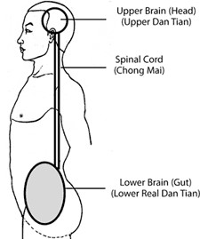

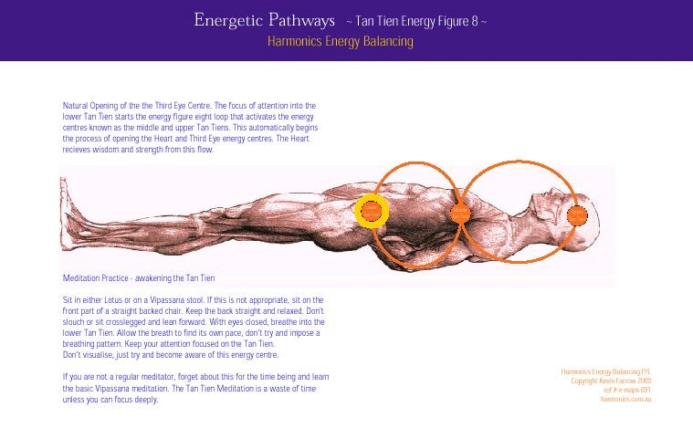

As Tai Chi and [qigong master Waysun Liao states](https://books.google.com/books?id=rTGJ-p1pHTQC&pg=PA134&lpg=PA134&dq=lower+tan+tien+behind+the+navel&source=bl&ots=lk853i3uzw&sig=YDu0ptRr3GilCevT7L1zRQyPmcU&hl=en&sa=X&ei=rl9AVfHMF_DlsATZ94HYCQ&ved=0CC4Q6AEwBA#v=onepage&q=lower&f=false):

*The center of our life energy resides in our lower tan tien, which is located behind the navel, in the lower stomach.*

And then we have to turn to *Foundations of Internal Alchemy* by Wang Mu (pp. 21-2) to get further clarification:

*The medical texts usually say that it is located 1.3 inches below the navel. According to the alchemical texts, instead, it is found 1.3 inches behind the navel....Why is it also said that the Cinnabar Field is located 1.3 inches below the navel? Zhao Taiding (Ming dynasty) gives the following explanation:*

*[translated from Mandarin] When we say 1.3 inches below the navel, this measure is taken with the body lying horizontally. [The Cinnabar Field- then is the point found 1.3 inches under the navel, that is between the kidneys.*

*In addition these explanations, there is another one. The Cinnabar Field is where the Elixir coalesces. As this is similar to a seed sown in a field, which naturally gives birth to sprouts and fruits that ripen in due time, it is called "field."*

|  |
| --- |
|  |
| [Kevin Farrow of Acuenergetics diagram](https://books.google.com/books?id=emaaAgAAQBAJ&pg=PA498&lpg=PA498&dq=kevin+farrow+lower+tan+tien&source=bl&ots=gzHEcEqVIO&sig=xG-DSZkaxxfjEmPKKazUeJVZBp4&hl=en&sa=X&ved=0ahUKEwjs-oy3nIvTAhUU8GMKHVrfB1QQ6AEIHDAA#v=onepage&q=kevin farrow lower tan tien&f=true) |

[Accordingly, this Lower Tan Tien wrong message of "below the navel" was erroneously passed down from a Master](http://archive.is/20130204074022/www.taijiquandao.com/03paginasingles/01introduction/10thedantian.htm) [lying on his death bed to a student, and so on. As qigong Taoist alchemy master Jerry Allan Johnson details - the lower tan tien is posterior or "behind" the more superficial acupuncture points and the location varies slightly for](http://www.ichikung.com/html/dantians.php) males and females, but the small intestines definitely store the qi energy:

*In these particular schools, students are taught that in men, the center of the Lower Dantian is located posterior to the Guanyuan CV-4 (Gate of Original Chi (Qi)) point. The center of the Dantian area in a women is said to be located higher, posterior to the Qihai CV-6 [Sea of Chi (Qi)] point, located within the center of the Bao or Uterus.*

|  |
| --- |
|  |
| [The alchemical secret of the Wu Chi point from the shen below the jing to build up Yuan Qi](https://www.slideshare.net/GeorgeLove1/medical-qigong-and-psychopritu) |

In the book *Hara Diagnosis: Reflections on* [*the Sea* (1988) - a further connection is made between the Ming Meng and lower tan tien and this same insight is described by others, like](https://books.google.com/books?id=ktO5Atic5u4C&pg=PA139&lpg=PA139&dq=greasy+membrane+between+the+kidneys&source=bl&ots=heosQuxoLB&sig=l0-gB4kRsPLLhWK1FsKQaGsYrkE&hl=en&sa=X&ved=0ahUKEwjpz5PNkIvTAhUX7WMKHYENBKsQ6AEIHzAB#v=onepage&q=greasy membrane between the kidneys&f=false) [Dr. Norman Bethune Allan:](http://www.normanallan.com/Misc/mingmen.htm)

*one old old source says that it is also the "greasy membrane between the kidneys." And what could that be? Surely it's the crus of the diaphragm!...Where the oesophagus passes through the diaphragm (the diaphragmatic hiatus), the diaphragm loops a bit of muscle round the left that then crosses over, below, to the right (to the right of the abdominal aorta)... The pieces of the diaphragm either side of the oesophagus, and then below, either side of the aorta, are called the crus of the diaphragm - the cross of the diaphragm.*

|  |
| --- |
|  |
| The secret Triple Burner, Heart-Small Intestine-Lower Tan Tien-Lung connection |

*Arising from the crus is a very interesting structure, the ligament of Treitz. This starts as a slip of striated*

*(voluntary) muscle from the diaphragm, becomes ligamentus, and then continues as smooth (involunatary) muscle to join (and suspend) the small intestine at the juncture of the duodenum and the jejunum (the second section of the small intestine). This suspensory ligament is the structure we feel relax when our "stomach" falls with fear, for instance.*

*But back to mingmen, the Life Gate; this is (likely) this structure between the kidneys, the crus of the diaphragm (and ligament of Treitz) the gateway in the diaphragm and the gateway in the energy fields.*

In the 2016 book [*The Mystical TCM Triple Energizer: Its Elusive Location and Morphology Defined Dr. Louis Gordon*](https://books.google.com/books?id=oQAyDQAAQBAJ&dq=greasy+membrane+between+the+kidneys&source=gbs_navlinks_s) [makes the same insight - that the source of energy is an alchemical "fire in the water" secret. According to Dimitri Kostynick:](http://www.jadedragon.com/tao_heal/bydchi21.html)

*Classical alchemy defines the three heaters as the three tan tiens.*

The key for the qigong alchemy training is to keep building up the parasympathetic nervous system energy, so as to ionize the life force, and this is why the qigong alchemy training is jokingly called "virgin kungfu" in the Old Skool kungfu films.

*The skill of Hai Teng [top qigong master of Shaolin] contains of* [*108 moves*](http://yogiaaron.com/examples-of-108-as-a-special-or-sacred-number)*. Both strong and soft. Hai Teng can still perform at [84 still virile] according to himself, is to keep his virginity and to always practice the internal 'Chi.'*

[But as this documentary of the qigong alchemy Shaolin monk Master Hai Teng details](https://www.youtube.com/watch?v=OUVZXg-h3sg) - maintaining his virginity of both mind and body is the key secret of his alchemy qigong training, at 1 hr, 17-19 mns.

*" What happens next, if you are male? You are having a terrific time with someone. Maybe you are breathing faster, your heart rate has increased. Gradually parts of your body are taking on a sympathetic [nervous system] tone....After awhile, most of your body is screaming sympathetic while, heroically, you are trying to hold onto the parasympathetic tone in that one last outpost as long as possible. Finally when you can't take it anymore, the parasympathetic shuts off at the penis, the sympathetic comes roaring on, and you ejaculate." Robert Sapolsky,Why Zebras Don't Get Ulcers (Holt Paperbacks, 2004), p. 124.*

|  |
| --- |
|  |
| Shang Dynasty Triple Cauldron 1600 BCE: Fire under water to make Qi |

So in the pure energy of innocent, moral youth then there is strong unified qi-shen, so there is a strong heart love energy, as oxytocin heart love theta "waking" REM holographic vision. By the age of 16, consciousness (mental thinking) takes over from shen spirit-yuan qi energy. This is why youth before puberty can learn very fast and learn new things easily, given the opportunity as mind-body harmonization. The best age to start the qigong [alchemy training is then by or before age 9, as Dr. Yang, Ywing Ming explains:](http://www.williammartino.com/enlightening-wellness/articles/three-treasures-internal-health-chinese-medicine-zen-tai-chi-and-kung)

*While the Fire Energy will strengthen your spirit, Water Energy will strengthen the mind to control the energized spirit. The spirit which is kept in its residence by the mind, which is nourished by the Original Energy is called Original Spirit (Yuan Shen.) Therefore, the root of your Original Spirit is traced back to your Original Essence. When your spirit is energized but*

*restrained by your mind it is called Essence Spirit (Jing Shen, also “spirit of vitality.”)...the wisdom mind (Yi) comes from the Pre-birth Qi (Yuan Qi) which is converted from the Original Essence you inherited from your parents.*

|  |
| --- |
|  |
| The Wuji Posture of standing alchemy Tai Chi |

The spirit leaves the body through the eyes during the waking state and the left-brain dominant mind becomes possessed at the speed of light (a sympathetic nervous system switch) by the subconscious right brain visual images seen that trigger, via the pineal gland, the loss yuan qi via the reproductive fluid (asymmetric lecithin stores up the qi charge) at night by the males. *Taoist Yoga: Alchemy and Immortality*: "If intellect is not frozen passions can not be cut off." Quick Fire breathing fixes these subconscious blockages - along with the Tai Chi trance dancing: This is the quick fire method - to convert the "postnatal" generative force from food into yuan qi energy.

In chapter 5 of *Taoist Yoga: Alchemy and immortality* the Quick Fire technique is described with the eyes open, by looking at a candle flame, but later in the book the Quick Fire breathing is described with eyes closed.

So the common denominator is actually strong deep belly reverse breathing which actually physically activates the adrenal medullae, thereby doubling your adrenaline levels - just by the breathing technique. (see below for quotes from the Wim Hof or tummo method).

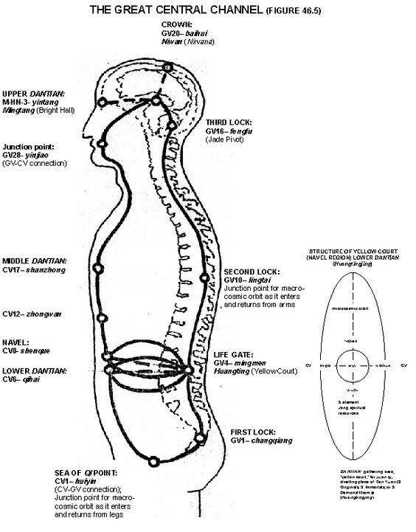This also pumps the blood and hormones up to the pineal gland which is also the source of the adrenaline and serotonin as neurotransmitter - so this creates a positive feedback between the kidney "yuan qi" activated by the Quick Fire and the third eye where "yuan qi" emanates.

So as *Taoist yoga* describes Quick Fire - the trick is that it activates the Yuan Qi which then has the "power" to spread the yin qi throughout the body to clear out any energy blockages.

Then with the Wim Hof technique from Tummo - holding the breathing after exhale, after the Quick Fire breathing activates the parasympathetic nervous system which then is the "shock" as the extreme dialectical reversal to store up the serotonin and electromagnetic energy.

So with each cycle - the breath can be held longer and when the breath is held after exhale this causes the blood to flood the brain to feed the most important organ in the body oxygen. The increased oxygen in the brain - ironically from holding breath after exhale - then causes increased shen light to build up from the increased mitochondria biophoton activation.

Then as the pressure builds up in the brain from the cerebrospinal fluid - this increases the yuan qi from the microtubules as quantum consciousness qi - and the cerebrospinal fluid soaks up that charge and then overflows out of the sinus cavity, with the tongue against the roof of the mouth. This is swallowed, causing great heat in the pit of the stomach. No food is eaten for a half hour to hour after wards and the qi energy is then absorbed back into the small intestines.

|  |
| --- |
|  |
| Secret of Quick Fire is strong reverse breathing to activate the Yuan Qi through the adrenal medullae |

From there it cycles back through the cerebrospinal fluid up the spine, etc. as the small universe.

So the Quick Fire is contrasted with the Slow Fire - which in deep serenity has the "appearance" of no breathing at all. In fact - when the qi builds up then it takes care of the chemical reactions like protein for food and oxygen for breathing, etc. That's when "deep serenity" occurs. If there is loss of energy again by the qi being deconverted back into fluid from impure lower frequency interactions - then the Quick Fire by deep reverse breathing to activate the adrenal medullae - that is the only technique that has the power to reverse the damage.

So with the horse stance you get the added benefit of the standing wave resonance with the Earth's schumann resonance from the legs shaking 7 to 8 times per second - also causing this Quick Fire extreme sympathetic nervous system reaction that dialectically reverses as an extreme parasympathetic reaction, flooding the intestines with serotonin, thereby getting the "shit scared out of you" as the saying goes. haha. That is actually a serotonin parasympathetic nervous system reaction.

O.K. so that process of aging has to be reversed by building up the Yuan Qi and the quickest way to convert jing to qi energy is through the knees bent with the increase in pressure and gravity as increased electromagnetic qi potential. The quick fire is used to sublimate the outer alchemical agent - external breathing - to transmute and purify the yin qi into Yuan Qi.

*the role of photon emission in vivo may be tremendous, as it becomes evident that disturbances in the symmetries of skeletal forces can result in enhanced phosphorescence, as a consequence of skeletal mechanically-induced luminescence (or triboluminescence). (biophoton study linked below)*

What happens is a standing wave with the Earth's Schumann Resonance - at 7 to 8 pulses per second - as the "yuan qi" energy. [Infrasound Emission is dramatically increased from qigong masters.](http://www.qigonginstitute.org/abstract/139/measurement-and-analysis-of-the-infrasonic-waves-from-emitted-qi)

*The [infrasound ELF] energy of the qigong masters was over 100 times higher than that of ordinary persons.*

|  |
| --- |
|  |
| 7 to 8 times per second ELF (extremely low frequency) is the pulsation of the yuan qi energy in resonance with Schumann |

This, in other words, is the trance dance training, and with the legs shaking seven times per second, the sympathetic stress nervous system gets pushed to its extreme, spiking the adrenaline and causing an extreme dialectical [reversal. Dr. Bradford Keeney's book on the original spiritual training of humanity has 56 results for "shaking." The](https://books.google.com/books?id=yhpKqtajCz4C&printsec=frontcover&dq=inauthor:%22Bradford+Keeney%22&hl=en&sa=X&ved=0ahUKEwjGxI-Bt5XOAhUGQSYKHUE9AYUQuwUIITAA#v=onepage&q=shaking&f=false) reversal floods the lower body with serotonin as a parasympathetic nervous system "flush" of the colons and then this serotonin flows [up the body into the pineal gland via the cerebrospinal fluid. Dr. Bradford Keeney article from his 2007 book Shaking Medicine: The Healing Power of Ecstatic Movement.](http://spiritualityhealth.com/articles/shaking-medicine)

|  |
| --- |
|  |
| Secret Alchemical Reason why Left Hand (Lunar) is held in front of lower body and right hand (Solar) in front of top of body! |

Now the Taoist alchemy trick with this trance dance training is that the left hand palm facing the belly button is the yang left hand facing the yin lower body and just like licking a 9-volt battery that connects the yin and yang, that creates a qi charge. So then the right hand palm facing the upper [body yang creates a yin right hand and yang upper body qi activation also. This is the "moving of yin and yang" exercise.](https://www.youtube.com/watch?v=oh7OY2r47YI)

*of interest was the shift in [biophoton] emission rate between the left and right hands; there was an intensity increase on the left (yin) hand starting around 8 PM, and from 12 PM until 5 AM the left hand emits more than the right. Subsequently, the left side emission decreases and right side (yang)* [*increases, being higher between 10 AM and 3 PM [32, 33]. biophoton study confirms yin-yang secrets of alchemy*](http://www.jams-kpi.com/article/S2005-2901(10)60041-6/fulltext)

|  |
| --- |
|  |
| [Son of Fritz-Alfred Popp, Alexander Popp gives biophoton lecture, youtube](https://www.youtube.com/watch?v=ag6-JEGzzHc) |

Now I had to study *Taoist Yoga* alchemy for years just to figure out that secret - and it is only for males! haha. Note in the biophoton study the left hand is claimed to be yin - it is for females. [biophoton 2014 medical textbook](https://books.google.com/books?id=FpgzBQAAQBAJ&printsec=frontcover#v=onepage&q&f=false) It's counter[intuitive as since the right hand is typically considered dominant we would think of it as yang but it's not! As I detail in my previous blogpost:](https://voidisyinyang.blogspot.com/2016/06/left-hand-is-yang-for-moving-of-yin-and.html)

*Smits then explains that since the body is a microcosm of the Universe this means that an imbalance on the top yang upper body is yin and therefore, facing south, is on the right side of the body, to the west as yin. The opposite is for the lower body, an imbalance on the yin half of the body is then on the east side or left side, the yang side of the body.*

So I knew from reading Wang Mu *Foundations of Internal Alchemy*, that the Dragon is the *yin* within the *yang* of the Sun fire while the Tiger is the *yang* within the *yin* of the water Moon. At first the "green dragon" is the liver qi that needs to be sublimated into the "red dragon" of the Solar heart. The white tiger is the opposite process so that Earth and Heaven are fully turned into yang qi energy. Dr. Aaron Cheak summarizes the alchemy training:

*Hence when yang (fire) contains a yin essence, it is known as wood (lesser yang) and when yin (water) contains a yang essence, it is known as metal (lesser yin)....just as greater yang (fire) grows from lesser yang (wood), so must fire be retracted back into wood. Just as greater yin (water) grows from lesser yin (metal), so must water be retracted back into metal. The two retracted halves - wood and metal, lesser yang and lesser yin, are then able to form the perfect earthly balance. This retraction and unification of yin and yang provides the matrix in which the golden embryo grows or is* [*cultivated. 'Taking from water (☵) to fill in fire (☲)': The History and Dynamics of Daoist Alchemy by Aaron Cheak, Ph.D.*](https://books.google.com/books?id=jUSwAQAAQBAJ&pg=PA23&lpg=PA23&dq=The+Perfect+Black:+Egypt+and+Alchemy%E2%80%9D&source=bl&ots=xjjfFbvEPj&sig=6Q2qIUS0-2Zmxk0iTeNx8S4zi8A&hl=en&sa=X&ved=0ahUKEwjEiKqdhL3PAhUE7GMKHcIdAIwQ6AEIQzAK#v=onepage&q=The Perfect Black%3A Egypt and Alchemy%E2%80%9D&f=false)

So then, as per the "moving of yin and yang" image above, the right hand is held over the lungs of the upper body as the yin is over the yang upper body which then grabs the "yin" (white tiger of metal lungs) *within the yang*. The yang left hand is held facing the yin lower body so that the yang left hand is now grabbing the yang green dragon (yin qi) *within the yin jing*.

[*"the right hand grabs the white tiger, left hand grabs the green dragon,"*](https://books.google.com/books?id=9CDSu89LQXMC&pg=PA1273&lpg=PA1273&dq=the+right+hand+grabs+the+white+tiger,+left+hand+grabs+the+green+dragon&source=bl&ots=577xJXWpvL&sig=8Uyk8U02ODRc45Dk5-2VOAgyrb8&hl=en&sa=X&ved=0ahUKEwjM8betvNHOAhVI72MKHSUTAkMQ6AEIHDAA#v=onepage&q=the right hand grabs the white tiger%2C left hand grabs the green dragon&f=false)

Yin qi (green dragon) of the wood liver is the essence of the yang shen of the solar heart (grabbed by the right hand) - and so it is the yang jing hidden within the yin of the lower body emotional energy (xin of the heart). The yin qi of the lungs (white tiger) is the essence of the prenatal yang qi lunar kidney energy (grabbed by the left hand).

If anyone doubts the importance of this secret - consider again the 5000 BCE alchemical tomb of the dragon and tiger: [It is validated by a similar later finding:](http://members.westnet.com.au/gary-david-thompson/page11-24.html)

|  |
| --- |
|  |
| copulation of White Tiger and Green Dragon |

*The skeleton is oriented so that its skull points to the south. The interest in this discovery lies in the comparison with the astronomical diagram found in the tomb of Marquis Yi of Zeng (a minor state). It can be readily identified that in both cases the dragon lies in the east and the tiger in the west.*

Again the left hand is east as yang grabbing the green dragon (yin qi of the yin lower body). The right hand is west as in yin grabbing the white tiger (yin qi of the yang upper body). This connects with the astrological constellations that opens up the Pole Star connection (see the final secret of this alchemy blogbook/article).

[Professor Gerald Pollack reveals the secret of this "yuan qi" heaven superconducting protons](http://www.greenmedinfo.com/blog/can-humans-photosynthesize-1)

*Richard Feynman, the legendary Nobel Prize physicist of the late 20th century understood the principle, opining that: "like-likes-like because of an intermediate of unlikes." The like-charged droplets "like" one another, so they come together; the unlike charges lying in between those droplets constitute the attractors (Figure 3).*

This is the "moving" or copulation of dragon and tiger and yin and yang. Just to emphasize this alchemical secret, consider this [Hadith of Islam](https://en.wikipedia.org/wiki/Second_and_third_deputation_with_Abu_Talib):

*“Oh my Uncle, By Allah, if they put the sun in my right hand and the moon in my left hand on condition that I abandon this matter (Islam), until Allah has made victorious or I perish, I will not abandon it.”*

[The real secret of that Hadith is that Muhammad was an alchemy blacksmith initiate as the ability for Islam to spread was based on their newly acquired iron-weapon forging skills. The water yin jing kidney energy - has a yang jing or](http://www.levity.com/alchemy/islam01.html) yin qi that is yuan qi and enables the ability to fast 40 days, as Moses, Muhammad, Buddha and Jesus all did. As Taoist quantum jazz biologist Dr. Mae-Wan Ho revealed - it is quantum coherent water, excited by the piezoelectric [resonance of collagen, that traps light as "imaginary mass" thereby splitting the water to create superconducting proton-proton energy as the "yuan qi" alchemy secret. pdf](https://www.researchgate.net/profile/Mae-Wan_Ho/publication/279066458_Illuminating_water_and_life_Emilio_Del_Giudice/links/559e358a08ae76bed0bb6e30/Illuminating-water-and-life-Emilio-Del-Giudice.pdf)

*Each CD [coherent domain] of water is effectively a resonating cavity produced by the*

*electromagentic field that ends up trapping the field because the photon acquires an imaginary mass, so the frequency of the CD [coherent domain] becomes much smaller than the frequency of the free field with the same wavelength.*

|  |
| --- |
|  |
| Dragon and Tiger Tripod Cauldron, Fire, Water, Qi Alchemy |

|  |
| --- |
|  |
| Increase alpha brain waves as ELF subharmonics as biophoton emission to power mitochondria |

That is the science of noncommutative phase-space as formless awareness Yuan Qi quantum entanglement negative entropy - from "quantum jazz" time-frequency *complementary opposites being in two places at the same time*.

*Excited coherent water is the basis of the oxidationreduction energy metabolism that powers all living processes...it orchestrates all the necessary chemical reactions. Dr. Mae-Wan Ho*

So that imaginary mass and virtual photons explains the qigong "bigu" fasting ability also called "converting jing to qi." The copulation of the crouching tiger, hidden dragon then cycles and builds up this yin qi to then "restore fire or *yang*, to its primordial celestial fullness" as Dr. Aaron Cheak details.

*"The dragon and tiger are respectively the yang and yin components of generative [jing] energy. Other names for the dragon are: the yang dragon that hides with the fluid, the yin within the yang (symbolized by the broken line flanked by two solid lines in the trigram Li [fire]), the vapor within the fluid, the vapor of pure yang, and the true fire. Other names for the tiger are: the yin tiger that hides within the vapor, the yang within the yin (symbolized by the solid line flanked by two broken lines in the trigram Kan [water]),*

*the fluid within the vapor, the fluid of pure yin (or the vapor of pure yin), and the true water. The dragon and tiger are therefore the components or ingredients of mundane generative energy. Do not confuse them with their carriers, fluid and vapor. Central to the preservation and cultivation of generative energy is the process known as the copulation of the dragon and tiger. The yin and yang components of generative energy meet and merge to become purified generative energy, with is also called the primordial vapor. [yuan qi or water pre-birth qi]. The process begins with the vapors of pure yang (dragon) and pure yin (tiger) rising from the base of the spine and traveling separately up the spine and through the shoulder blades. When the vapors reach the head, they interact (copulate) and merge to become one unified vapor. This unified vapor descents to the palate of the mouth and is manifested as nectar, a sweet, sticky fluid. Swallowed down the throat, the nectar enters the middle tan-t'ian (in the area of the solar plexus) and eventually completes its circuit when it reaches the base of the spine again."*

- [*Nourishing the Essence of Life*](http://www.amazon.com/exec/obidos/ASIN/1590301048/gardendigest)*: The Outer, Inner and Secret Teachings of Taoism*. Translated with and

Introduction by Eva Wong. Boston, Shambhala, 2004. Pages 9-10, 8-23,94. Translation of three texts from the Daoist Canon, circa 1400 CE, called *The Mysteries of the Tao* (Tao-hsuan p'ien), *Understanding the Mysteries* (Wushuan p'ien), and *the Sacred Treatise on the Great Mystery* (T'ai-hsuan pao-tien) of the Complete Reality School of Daoism.

|  |
| --- |
|  |
| When legs shake 7 to 8 times per second this resonates with Earth's Schumann Resonance as free electrons |

O.K. so then - that moving of the yin and yang trance dance Tai Chi exercise is the foundation of the practice since it creates the Quick Fire (deep fast reverse breathing) which is the *only means* to convert the yin jing back into yang jing or yin qi energy. Quick fire activates the Yuan Qi in order to drive the yin qi to clear out the blockages. Quick fire breath turns the generative fluid from food into generative force yin qi (instead of fluid).

*Taoist Yoga: Alchemy and Immortality*:

*Spirit can only hold vitality temporarily but lacks the driving power of breathing, and without breathing, vitality cannot be driven into the channels of control and function and will drain away by the genital gate; this is caused by lack of pressure from in and out breathing. p. 87*

So now we have the first step but we learn that the kidneys are either yin jing or yang jing. It's said that the adrenal medullae on top of the kidneys are the yang jing which makes sense.

[The adrenaline increases from the quick fire deep oxygen breathing](https://www.google.com/url?sa=t&rct=j&q=&esrc=s&source=web&cd=1&cad=rja&uact=8&ved=0ahUKEwjolNba9ZfOAhVMMSYKHXBVBI8QFggeMAA&url=http%3A%2F%2Fwww.icemanwimhof.com%2Ffiles%2F2016wimhofmethod-revealed.pdf&usg=AFQjCNF4c2xN_6e4RC5PCqxUxj-VQcwYyg&sig2=7L8mILGUIkqHcgvBxk5mbw) [scientifically explained by the *Wim Hof Method*, pdf link:

*The researchers also concluded that this experiment confirmed that a clear voluntary activation of the autonomic nervous system triggers an increase in the production of the stress hormone adrenaline. In turn, this resulted in a suppression of the activation of the immune system.*

Again it pushes to the extreme, doubling, and causing an opposite extreme rebound reversal, as an increase in serotonin from the parasympathetic nervous system. [head and full body shaking medicine:](https://books.google.com/books?id=Z_nwjLjUVBgC&pg=PA30&lpg=PA30&dq=arita+hideo+serotonin&source=bl&ots=CnDjRS4fkC&sig=_quR4ZIyQUs88J8X3UHn3UmxY08&hl=en&sa=X&ved=0ahUKEwixx-fV2JTOAhWM4yYKHRE7BU8Q6AEIQTAG#v=onepage&q=arita hideo &f=false)

|  |
| --- |
|  |
| Yuan Qi is normally jing-shen between the kidneys but transformed into shen-jing through alchemy training of the 12 channels |

*To study the effects of Brain Wave Vibration on serotonin production, Prof. [Arita] Hideo had a group of people practice Brain Wave Vibration for 15 minutes on three separate occasions. He found that the group had an average serotonin level of 186 [nanograms per milliliter] before the training. Immediately after experiencing Brain Wave Vibration, the subjects’ levels increased to an average of 210. These effects were shown to remain relatively stable, as the average serotonin level one hour after training*

*averaged 200. __The*

*study also showed an increase in alpha wave production, the brainwave state associated with waking relaxation and greater blood flow in the brain, especially in the prefrontal cortex.*

|  |
| --- |
|  |
| Yuan Qi is from activation of "yang jing" as extreme reverse breathing doubling of adrenaline going up to pineal gland |

Reverse breathing means below the bellow button the stomach goes in on the in breath and above the belly button on the in breath the stomach goes out and the diaphragm is flexed down. This is also called "pressure breathing." The quick fire breathing (fast deep reverse breathing) doubles the adrenaline levels by physically stimulating the adrenal medullae or "yang jing" on top of the kidneys. [Again the Wim Hof tummo method was tested:](https://www.ncbi.nlm.nih.gov/pmc/articles/PMC4034215/)

*Epinephrine [adrenaline] levels in trained [for 4 days] individuals were even higher than those reported in a recent study in which acute stress elicited by a bungee jump was found to suppress cytokine production by leukocytes ex vivo stimulated with LPS (*[*13*](https://www.ncbi.nlm.nih.gov/pmc/articles/PMC4034215/#r13)*). As norepinephrine, dopamine, and cortisol levels were not increased in the training group, it appears that the techniques predominantly result in stimulation of the sympathetic input to the adrenal medulla, because this is the most abundant source of epinephrine [adrenaline] in the body and epinephrine-producing chromaffin cells in the adrenal medulla*

Then a dialectical reverse of extreme sympathetic causes an extreme parasympathetic vagus surge in serotonin that flushes out the colon and increases serotonin into the pineal gland, thereby further increasing adrenaline and [serotonin. Qigong studies have revealed that qigong training increases serotonin in the cerebrospinal fluid and nervous system while decreasing serotonin in the blood and increasing adrenaline and dopamine in the blood.](http://yang-sheng.com/?p=3829)

*Ma (6) and Xia et al. (7) discovered that in the CNS, 5-HTP [serotonin] increased, dopamine decreased, and the metabolism of norepinephrine fell by 60%. It was also reported that frequent Qigong practice rendered the production and excretion rate of 5-HTP two to three times higher than the normal....After Qigong exercise, the blood levels of serotonin (5-HT) decreased,*

See then the Guanyuan - Ren 4 [small intestines] encountered again as in the first image I posted - as the original human culture emphasized, the small intestines are considered the largest source of N/om (spirit-vitality or shen[yang jing) as the lower tan tien. According to Traditional Chinese Medicine, the small intestines create the "humors" as the cerebrospinal fluid. As Master Nan, Huai-chin states, only when the colon is cleared out, is a person then able](https://books.google.com/books?id=tKNrg-gG3pgC&pg=PA53&lpg=PA53&dq=small+intestine+cerebrospinal+fluid&source=bl&ots=rbj9ZNsz9q&sig=gx-AkpP16uzGI-w8-zK5kpNP62s&hl=en&sa=X&ved=0ahUKEwiiqeKU5bjPAhVMxWMKHfhIAToQ6AEINTAD#v=onepage&q=small intestine cerebrospinal fluid&f=false) to see light in the upper tan tien, the pineal gland third eye.

*Potassium has the same effect as lecithin, lecithin as the vagus (parasympathetic), and the vagus, finally, as pleasurable excitation, swelling, turgor, increased surface tension, and as was recently* [*shown, electrical charge. Wilhelm Reich, Bion Experiments, 1938 in German, published in English, first time, 2013.*](https://books.google.com/books?id=Rm_PJzLtrccC&dq=lecithin++potassium+charge&source=gbs_navlinks_s)

As I pointed out in my [*Secret Science of Spiritual Healing*](http://viewzone.com/spiritualhealing22.html) article, electric eels convert serotonin in the pituitary gland to ACTH and this is used to dramatically change the potassium to sodium ratio for the synapses which then creates an electromagnetic field that is transmitted, strong enough to take down a large man standing in the water! Electric eels store their charge up in lecithin.

[Lecithin is the main component of semen but lecithin is also the main component of storing up charge in the neurons - the myelination of neurons. Eggs as the main food source of lecithin are then considered "brain foo](http://davidpratt.info/bernard.htm)d" by the Taoists who teach how to "feed the brain." Soy is the main vegetarian source of lecithin and the main protein source in the Buddhist monk diet. [As the original qigong master states:](https://www.facebook.com/SpringForestQigong/)

*Our feelings, thoughts, and emotions are all energy. Each has its own energy frequency and vibration, as all things do. When that frequency and vibration meets the frequency and vibration of an organ in the body, they will produce resonance.*

*The resonance created by positive, balanced thoughts and emotions can help to strengthen and heal.*

[Our Electric Emotions (2013) details why eating fish oil stores up electric charge.](https://books.google.com/books?id=9yTkAwAAQBAJ&pg=PA82&lpg=PA82&dq=lecithin+electric+fish&source=bl&ots=UlGrpmN_3Y&sig=rSQ9BM0Z5t69q4Li4FgtqHWGoBs&hl=en&sa=X&ved=0ahUKEwihytmh4t_OAhWFdh4KHeDDDa8Q6AEINDAE#v=onepage&q=lecithin electric fish&f=false) The phase boundary potentials

|  |
| --- |
|  |
| [2015 pdf on the Fatty Acid-Serotonin-Microtubule-Biophoton Consciousness resonance](https://www.google.com/url?sa=t&rct=j&q=&esrc=s&source=web&cd=1&ved=0ahUKEwjH37KF84XSAhUUwWMKHao3C_MQFgghMAA&url=https%3A%2F%2Fwww.researchgate.net%2Fprofile%2FJack_Tuszynski%2Fpublication%2F280583256_On_the_possible_quantum_role_of_serotonin_in_consciousness%2Flinks%2F55db225d08aeb38e8a8aede0.pdf%3FdisableCoverPage%3Dtrue&usg=AFQjCNHDknE9Nt8KXVQfHxnnrEusd0r8hA&sig2=dd3leMDAWLws-GidgGv38g&cad=rja) |

(the 10 microsecond phase wavelength of the ultrasound megahertz frequency) make possible the static electricity produced by the cells. As *Taoist Yoga: Alchemy and Immortality* teaches, when the qi leaves the lower tan tien, it turns back into ejaculation (lecithin). In the lower tan tien it is ionized jing as the alchemical pill; asymmetric lecithin is piezoelectric. When generative and vital forces leave the lower tan tien they become separated and so the generative force (yin qi) turns negative, back into fluid, causing the true vitality to "scatter." When the generative force and vitality move away from the lower tan tien they become liquid. When they return back to it they become prenatal vitality or yuan qi. True vitality (yuan qi) sustains the generative force as "fire in the water."

Taoist alchemy Master Wang Liping teaches to sit in full lotus yoga meditation six hours a day for a year to restore the Yuan Jing energy. The brain cerebrospinal fluid gets ionized by the unification of shen-qi via the pineal gland. When the brain fills up with energy with the tongue against the roof of the mouth, through the vagus nervous system, then the "ambrosia" overflows out of the skull cavity via the nasal sinuses.

*The researchers claim to have found a sweet spot in the 2-3 MHz range, [ultrasound] where the normally slower mechanical vibrations (usually*

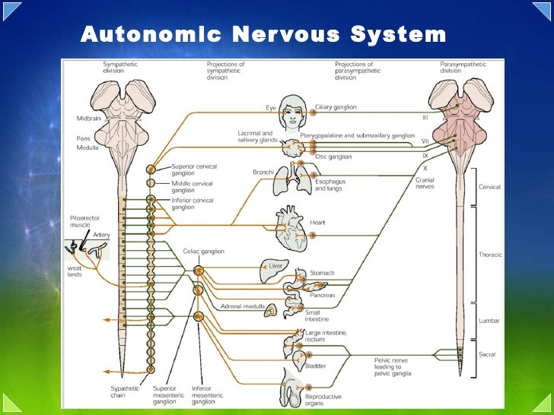

Te

stes are parasympathetic while erection is sympathetic, so increased parasympathetic orgasm empties out the testes and fills the lower tan tien with qi

energy.

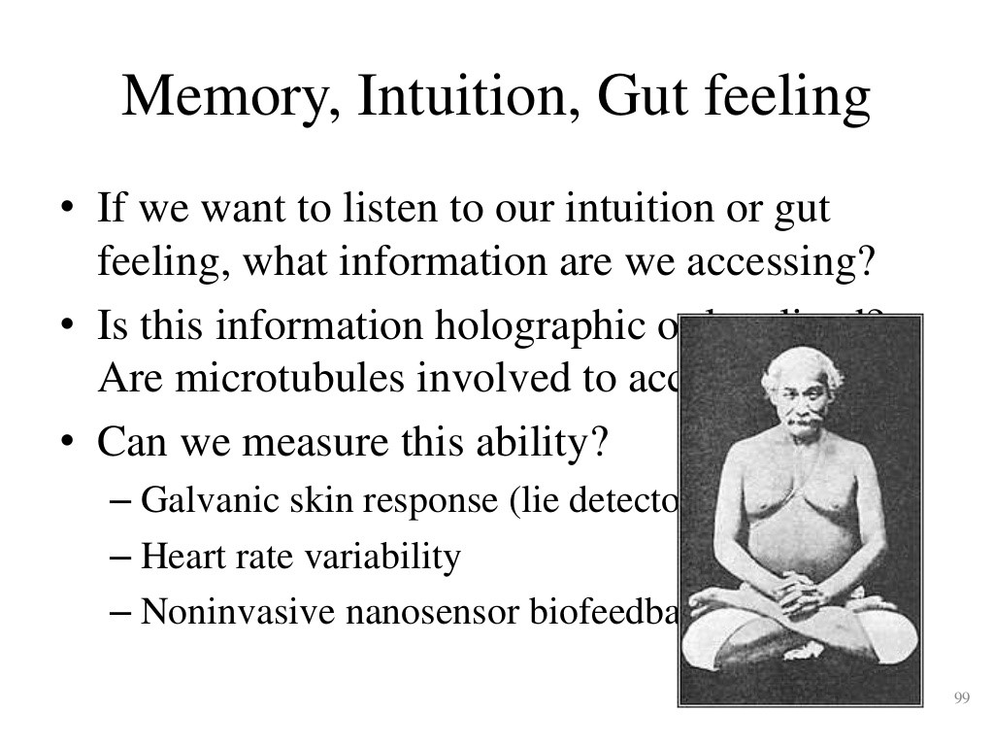

Kriya Yoga and Taoist Alchemy - same teaching: 6 hours of full lotus a day to restore Yuan Jing

*associated with protein folding) of tubulin monomers and polymers*

*overlapped with the typically*

*higher intrinsic electromagnetic*

*vibrations of the molecule.*

*Hidden information-processing networks*

*in the*

*skeleton of cells*

*However, there are 30000 and above proteins*

*working relentlessly in our body, the “common*

*frequency point”*

*[*

*ultrasound] if it exists for all proteins, would open up a possibility*

*to remotely cure*

*diseases.*

*Nature*

*2014*

Craniosacral [Polarity Therapist Dr. Rudolf Stone](http://www.positivehealth.com/article/polarity-therapy/polarity-therapy-linking-ancient-knowledge-and-modern-physics) called it the "Ultrasonic Core"

*The ultrasonic core is the name given by Dr Stone to the central shaft of the Caduceus. He writes "The central core is the ultrasonic energy current of the Soul. It is the primary energy which builds and sustains all others… (it is) located anatomically within the central canal of the spinal cord and resonates with the 'Eternal Sound Current' … the Unitive Field of Cosmic Intelligence....Dr Stone again "The cerebrospinal fluid(CSF) seems to act as a storage field and a conveyor of the ultrasonic and life energies."*

By the complementary opposite harmonics of alchemy practices:

*Obviously, for some proteins the survival for microseconds is the “common frequency point”. In this case, the common point is the inverse of microseconds that is the megahertz frequency. ultrasound as the "wirelessly" means of healing.* [*Nature 2014*](http://www.nature.com/articles/srep07303)

This qi-infused saliva as cerebrospinal fluid is swallowed, causing great heat in the belly. No food is to be eaten for a half hour after meditation and the qi energy is then absorbed into the small intestines through the back wall or pit of the stomach. As the Yuan qi increases then the internal heat increases. To quote Jerry Alan Johnson,

*...the disciple will notice intense heat suddenly begin to radiate from within his Lower Dantien, caused from the increased cultivated Generative Force (Jing) and Vitality (Qi) being stored within his lower Elixir Field. After some time of experiencing the intense heat (usually within a two week time period), the Lower Dantien will suddenly begin to vibrate, causing the entire body to shake. p. 553, Daoist Alchemy chapter*

Frank Znidarsic discovered that at 10 microns, the wavelength of collagen, inside atoms the speed of light slows down to ultrasound frequency. So the speed of sound inside the fluid of the molecules actually becomes the "quantum transition" energy to resonate photons and to split water into superconducting proton-proton Yuan Qi energy. The lecithin gets ionized into a nonlinear quantum relativity soliton so that increased piezoelectric collagen pressure actually causes the denser lecithin to travel at faster speed and higher frequency of energy as increased qi energy. [The Thermodynamics of Thought: Sound pressure and solitons pdf 2013](https://www.google.com/url?sa=t&rct=j&q=&esrc=s&source=web&cd=3&ved=0ahUKEwjh-4CX39_OAhVF2B4KHSUFCNMQFgguMAI&url=http%3A%2F%2Fwww.membranes.nbi.dk%2Fpress%2F2013-09-thermodynamics-thought-soliton-spikes-heimburg-jackson.pdf&usg=AFQjCNHN2ty1Kj7et2o27QwwugPIYsBpkg&sig2=OsVVA5t3uTrj1Ixnr2q1ag&cad=rja)

*The crystal strains (expands or contracts) when a voltage is applied. When the voltage is reversed, the strain is reversed. This is known as the piezoelectric effect. Oscillation is sustained by taking a voltage signal from the resonator, amplifying it, and feeding it back to the resonator. The rate of expansion and contraction is the resonance frequency and is determined by the cut and size of the crystal. The output frequency of a quartz oscillator is either the fundamental resonance or a multiple of the resonance, called an overtone frequency. Most high stability units use either the third or fifth overtone to achieve a high Q. Overtones higher than fifth are rarely used because they make it harder to tune the device to the desired frequency. A typical Q for a quartz oscillator ranges from 104 to 106. The maximum Q for a high stability quartz oscillator can be estimated as Q = 1.6 ´ 107/f,* [*where f is the resonance frequency in megahertz [ultrasound]. Fundamentals of Time and Frequency*](https://www.google.com/url?sa=t&rct=j&q=&esrc=s&source=web&cd=1&cad=rja&uact=8&ved=0ahUKEwiM5O3ypIjPAhUHS2MKHUq0CRkQFggeMAA&url=http%3A%2F%2Ftf.nist.gov%2Fgeneral%2Fpdf%2F1498.pdf&usg=AFQjCNEQtpISun8Qsb_qXZ3dbaS8e3Fb7Q&sig2=fJykak5HsY8brjGs9ZMMSQ)

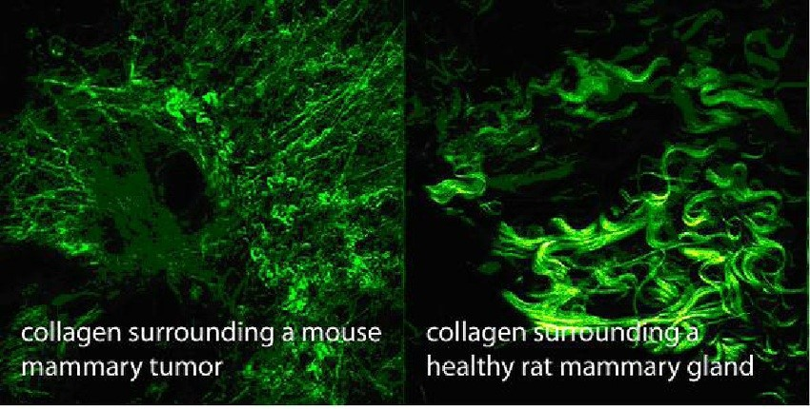

biophotons In Vivo imaging have 2nd Harmonic Generation - higher frequency light from "imaginary mass" of superconducting delocalized water protons

(

Yuan Qi) from piezoelectric collagen resonance.

*pdf*

So basically this process is reversed for alchemy training - gravity differential pressure of the standing "moving of yin and yang" exercise on the collagen and bones resonates piezoelectric ultrasound energy so that the vagus nerve to the inner ear creates ringing as indication of the kidney jing energy. There is a nonlinear feedback between ELF waves and ultrasound waves and quantum consciousness and qi or prana. [For example:](http://anesthesiology.pubs.asahq.org/article.aspx?articleid=1942166)

*Electroacupuncture (electrical stimulation of acupuncture points) with high-frequency (100–200 Hz) stimulation provides rapid-onset analgesia that is not cumulative and cannot be blocked by naloxone. This type of analgesia is probably mediated by norepinephrine, serotonin, and dynorphins.*[*47*](http://anesthesiology.pubs.asahq.org/article.aspx?articleid=1942166) *In contrast, low-frequency (2–4 Hz) and medium-frequency (15–30 Hz) stimulation produces an analgesic effect that is reversed by naloxone (and therefore presumably mediated by enkephalin and endorphins), has a tendency to accumulate, and lasts at least an hour after treatment ceases.*[*45,47*](http://anesthesiology.pubs.asahq.org/article.aspx?articleid=1942166)

Dr. Mae-Wan Ho:

*...ultrasound emissions from mechanoelastic vibrations caused by electrical pulses applied to the tissues. Muscle physiologists have long detected sounds from working muscles, but have treated them as distracting noise when electrical or mechanical signals are being recorded.... the memory of our body, inhering in the liquid crystalline continuum, were to exist in a quantum holographic form.*

*Rainbow and the Worm, p. 192, p. 195*

|  |
| --- |
|  |
| Ultrasound at 50 microwatts/cm squared activated acupuncture point as quantum coherence |

Dr. Mae-Wan Ho:

*On that basis of the 100-fold difference in electrical conductivity along the fibre compared to that across the fibre, it would be expected that collagens fibres will align in the direction of the applied electric field. Julian Haffegee in our laboratory has confirmed this, and has achieved the first successful alignment of collagen fibres under self-assembly by weak electromagnetic fields.24 This work has important implications for wound healing and regeneration, as the movement of cells are known to be guided by oriented collagen fibres in the extracellular matrix.*

*Rainbow and the Worm, p. 190.*

People can use [ultrasound machines](http://www.ncbi.nlm.nih.gov/pmc/articles/PMC522144/) with the effect of:

*Vigorous heating, or an increase of 4°C or more, has been suggested to alter the viscoelastic properties of collagen and inhibit sympathetic activity*[*.10*](http://www.ncbi.nlm.nih.gov/pmc/articles/PMC522144/#B10)[*–13*](http://www.ncbi.nlm.nih.gov/pmc/articles/PMC522144/#B13)

*Laozi's notion of chapter 41 of the Tao Te Ching that “the highest note cannot be heard”*

[As the original qigong master says in this interview - Qi machines do not have love and life force energy.](https://view.publitas.com/p222-665/se-2015-winter-vol-26-issue-3/page/22-23) The highest note we hear externally as a ringing pitch, is actually the subharmonic of internal ultrasound that resonates [the quantum consciousness microtubules of the collagen. Dr. Joie P. Jones has used fMRI to document ultrasound activation in the toe acupuncture point triggers the occipital vision - just as strong as shining light in the eyes - pdf on Ultrasound Acupuncture (see image above).](https://www.google.com/url?sa=t&rct=j&q=&esrc=s&source=web&cd=1&cad=rja&uact=8&ved=0ahUKEwiVpdS-kYPSAhUJ02MKHZ7bD3EQFggcMAA&url=http%3A%2F%2Fbst.sagepub.com%2Fcontent%2F22%2F5%2F362.full.pdf&usg=AFQjCNFswCaEZbixKShL19Dkp94WN6wDeg)

*Monitoring neural vascular function with Doppler ultrasonic imaging provides unexpected support for the brain ultrasound demodulation theory. When the imaging beam was focused at the center of the brain, patients reported hearing a high audio sound, much like tinnitus. When the ultrasonic beam was directed at the ear, the sound disappeared. Setting the brain into resonance resulted in a clear high-pitch, audible sensation consistent with brain resonance in the 11- and 16- kHz range....Because ultrasound produces high audio stimulation by virtue of brain resonance, the direct use of high audio stimulation is more economical in power requirements and still stimulates the brain at resonance. Dr. Martin L. Lenhardt, “Ultrasonic Hearing in Humans: Applications for Tinnitus Treatment,” International Tinnitus Journal, Vol. 9, No. 2, 2003, p. 3 and p. 6.*

|  |
| --- |
|  |
| [Vagus nerve activation via Ear electrical stimulation - shown to improve memory and decrease implicit emotional racial bias](http://journal.frontiersin.org/article/10.3389/fpsyg.2015.00102/full) |

Dr. Stuart Hameroff has provided the biological connection to quantum consciousness via the ultrasound resonance of microtubules (*Discovery of quantum vibrations in 'microtubules' corroborates theory of consciousness* 2014) collaborating with quantum cosmologist Roger Penrose. Dr. Hameroff has even tested his own brain, reporting increased bliss from ultrasound treatment.

[Low-intensity pulsed ultrasound treatment improved the rate of autograft peripheral nerve regeneration in rat](https://www.ncbi.nlm.nih.gov/pmc/articles/PMC4840319/)

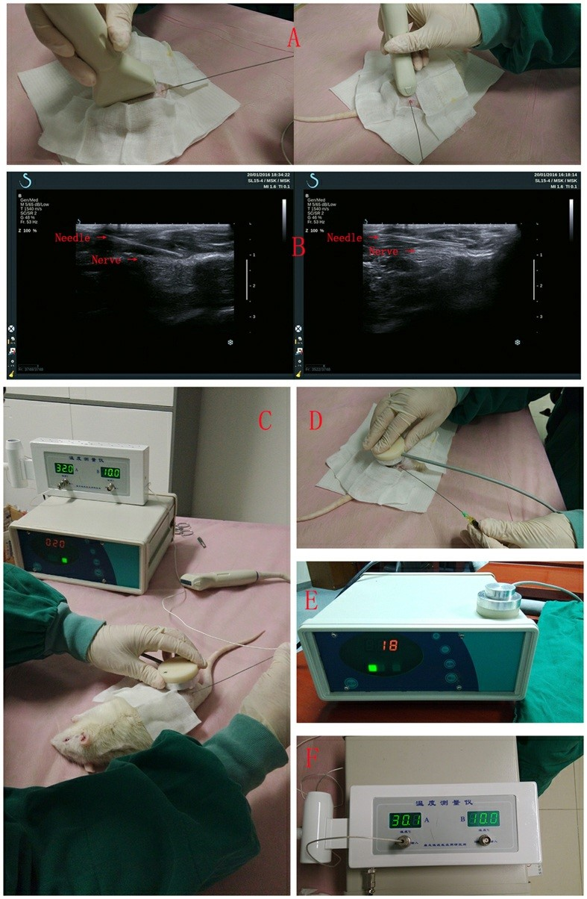One of the Qi healing training schools emphasizes instead of increasing jing hormone energy, the qi school increases "nerve fiber" axion growth. Sure enough science has as of 2016 proven the key to growing nerves:

*LIPUS of 250 mW/cm2 significantly induced faster rate of axonal regeneration.*

As Dr. Hameroff details - the quantum microtubules in neurons switch between classical and quantum realms, (i.e. quantum chaos) just as music uses different frequencies, but ultrasound has the strongest amplitude resonance [with the non-local quantum entanglement as consciousness. An overview as of 2015 of the various medical devices as vagus nerve or brain stimulation, with their various problems. The Nada (inner sound) Yoga describes it as thu](http://kronstantinople.blogspot.com/2013/09/our-future-everything-in-modulation.html)s (*Merging with Shiva, Hinduism’s Contemporary Metaphysics*, 2004):

*When you can see a white light aglow in your head in a darkened room, or even see*

*a flash of it, or hear the inner, high-pitched sound, “eee,” humming in your inner ear, then you know that you are consciously functioning in the subsuperconscious state of mind. Devotees who have had their first flash of white light in their head or heard the constant high-pitched “eee” in their inner ear have awakened the process of the subsuperconscious state of mind, and it works quite automatically after that.*

|  |
| --- |
|  |
| [Vagus nerve stimulation shown to treat depression, 2015](https://www.omicsgroup.org/journals/transcutaneous-auricular-vagus-nerve-stimulation-a-novel-noninvasive-nonpharmacologic-treatment-for-major-depressive-disorder-2167-1044-1000239.php?aid=77116) |

The key secret of the alchemy training is not only to inhibit the sympathetic nervous system activity - or to not "reverse the voltage" - but instead as a parasympathetic oscillator to keep building up the qi charge. So at first then the right side of the brain is "emptied out" by the right side vagus nerve pumping up the lower body blood and cerebrospinal fluid, via the increased adrenaline and dopamine from strong reverse breathing. Then at extreme sympathetic nervous system "shaking" (either in full lotus with legs numb or horse stance with thighs parallel to ground) there is the extreme parasympathetic rebound that triggers the internal vagus nerve orgasmic kundalini emission (not sympathetic ejaculation) of fluid into the brain. This increases serotonin into the pineal gland, to increase the qi energy and then the biophoton shen.

As this process continues it converts dopamine to serotonin via the left side vagus nerve going down from the left side of the brain to the heart, thereby clearing out the left side

"conceptual" mind as the cerebrospinal fluid begins to overflow out of the nasal sinus cavity into the mouth, infused with qi-shen energy. This then converts serotonin to increased oxytocin of the heart.

|  |
| --- |
|  |
| Left side kundalini vagus nerve has "efferent" energy away from brain to heart |

This overflowing brain cerebrospinal fluid is then swallowed, creating great heat in the "pit of the stomach" and then no food is eaten, so the qi then passes through the back stomach wall into the small intestines as the lower tan tien energy. So for example the hunger sensation is caused by the left side vagus nerve going from the front of the stomach up to the brain, as an afferent nerve, while "flexing" the sphincter muscle activates the right side vagus nerve to pull the energy down the front and up the spine. The parasympathetic nervous system goes to the testes and sphincter while the sympathetic nervous system goes to the erection as ejaculation.

[As Thomas McCombs describes in his *Anatomy of Alchemy* presentation:](https://www.slideshare.net/ThomasMcCombsDO/anatomy-of-alchemy)

|  |
| --- |
|  |
| [Asymmetric Afferent Emotional Healing: The Parasympathetic Afferent Nerves cross over from the right side of the body to the left side via the third eye, going down as the left side efferent vagus to the heart pdf link](http://www.isatapsy.com/publications/33-c12-presence-in-mind-2014/file) |

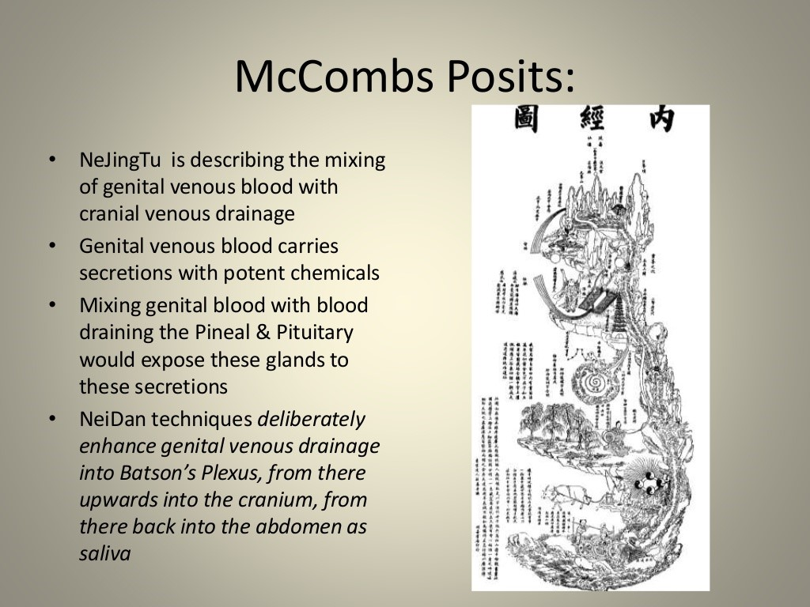

As the *Huang Di Nei Jing Su Wen* (*Yellow Emperor's Canon of Internal Medicine*) states, when the 12 channels

(modeled as 12 rivers) are filled up with qi, then it overflows into the Ren Mai (conception vessel or Jen-Mai) and Du [Mai, (governing vessel or Tu-Mai), as the "small universe" or microcosmic small heavenly orbit. Physicist engineer Wing Y. Pon quotes the *Nei Ching*, Yellow Emperor Classic on Traditional Chinese Medicine:](http://holon137.com/Matter-BeingProject/?p=5839)

*The theory may be compared to the plan of a Sage in designing the map of waterways which, when full, will flow into the deep lakes; by the same token, when the Ch’i fills up the master meridians, it will flow into the eight extraordinary meridians and stop circulating through the twelve master meridians. When the extraordinary meridians are under attack of the vicious Ch’i, which blocks up circulation, it will give rise to swelling and hot sensations, which should be treated by stone needles.*

This is the key secret of the full lotus yoga Taoist 49 day no sleep, no food cave meditation as building up the parasympathetic qi energy. To quote Wing Y. Pon again quoting a TCM doctor:

*The Eight Extra Meridians are capable of regulating the functions of the twelve Master meridians by way of a number of special points and also through their close and complicated connections with the Master Meridians.*

*Out of the Eight Extra Meridians, the Du Mai and Ren Mai are the most important Yang-Yin pair. First*

*of all, the acu-points for the other six extra-meridians are subsets of the 12-organ meridian acupoints.*

|  |
| --- |
|  |
| [Energy goes up the spine and down the front of the body.](http://www.springforestqigong.com/learn-qigong/small-universe-30-minutes/) |

The advanced stage of Taoist Alchemy as detailed in *Taoist Yoga: Alchemy and Immortality* states no salt is allowed in the diet, thereby having no negative ions that increase the sympathetic nervous system, with the potassium maximized against the sodium.

*Both a French and a Japanese scientist, Louis Kervan and George Ohsawa, showed how sodium can be transmuted into potassium with the addition of oxygen [quick fire* [*breathing] and...electrical energy! The Sonobioelectronic and Sonobioelectrogravitic Nature of Life...*](https://www.researchgate.net/publication/242650713_The_Sonobioelectronic_and_Sonobioelectrogravitic_Nature_of_Life_on_Earth_And_Why_Pilot-wave_Subquantum_Mechanics_and_Information_Is_Not_Enough)

Cave meditation is called "converting jing to qi" with constant full lotus meditation, no sleep for a month as the original qigong master did at the origin of Taoism and Tai Chi, the sacred Mt. Qingcheng

*As a part of their training, all the Lineage holders of ’ Fire Dragon Shen Gong were brought into the secret “Fire Dragon Cave” on Mt. Qingcheng. There, they did the “49 days Ritual Purification Fasting” under the personal guidance and instruction of their own Master. As a result, they reached the highest level possible. Following in these footsteps, Master Yuanming Zhang has been brought into the Fire Dragon Cave once every three years, since he was 3 years of age, by his Master. The cultivation during these times began at midnight on August 15, the full moon day.*

*What follows is a description by Master Yuanming Zhang of what one feels like when performing the*

*49-day fast in the cave. “During the first week, you will feel like you are near a volcano or having a Sauna. You will sweat a lot and with the sweats the whole body and mind will be cleansed and purified and all the ill “Qi” and “evil spirits” will be dispelled.*

*In the second week, you can feel as if the lower Dantien were a Volcano or steel-smelting furnace, with bright-red energy flowing to all parts of your body. Instead of sweating, the hot feeling in the abdomen rises upwards.*

|  |
| --- |
|  |
| [Chao Yang Cave, Mt. Qingcheng has 8 large caves, 72 small caves, home of alchemy Taoist training](http://qigongmaster.com/) |

*The third week brings the feeling that genuine Qi in the abdomen is turning into a fire dragon floating along the circulation track of the body’s energy channels. All the energy channels and meridians open up, the circulation of both microcosmic and macrocosmic orbits is running smoothly; It’s as if one’s entire body is floating in the space. The happiness and “lightness” of being in this “fairyland” cannot be expressed in words.*

*By the fourth week, the third eye will be opened and special abilities appear. You can actually see the fire dragon travelling along the body’s energy channels when you “look” inside the abdomen. When your master emits energy directly to your Heavenly Eye Acupoint, you will see a bright red and yellow colour spot gradually growing into a “FireOcean” in the darkness. Colourful*

*scenery can be seen with mountains, rivers, pavilions, buildings, birds, animals and Immortal Images from ancient times. It’s exactly the feeling of being linked with Universal Spirit and Energy.*

*Over time, you can receive the highest level energy from“viewing” those scenes. This leads to improvement your health, develops intelligence and opens latent abilities. After the 49 days*

*Cultivation, 80% of practitioners are able to see the “Qi light” in the sky with their naked eye. The “Qi light” looks like sperm and ovum. Master Yuanming named this “Qi Light,” “Dragon Sperm.” A few people can even see a giant dragon image in the sky.”* [*Qi Magazine pdf*](https://www.google.com/url?sa=t&rct=j&q=&esrc=s&source=web&cd=9&cad=rja&uact=8&ved=0ahUKEwik06OM6t_OAhXDsh4KHUTNBVcQFghLMAg&url=http%3A%2F%2Fwww.qimagazine.com%2Ffileadmin%2Ffree_downloads%2FQi_Mag_Back_Issues%2Fqi_37.pdf&usg=AFQjCNHZv58QOZdZVwOcXYF4rQ42E2GKIQ&sig2=ZNFu2HgJUou_xn_lUskNgg)

The original human culture Choma or Tshoma month-long trance dance male puberty N/om training requires no salt in the diet. The Bushmen diet was overall very low salt. In Celtic shamanism the fey (meaning spirit light fairies) despise salt. Fey is the etymological origin of the word faith. Too much salt over-activates the stress sympathetic nervous system, thereby shutting down the build up of qi through the parasympathetic potassium nervous system. During the trance dancing the males at height of puberty, have very little food.

So ideally a person could stand with the thighs parallel to the ground, without any shaking, and this would mean the yin qi is filled up in the lower tan tien - and the parasympathetic nervous system is storing up the qi energy. The yin heel channels have been filled up!

That is the first stage of the training and most never reach it. You would be able to stand for two hours nonstop without any shaking with the thighs parallel to the ground! This is the training the original qigong master did at Shaolin - every day like that for three months.

Now when qi is "discharged" or transmitted externally this means that the stored up parasympathetic nervous system energy has been switched to the stress sympathetic nervous system. "It's unbelievable!" says Gerhard H. Eggetsberger, biochemist and technical head of the Institute for applied Biocybernetics and Feedback Research, in Vienna.

|  |
| --- |
|  |
| Reverse Breathing or Pressure Breathing |

***"This man [qigong master Mantak Chia] is able to change his electrical skin resistance in a split second from 60 Q up to 6080 Q and to lower it down again. We even know how he does it -- through a kind of sympathetic reflex. This means that he can simply switch from the Nervus Vagus to the Nervus Sympaticus. An untrained body would never do this as completely as he does this. We are scientifically proving spiritual knowledge that is 6000 years old!"*** *(Through the Power of the Inner Smile,* [*http://Universal-tao.com*](http://universal-tao.com/)*)*

Another example is the amazing "psychic" tested in the [Soviet Union: Ninel Kulagina, As this documentary on Soviet paranormal research states: - she felt a sharp](https://www.youtube.com/watch?v=4BZSEVvhpPE) pain in her spine, her vision blurred, and her heart beat [rose to 240 beats per minute - Just as with qigong masters the close-minded skeptics have been debunked regarding Ninel Kulagina.](http://jamesaconrad.com/TK/Ninel-Kulagina-telekinesis-case-rebuttals-to-skeptical-arguments.html)

|  |
| --- |
|  |
| Yin Heel Vessel leads to the "Ocean of Yin Qi" below the navel |

*"every physical measure revealed a profound stress reaction."*

This is why the qigong training completely relies on the emotional energy as the sympathetic nervous system is activated by lust, by anger, by fear, by sadness and worry - the lower emotions, each for a different organ. Anger is liver, lust is reproductive, fear is kidney, sadness is lung and worry is pancreas. It is through the parasympathetic nervous system that a hyperpotential is built up.

[*This parasympathetic shift can be readily achieved through meditation and deep breathing techniques. A pleasant facial expression is associated with this state and yellow shading throughout the figure help illustrate hyperpolarization 2015*](http://www.ncbi.nlm.nih.gov/pmc/articles/PMC4550793/figure/F9/)

***"But, without the powerful parasympathetic function, all the internal organs can not work properly. It is like the appliances working under a low electric power supply. Each organ must store sufficient parasympathetic bioelectricity you call it 'Yin Chi' such as the 'Liver Chi', 'Kidney Chi', 'Heart Chi'..., so that the sympathetic nervous function in each organ can convert the bioelectric energy into 'work', output of forces or products."*** [***Newman K. Lin, Ph.D., PE.***](http://www.actionlove.com/cases/case8940.htm)

And so the real alchemy training relies not just on a relaxed nervous system but more so on a relaxed mind as that is the source of the nervous system - a relaxed heart mind. And so we find that the qigong masters and other [spiritual healers, as studied by several sources (Tesla, CIA mind control scientist Dr. Andrija Puharich](https://www.google.com/url?sa=t&rct=j&q=&esrc=s&source=web&cd=1&ved=0ahUKEwi1trvTiZjOAhVNID4KHWVFDv0QFgggMAA&url=http%3A%2F%2Fwww.bobbeck.com%2Fpdfs%2Fbeck-article-elf-waves-and-eeg-entrainment.pdf&usg=AFQjCNFVSNOrvoA2zV44nYQVZBE8htmyQw&sig2=GeTuE7dhTnMPNNJjh971hw) [, Dr. Bob Beck](https://www.google.com/url?sa=t&rct=j&q=&esrc=s&source=web&cd=1&ved=0ahUKEwi1trvTiZjOAhVNID4KHWVFDv0QFgggMAA&url=http%3A%2F%2Fwww.bobbeck.com%2Fpdfs%2Fbeck-article-elf-waves-and-eeg-entrainment.pdf&usg=AFQjCNFVSNOrvoA2zV44nYQVZBE8htmyQw&sig2=GeTuE7dhTnMPNNJjh971hw) [pdf link on ELF Schumann psychic resonance, Dr. William F. Bengston and Luke Hendricks on Schumann ELF healing energy pdf etc.), actually *transmit electromagnetic energy* that is 1000 times stronger than the normal h](https://www.google.com/url?sa=t&rct=j&q=&esrc=s&source=web&cd=1&cad=rja&uact=8&ved=0ahUKEwiW58DJh5jOAhWDNiYKHaKGCQkQFgggMAA&url=http%3A%2F%2Fwww.equilibrium-e3.com%2Fimages%2FPDF%2FJSE%2520243%2520Bengston%5B1%5D.pdf&usg=AFQjCNEZyFxx7VVJfc9X1rR9iHF16VzJEQ&sig2=N8JvOq5Gr3648_pV9EFlFg)eart electromagnetic energy.

|  |
| --- |
|  |
| After Yin Heel qi is filled up then 2 hrs nonstop every day like this for 3 months! |

*This entrainment of the harmonics to be in-phase (or phase coupled) was observed to occur during the healer’s bursts of 7.81 Hz EEG activity seen with the bispectral coupling and spectral harmonics. (Hendricks, 2010).*

Dr. Elmer Green, a pioneer in biofeedback therapy at the prestigious Menninger Foundation found similar results: [pdf](https://www.google.com/url?sa=t&rct=j&q=&esrc=s&source=web&cd=10&cad=rja&uact=8&ved=0ahUKEwj__smuiM7OAhVE02MKHTZSCsMQFghVMAk&url=http%3A%2F%2Fstress.org%2Fwp-content%2Fuploads%2F2011%2F11%2FOctober-2013-Health-and-Stress.pdf&usg=AFQjCNFvdEKPlNZSRxR7PdSLRkSiMnyxPA&sig2=ZvX1Juof2MGzCL_2czWGTw&bvm=bv.129759880,d.cGc)

*At one of our Congresses, in which Elmer gave his Hans Selye Award lecture, "The Detection and Measurement Of Subtle Energies", he repeatedly demonstrated that a healer's energy could produce changes of 80 volts or more in EEG tracings of an invisible subject seated 10 feet away in an enclosed and shielded booth.*

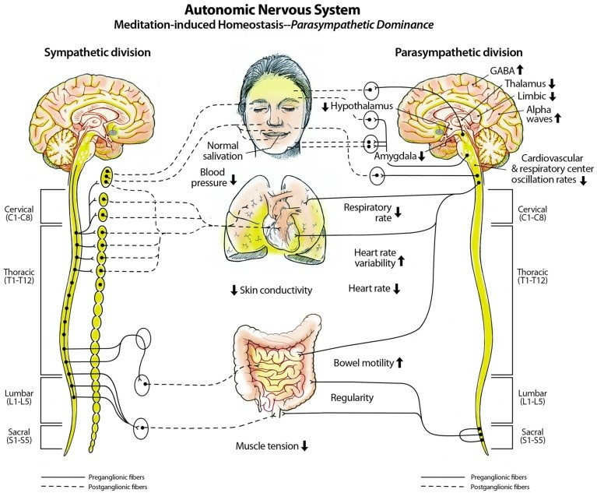Both [qigong master Yan Xin (pdf)](https://www.google.com/url?sa=t&rct=j&q=&esrc=s&source=web&cd=2&cad=rja&uact=8&ved=0ahUKEwiX34qJ_9_OAhXHBcAKHWOiAqcQFggjMAE&url=http%3A%2F%2Fciteseerx.ist.psu.edu%2Fviewdoc%2Fdownload%3Fdoi%3D10.1.1.486.3229%26rep%3Drep1%26type%3Dpdf&usg=AFQjCNHQY2x_WCIfOmCE--dYr-HftHYrUg&sig2=BhHdUEOn853oLPiRfAf3Og) and qigong master

[Yuanming Zhang have been proven to achieve long distance qi transmission:](http://qigongmaster.com/from-the-heartland-of-the-dragon/)

*In order to convince the skeptics and further qigong’s development, Yuanming Zhang has also submitted himself to close scientific scrutiny. When hooked up to sensitive measuring devices during external qi emission, researchers at Shanghai’s Fudan University detected a concentration of energetic particles that was three times as high as regularly present in nature. Lab technicians at Xian’s Northwest University observed significant changes in a chemical target solution when he emitted external qi thousands of miles away in Shanghai.*

So as CIA mind control physiologist Dr. Andrija Puharich discovered this as the Psi-Plasma or the protoconsciousness of the universe - from Tesla's sound-wave ether discovery:

|  |  |
| --- | --- |
|  | *Thus the head neurons see the following signal: 20 KHz [ultrasound] + 100 Hz [ELF] = 20,100 Hz:20*  *KHz - 100 Hz = 19,900 Hz. The 20,100 Hz and the 19,900 Hz beat against the center frequency of* |
|  |  |
| 12 | organs, 12 meridian channels, 12 infinite Perfect Fifth/Perfect Fourth yin-yang small universe Taoist alchemy time-frequency infinite energy as stored up parasympathetic hyperpolarization qi energy |
|  | *20,000 Hz and the result is the deaf person "hears" 100 Hz. Certain proton nuclear ELF magnetic resonant (NMR) signals in the nervous system may be of this nature where the actual perceived signal may be a side-band signal....These side-bands are due to ELF proton-proton spin couplings. Such proton-proton spin couplings may have great importance in memory induction.... The effects all add up to a phonon-pumping mechanism working on the unit hydron. We would expect that the end product of this action (before splitting of the water molecule occurs) is to stimulate the emission of photons, or the true PHASER effect....It is known there is a spin/spin: proton/proton magnetic coupling of 8 Hz which is a fundamental constant.* |

And we find that the Earth's ELF waves are also 1000 times stronger than the normal heart electromagnetic energy. Finally we find that the brain resonates with the Earth's ELF waves when the brain is in the theta to alpha brain waves - and that alpha brain waves also peak the serotonin levels in the brain.

[Schumann Entrainment qi healing:](http://www.ussdiscovery.com/SchumanEntrainment.htm)

*In the early 1980s, Dr. John Zimmerman (1985, "New technologies detect effects of healing hands." Brain/Mind Bulletin,10, 3.) began a series of important studies on therapeutic touch with a SQUID magnetometer at the University Of Colorado School of Medicine in Denver (Zimmerman 1990)....The therapeutic touch signal pulsed at a variable frequency, ranging from 0.3 to 30 Hz,* ***with most of the activity in the range of 7-8 Hz.***

|  |
| --- |
|  |
| Quantum holographic Yuan Qi proto-consciousness memory storage aka trans-metamorphic memory |

|  |
| --- |
|  |
| The universal 7 to 8 Hertz "shaking medicine" documented by Dr. Bradford Keeney, is a standing wave Schumann Resonance. |

*Seto et al (1992, Detection of extraordinary large bio-magnetic field strength from human hand during external qi emission.*

*Acupuncture*

|  |
| --- |
|  |
| Qi Energy healing Signal recorded by Dr. John Zimmerman |

*& Electro-therapeutics Research, 17, 75–94.) confirmed that an extraordinarily large biomagnetic field emanates from the hands of practitioners of a variety of healing and martial arts techniques, including Qi Gong, yoga, meditation, Zen, etc. The fields were measured with a simple magnetometer consisting of two 80,000 turn coils and a sensitive amplifier. The fields had a strength of about 10 ^ -3 gauss, which is about 1000 times stronger than the strongest human biomagnetic fields (from the heart) which are about 10 ^ -6 gauss and about 1000 000 times stronger than the fields produced by the brain....* ***As in Zimmerman's study, the biomagnetic field pulsed with a variable frequency centered around 8-10 Hz.***

|  |
| --- |
|  |
| leg shaking at 7 to 8 hertz alpha-theta resonates Earth's ELF waves through heart-mind |

So all these factors converge to reveal the secret of how the Tai Chi trance dance training resonates the Earth's energy based on this fundamental "moving of the yin and yang" exercise which also converts the lower emotional blockages the quickest and most effectively to store up the qi energy. So the original qigong master who teaches this "moving of yin and yang" exercise says it should be done three times more than the sitting meditation at the preliminary level of qigong training. I like to do it several times during the day as an exorcism of the yin jing [into yang jing or yin qi energy. Dr. Shin Lin pdf on science and tai chi-qigong:](https://www.google.com/url?sa=t&rct=j&q=&esrc=s&source=web&cd=2&cad=rja&uact=8&ved=0ahUKEwitzuyj85fOAhXJOiYKHdoqCboQFggiMAE&url=http%3A%2F%2Fmindbodylab.bio.uci.edu%2Fdownloads%2FTaiChi_ShinLin-color_dpi500.pdf&usg=AFQjCNHQbVJgEChODaWWhtM7dOkCcG2ZXw&sig2=sJ8aEKuvXnUczbSfSU2dwg&bvm=bv.128617741,d.eWE)

*"The higher the conductance, the better the indication that the person is healthy. We measured all 12 meridians, corresponding to the major organs of Chinese traditional medicine. "On the average, the increase in the conductance of these meridians measured at the jing well points would increase by as much as 35 percent after practice [15 minutes of either Tai Chi or qigong]. This is a huge change. And these are very precise measurements." In contrast, he said, the same people when asked to ride a stationary bicycle for the same amount of time before the test of conductance experienced a very small change in conductance. It was very small, less than five percent, he said. When the participants lifted weights as part of the test, he said, there was almost no change in conductance.*

So we should start the morning with the "moving of yin and yang" exercise or Tai Chi, then in the evening before dinner, and then before meditating at night. Just to clarify - the goal is to clear out the colon before the night meditation, since the leg shaking with the Tai Chi pushes the dopamine desire (lust) to its extreme so that an opposite extreme of serotonin (sublimation) flushes out the colon. So when the colon is cleared out then you get a win-win of also exorcising the subconscious desire. So with the thighs more parallel to the ground, the legs shake, the thighs get sore, and you push the sympathetic to the extreme to activate the opposite extreme.

[Professor Dr. Shin Lin UC-Irvine Los Angeles CBS May 10, 2016 t.v.:](http://losangeles.cbslocal.com/2016/05/10/defeating-stress-uc-irvine-professor-studies-benefits-of-tai-chi/)

*“Our research shows when you move in this repetitive way, you actually generate more neurons in the part of the brain called the hippocampus,” Lin said. “Some of those neurons suppress the stress response.”*

*Lin said he found in a study of senior citizens that participants who did tai chi for six weeks built up antibodies to shingles equivalent to study participants who did not practice tai chi, but instead got vaccinated*

Similarly science has shown a dramatic increase in stem cells from Tai Chi, from Lin Hsin-jung, a neural surgeon and head of China Medical University Beigang Hospital in southern Taiwan:

|  |
| --- |
|  |
| [The Five Tones music qigong are from the Perfect Fifth/Perfect Fourth as Yin-yang cosmology](https://books.google.com/books?id=7heKJ_xlLO4C&printsec=frontcover#v=onepage&q=yin-yang&f=false) |

|  |
| --- |
|  |
| Perfect Fifth as subharmonic is 2/3, C to F, while Perfect Fifth as overtone is C to G, 3/2: Secret of Yin and Yang |

*The researchers concluded that the tai chi practitioners saw their individual stem cell counts increase by increments of three to five times.*

*Regular tai chi exercises helped the subjects with heart function, reinvigorated neural cells in the brain, balanced excitement and inhibition controls, and helped with mental trauma and nerve* [*exhaustion, Lin said. cover story of 2014 medical journal*](http://focustaiwan.tw/news/aedu/201406070027.aspx#.V1mCNFqL_H0.facebook)

And [other research, 2015](https://www.google.com/url?sa=t&rct=j&q=&esrc=s&source=web&cd=1&cad=rja&uact=8&ved=0ahUKEwiciJSlh8zPAhVPwGMKHUbqALMQFggcMAA&url=http%3A%2F%2Fwww.ncbi.nlm.nih.gov%2Fpmc%2Farticles%2FPMC4516580%2F&usg=AFQjCNFdzT5TgawfMifGbloa4I5GGgoG1Q&sig2=ii79lYRY94vsesXfj7sVyA&bvm=bv.135258522,d.cGc):

*"ELF resonance fields stimulate embryonic stem cell differentiation and demonstrate the synergistic effects of a physical stimulus (EMF) with a biochemical stimulus (differentiation media)." and "...obese (Ob/Ob) mice lose their weight and fat when treated with 0.5 T direct current electromagnetic fields. We also observed that 7.5 Hz, 0.4 T rotation of extremely low frequency magnetic fields (ELF-MF) has an inhibitory effect on obesity."*

|  |
| --- |
|  |
| [Physicist Sir James Jean notes the "true clock face" of time-frequency as harmonic Perfect Fifths is infinite!](https://archive.org/stream/sciencemusic00jean#page/166/mode/2up) |

Now a lot of people get hung up over words - Chigong, qigong, alchemy, neidan, neigong, Nei Kung, Daoyin, Reiki, Yoga, pranayama, shamanism, trance, meditation, Voodoo, sorcery, magic, wizardry, etc. But the whole point is that through this training you are able to get beyond words to empty out the conceptual mind. Doing the standing "moving of yin and yang" exercise with the legs shaking 7 times per second is the fastest way to empty out the lower emotional blockages that possess the left-brain conceptual mind. Sound as harmonic vibrations beyond just music, infrasound and ultrasound, that ionizes hormones to create qi and shen energy is the universal music model of alchemical shamanism:

*But the fifth is a given of the Chinese pentatonic scale (possibly symbolized by five dots in the center) and is omnipresent in Daoist cosmology as the first female (2) and first male (3) number, as cited previously in verse 42 of the Daodejing. - Michael*

*Winn*

|  |
| --- |
|  |
| [The Metaphysics of Medicine and Music](https://www.slideshare.net/HoangTran60/ss-47494957): 3 in 1 unity from time-frequency harmonics, India and China |

*Such a conclusion was arrived at by Claude Lévi-Strauss (1950) from a consideration of so-called ‘empty referents’— words such as mana, wakan, manitou, and orenda — which are found in many languages throughout the world, and variously translated as ‘medicine’ or ‘sacred power’. However, as Lévi-Strauss noted, the same words are also used to refer to anything new or strange – anything for which no other word can be found. In this sense they are not unlike empty referents in modern English, such as ‘thingummy-jig’ or ‘what’s-it’, or, even better, the American ‘oomph!’ (implying that a woman has ‘got something’ beyond the power of words to express). Lévi-Strauss was greatly intrigued by the curious fact that a word that referred to the most powerful creative force in the universe — as conceived in indigenous cosmologies—could equally be used to refer to anything currently unnamed....Empty referents thus stood for the primemover in the creation of a humanlyconceived cosmos and, at the same time, were the direct progeny of the first linguistic utterance.*

*Charles Whitehead, The Human Revolution* [*2008 pdf*](http://www.socialmirrors.org/cms/images/downloads/JCS_Knight_Intro_CRC.pdf)

As qigong master Yan Xin points out with the standing exercises the brain empties out whereas during the sitting meditation the brain focuses on visualizing the energy movement. Standing moving exercise is called "cultivating" the qi (building it up) while sitting meditation is called "harvesting the qi."

|  |
| --- |
|  |
| When the Yin Qi is filled up then the body channels open up. |

So the brain is very active when the body is passive and vice versa. haha. It's funny because qigong master Yan Xin says if you suddenly get a flash vision energy message to sit in full lotus then you should act on that light energy and move your body into full lotus! Yan Xin says that too much emptiness meditation does not then build up this qi energy and so just the "dead tree zen" emptying out of the conceptual mind as mental focus is dangerous for older people. Visualization is again the foundational secret of converting the jing to qi energy as it is the shen that consciously sublimates the jing energy into qi energy.

So then we have four factors - jing, qi, shen and Emptiness. The Emptiness is this eternal process of unified alchemical energy transformation. The shen under the jing (fire under water) creates more qi but the process entails all the parts at the same time. [Thomas Widlock pdf](https://www.google.com/url?sa=t&rct=j&q=&esrc=s&source=web&cd=17&cad=rja&uact=8&ved=0ahUKEwiA1fD-ms7OAhVJw2MKHbRkAVE4ChAWCD8wBg&url=http%3A%2F%2Fwww.khoisanpeoples.org%2Findepth%2F10_WIDLOK.pdf&usg=AFQjCNEc5o9B27SlBNPto7Z8JeUQTb-NHw&sig2=kmAejdIFwzVLJDhCHqEmLg)

|  |
| --- |
|  |
| [*Taoist Yoga: Alchemy and Immortality* relies on the 12 nodes as infinite time-frequency resonance: pdf link](https://www.google.com/url?sa=t&rct=j&q=&esrc=s&source=web&cd=1&cad=rja&uact=8&ved=0ahUKEwjtrsrFqKXNAhVBQFIKHZyHB_EQFggeMAA&url=http%3A%2F%2Fterebess.hu%2Fzen%2Fmesterek%2FTaoist-Yoga-Alchemy-and-Immortality.pdf&usg=AFQjCNGy4SrrA7UspVUt4BXCO5nDid_6UA&sig2=i4g4HzA-5kO3qPs9h1qCXw) |

*the singing of the women is an important way through which the (usually male) dancers receive n/um (Katz, 1982:*

*295). Katz, R. 1982.*

*Boiling Energy: Community Healing among the Kalahari !Kung. Harvard*

*University Press,*

*Cambridge, Mass*

Music is then the unifying factor in this training as sound expresses the jing emotional energy and music as frequency is right brain dominant as visualization and music as [timing is left-brain dominant as body movement.  *Bodies swayed to music: The temporal arts as integral to ceremonial ritual* 2009 pdf by Professor Ellen Dissanayake:](https://www.google.com/url?sa=t&rct=j&q=&esrc=s&source=web&cd=9&cad=rja&uact=8&ved=0ahUKEwi9pZPXqIjPAhUP4WMKHT2fCZMQFghWMAg&url=http%3A%2F%2Fwww.ellendissanayake.com%2Fpublications%2Fpdf%2FDissanayake_CommunicativeMusicality_chapter_24.pdf&usg=AFQjCNGLmOyulqID5bX-fa9STaGWyTWbCw&sig2=hwEQM2Xgylh9Yfn8mOxx0Q)

*Behaviours such as dancing vigorously to rhythmic accompaniment excite sympathetic neurophysiological structures and eventually lead to parasympathetic rebound (an effect of the body's tendency to maintain homeostasis), which induces an 'altered' state felt a trance or ecstasy.*

*For example, sustained slow repetitive activity such as chanting or contemplative prayer stimulates the parasympathetic system and, when pushed to very high levels, the inhibitory effect opposite to that for sympathetic arousal occurs with a similar emotional effect of ecstasy, boundary loss, or 'flow'*

This process of intense music meditation ([internal listening or Ting Jing](http://www.clearstaichi.com/chi-energy/ting-jing-listening-energy-1134.html)) through trance dance and visualization is the means to the Emptiness.

*Goodman’s work shows that “compounds indicating stress, namely, adrenalin, noradrenalin, and cortisol, dropped, and at the same time there was evidence that the brain started synthesizing betaendorphin, the miracle painkiller of the body, which is also responsible for the intense joy felt after a trance. The EEG exhibited not the famous alpha waves, so well known from meditation, but a steady stream of the even slower theta waves, usually seen only in bursts shortly before a subject goes to sleep….”*

*Goodman, F. D. (1990) Where the spirits ride the wind: Trance journeys and other ecstatic experiences. Bloomington: Indiana University Press.*

|  |
| --- |
|  |
| ["Small Heavenly Circuit" Secret Reason Why There Are 12 nodes along the body as foundation of alchemy meditation!](http://www.springforestqigong.com/meditation-cds-and-downloads/) |

And so then we learn that the "small universe" or "microcosmic orbit" or "small heavenly circuit" meditation is the foundation of the sitting alchemy training - and [why? Just as with listening to music, qigong visualization is proven to be right-brain dominant. Because the](http://link.springer.com/article/10.1007/s10339-012-0441-4) 12 energy nodes of this meditation are really based on the 12 hours of time from the "water

clock" in China - but in meditation as emptying out or slowing down the conceptual word left brain (time) through [right brain visualization as increasing the frequency. *Conjugating time and frequency: hemispheric specialization, acoustic uncertainty, and the mustached bat 2015* As qigong master Robert Peng](http://www.ncbi.nlm.nih.gov/pmc/articles/PMC4410141/) [explains](http://www.robertpeng.com/shc/)[:](http://www.ncbi.nlm.nih.gov/pmc/articles/PMC4410141/)

*Since all the 12 meridians cross the path of the SHC [small heavenly circuit], the energy cultivated through this practice flows into the rest of the body, feeding and harmonizing the internal organs with high-quality Qi. The benefits of the practice are endless since it is said that practicing SHC is like doing all the other meditation practices at once.*

|  |
| --- |
|  |
| All human cultures use the Octave, Perfect Fifth/Perfect Fourth natural resonance, the secret of infinite time-frequency energy |

*Objective music is all based on ‘inner octaves.’ And it can obtain not only definite psychological results but definite physical results. There can be such music as would freeze water. There can be such music that would kill a man instantaneously. The Biblical legend of the destruction of the walls of Jericho by music is precisely a legend of objective music. Plain music, no matter of what kind, will not destroy walls, but objective music indeed can do so. And not only can it destroy but it can also build up. In the legend of Orpheus*

*there are hints of objective music, for*

*Orpheus used to impart knowledge by music. Snake*

*charmers’ music in the East is an approach to objective music, of course very primitive. Very often it is simply one note which is long drawn out, rising and falling only very little; but in this single note ‘inner octaves’ are going on all the time and melodies of ‘inner octaves’ which are inaudible to the ears but felt by the emotional center. And the snake hears this music or, more strictly speaking, he feels it, and he obeys it. The same music, only a little more complicated, and men would obey it.... Objective art requires at least flashes of objective consciousness; in order to understand these flashes properly and to make proper use of them a great inner unity is necessary and a great control of oneself.” Gurdjieff quoted in P.D. Ouspensky, In Search of the Miraculous, p. 297–298*

|  |
| --- |
|  |
| Superluminal, faster than light speed, "sonic boom" phonons of light |

The 12 notes of the music scale as time-frequency resonance are scientifically in fact an infinite spiral of yang Perfect Fifths energy - the infinite spiral of fifths (not the logarithmic circle of fifths or "plain music" as taught in the [West). This "universal scaling system" music theory secret was rediscovered by top mathematician Alain](https://www.google.com/url?sa=t&rct=j&q=&esrc=s&source=web&cd=7&cad=rja&uact=8&ved=0ahUKEwig8uCbvZXSAhVM5WMKHdh3B0cQFghDMAY&url=http%3A%2F%2Fwww.alainconnes.org%2Fdocs%2FQlattices.pdf&usg=AFQjCNGF5zo12W-9CAm7D1foKah9ark2Cg&sig2=aCZSL0P-IixBEPKjmFLJYw)

[Connes ("Music of the Quantum") pdf as Fourier](https://www.google.com/url?sa=t&rct=j&q=&esrc=s&source=web&cd=7&cad=rja&uact=8&ved=0ahUKEwig8uCbvZXSAhVM5WMKHdh3B0cQFghDMAY&url=http%3A%2F%2Fwww.alainconnes.org%2Fdocs%2FQlattices.pdf&usg=AFQjCNGF5zo12W-9CAm7D1foKah9ark2Cg&sig2=aCZSL0P-IixBEPKjmFLJYw)

Uncertainty or time-frequency uncertainty, arising from the fifth dimension of "noncommutative phase-space" that is the "time-like" oscillating wave origin of time-frequency energy (F subharmonic = 3 = G overtone harmonic at the same time, as complementary opposites Yuan Qi energy) as the source of quantum entanglement protoconsciousness:

*“Before the idea of frequency existed, however, the same relation was expressed simply in terms of length, the length of a resonating agent multiplied by 2/3 being equivalent to the frequency multiplied by 3/2. The length of a zither string, then, multiplied by 2/3 gives a note which when struck is a perfect fifth higher than its fundamental. This is the first step (or lü) in a process which evolves an unending spiral of notes. The length of the resonating agent which sounds the perfect fifth is then multiplied by 4/3, the resulting note being a fourth below the perfect fifth . . .” Joseph Needham, Science and Civilization in China, Volume 4, Part I, pp. 172–173.*

[Music qigong master Shen Wu gives us the secret of the "heavenly tone" music origin of qigong](http://webcache.googleusercontent.com/search?q=cache:SHwrxdGD2zcJ:www.joltv.us/PDF_files/Visualizing%2520Analysis%2520of%2520therapeuticalEnglish.ppt+&cd=7&hl=en&ct=clnk&gl=us) This alchemical secret is what Gurdjieff meant by "objective music" as alchemy training.

*From the viewpoint of 5D field theory, waves of de Broglie type have to be considered real. ...de Broglie waves are better understood in 5D ...it would mean a "wavicle" is two simultaneous realizations of flat [5D] space, one with waves and one without.*

So when time is zero, then frequency is infinite, at the speed of light, as a 5th dimensional phase-shift, creating the

["fifth-force" as the de Broglie superluminal quantum entanglement phase wave, detailed by astrophysics professor Paul S. Wesson. pdf](https://www.google.com/url?sa=t&rct=j&q=&esrc=s&source=web&cd=6&cad=rja&uact=8&ved=0ahUKEwjM5ub4vJXSAhVUImMKHZ0xAuIQFggyMAU&url=http%3A%2F%2Fthescipub.com%2FPDF%2Fpisp.2015.78.81.pdf&usg=AFQjCNENHOQG0ES2AY7mVKDQfNntC4x6jA&sig2=aZDmTrbYspGHtihxtfskEQ)

|  |
| --- |
|  |
| [Noncommutative phase-space of single photon is in two places at same time zero](http://www.nature.com/articles/ncomms7665) |

This hidden momentum is also called "heavy light" [by physics professor Gerard t'Hooft and M.B. van der Mark (pdf).](https://arxiv.org/pdf/1508.06478)

*It is not always appreciated that the De Broglie wavelength for quantum particles is a direct consequency of the reciprocal relativistic transformation of [mass = E/speed of light squared] and*

*[frequency=E/Planck's constant] while representing the same energy. Note that while the particle velocity is always below*

*the speed of light, the De Broglie wave is simultaneously associated with a phase velocity [speed of light squared/particle velocity] that is always higher than light speed. ..[As light] The emitter, electromagnetic wave and absorber are part of the same indivisible single event [at zero time, zero space].* [*pdf*](http://eprints.gla.ac.uk/110969/1/110969.pdf)

Also [B.G. Sidharth pdf](https://www.google.com/url?sa=t&rct=j&q=&esrc=s&source=web&cd=1&cad=rja&uact=8&ved=0ahUKEwiIyN7SvJXSAhVY4GMKHV0IBMQQFggcMAA&url=https%3A%2F%2Farxiv.org%2Fpdf%2Fphysics%2F0110059&usg=AFQjCNFkwaGNRlHQu79O3UwdUkDDG0_pbw&sig2=fhotrMT-tPpRI43eABzfuQ&bvm=bv.147134024,d.cGc), just as with Paul S. Wesson, realized when light is a "photon point" at zero time, it is really a tiny bundle of noncommutative phase-shift waves in the 5th dimension, as formless awareness or Emptiness that can not be seen, called a quantum entanglement "*self force*" or private quantum force by physics professor B.J. Hiley.

*Returning to the mass of the photon, it can be argued that this is a result of the non commutativity of spacetime at a micro scale.* [*Sidharth*](https://www.google.com/url?sa=t&rct=j&q=&esrc=s&source=web&cd=1&cad=rja&uact=8&ved=0ahUKEwjj0fyE5JXSAhVE7mMKHXJQA78QFggcMAA&url=http%3A%2F%2Faflb.ensmp.fr%2FAFLB-333%2Faflb333m497.pdf&usg=AFQjCNELf1i1_s_SxmVHxuilvNy-0-Jk4Q&sig2=EP-Tt-8SIKwICRfW8T88hw)

[J.P. Vigier calls it a "hypertube" inside light (pdf)](https://www.google.com/url?sa=t&rct=j&q=&esrc=s&source=web&cd=15&cad=rja&uact=8&ved=0ahUKEwi0xcOG_JPSAhUM1WMKHfRrBdc4ChAWCDAwBA&url=https%3A%2F%2Fisidore.co%2Fcalibre%2Fget%2FPDF%2FJeffers%2C%2520Stanley%2520%2526%2520Lehnert%2C%2520Bo%2520%2526%2520Abramson%2C%2520Nils%2520%2526%2520Chebotarev%2C%2520Lev-Jean-Pierre%2520Vigier%2520and%2520the%2520Stochastic%2520Interpretation%2520of%2520Quantum%2520Mechanics_5043.pdf&usg=AFQjCNGofffbZZEBzdeCPJnv9FJ2R4nl4g&bvm=bv.147134024,bs.2,d.eWE), again as faster than the speed of light, the de Broglie pilot wave.

*According to [UC-Berkeley physics professor, now emeritus Raymond] Chiao, such superluminal tunneling implies a third kind of non-locality: an observer moving past the barrier at close to the speed of light would infer that the particle exists simultaneously at both the entrance and the exit faces of the barrier!*

Chiao, Raymond Y. “Quantum Nonlocalities: Experimental Evidence." in *Quantum Mechanics: Scientific*

*Perspectives on Divine Action*, 2001, Ed. Robert John Russell, John Polkinghorne, etc. Center for Theology and the Natural Sciences

[As Erik Verlinde models, this is the cause of dark energy phonons (the hidden momentum of light) as negative entropy or antigravity, enabling levitation in deep meditation. In other words Yuan Qi creates a spacetime vorte](https://phys.org/news/2016-12-verlinde-theory-gravity.html)x as the Emptiness. And so the "yang shen" is from stored up virtual photons of the "yuan shen" projected as a container of matter - not mass. Light from relativistic mass has hidden momentum of stored up Yuan Qi phonons, that can be compressed in the lower tan tien, and then surround the Yuan Shen. *Taoist Yoga: Alchemy and Immortality*: The original spirit or yuan shen is the white light while the golden light is the spiritual fire that can destroy physical form to return to nothingness. The fa shen (essential body as these Yuan Qi phonons) causes the manifestation of the golden light. The physical body will absorb the essential body via the golden light and in three years time be turned into pure Yuan Qi..."sublimated into pure qi." This is the manifestation of the yang shen that can take form in one place or scatter into a formless boundless body (fa shen as yuan qi).

In my master's thesis for my University of Minnesota master's degree I cited the research on how yang is the music ratio 3/2 and yin is the music ratio 3/4 with the Emptiness as the octave, as infinite spiral resonance:

*Between heaven and earth, they say, there is perfect harmony. Now, 3 is the emblem of heaven, 2 is the symbol of earth. If two sounds are in the proportion of 3 to 2 [the perfect fifth interval], they will harmonise perfectly as heaven and earth. All the tubes were cut on the same principle, … The lüs [notes] were divided into two classes, the yang lüs and the yin lüs… Everything in Nature belongs to one of these two grand categories, from whose combinations and reciprocal action results all that exists or takes place in the universe.” J.A. Van Aalst, Chinese Music (Shanghai: Chinese Imperial Customs Service, 1933), p. 8.*

[This craniosacral therapy site has revealed another secret:](http://fiveseasonsmedicine.com/integrating-craniosacral-therapy-and-the-meridians/)

*So Lui (*呂*) is the character meaning spinal column, hence, it is directly related to our subject. This character has one more interesting meaning ‘ ‘frets’ (of musical instruments) (1,5,6), the construction of which is similar with that of the spinal column. We should also mention that Chinese musical scale is also called Liu Liu (*呂律*),*

In India, the meditation focus of Kriya Yoga is similarly based on this secret of the infinite spiral of fifths, as the oldest yoga philosophy of India, Samkhya, is from Dravidian-Sumerian culture that spread into China and Europe.

*The Quest for Divine Music by Suresh Chandra Dey:*

*Our whole universe is trigunatmaka, as it is pervaded by the three gunas...Therefore one gets a wonderful visualization of cosmogony, while doing the elementary Nada-sadhana, with the help of a tanpura, which is one of the oldest musical instruments....p. 82, As a result the first musical vibration (Spandan...) that has emanated out of the trigunatmaka (relating to the three gunas), equipoise of Cosmic Nature - that alone is the AUM or OMkara....p. 266*

22 notes of Indian scale from the 3 gunas as Tai Chi Tetrad - 1-4-5 music intervals or 1:2:3:4. The most common tuning for the four-string tanpura sets the first string at “Pa,” the fifth degree of the scale, while the second and third strings are tuned to the tonic above, and the last string is tuned to the tonic below.We know that the most acoustically pure fifth arises from a 3:2 frequency ratio...tanpura tuning.

*"Bandyopadhyay and his team will couple microtubule vibrations from active neurons to play Indian musical instruments. Consciousness depends on anharmonic vibrations of microtubules inside neurons, similar to certain kinds of Indian music, but unlike Western music which is harmonic [commutative logarithmic]" Hameroff explains (Science News, 2014)*

*Tuning the Brain talk video by Hameroff June 2014 Dr. Hameroff:*

*In my imagination I see microtubules as a kind of musical instrument being played by the cosmic Casimir force. here and the Casimir effect, due to the zero point fluctuations of the noncommutative complex scalar field,....*

So the Emptiness is the Octave as sattva, the Perfect Fifth is yang as raja and the Perfect Fourth is yin as tamas energy in Samkhya, based on the three gunas, the oldest yoga philosophy of India, from Dravidian culture.

*As Yogananda describes Kriya Yoga, "The Kriya Yogi mentally directs his life energy to revolve, upward and downward, around the six spinal centers (medullary, cervical, dorsal, lumbar, sacral, and coccygeal plexuses) which correspond to the twelve astral signs of the zodiac, the symbolic Cosmic Man. One half-minute of revolution of energy around the sensitive spinal cord of man effects subtle progress in his evolution; that half-minute of Kriya equals one year of natural spiritual unfoldment."*

|  |
| --- |
|  |
| The notes of the scale as the energy points of the spine. Ref: Sriranga sadguru in “Amaravani” |

"The 24 frets of the (Veena) instrument are analogous to the 24 cartilages in the spinal cord. The number 24 also relates to the 24 syllables in the Vedic Gayatri [mantra." Acoustic engineer and Vedic sound expert, Dr. M.G. Prasad. The](https://voidisyinyang.blogspot.com/2016/08/acoustics-of-vedic-yoga-by-hindu.html) sympathetic nervous system goes up the spine with increase adrenaline while the parasympathetic nervous system goes down the front of the spine via the leftside vagus nerve to the heart, increasing the love oxytocin and electromagnetic spirit energy (qi-shen). The tongue against the roof of the mouth activates the vagus nerve of the front, activating the salivary glands and the sinus cavity where the cerebrospinal fluid, infused with qi energy flows down the throat, to be absorbed back into the small intestines through the back pit of the stomach. Taoist quantum biologist Dr. Mae-Wan Ho explains that there are over seventy octaves of time-frequency coherent or synchronized harmonized natural resonance qi energy that she calls ["quantum jazz." Dr, Mae-Wan Ho:](http://www.i-sis.org.uk/quantumJazzBiology.php)

*I have no doubt that at least some of the more esoteric things people ascribe to quantum effects are real, such as instantaneous communication at a distance, remote healing, etc. But we can push the boundaries from the very conventional toward quantum coherence of the organism, to complete quantum coherence of the universe.*

In contrast to the plethora of symmetric Western math fractal resonance models, quantum jazz relies on the de Broglie Law of Phase Harmony as quantum relativity. When we "turn the light around" that means the shen spirit is a coherent laser as the speed of light squared, resonating the superluminal quantum self force as antigravity phonons or the de Broglie pilot wave, the noncommutative phase-wave of the 5th dimension.

|  |
| --- |
|  |
| The Small Universe Meditation is the Noncommutative Empirically True Infinite Time-Frequency Spiral of Perfect Fifths is the Secret of Yang or Yuan Qi alchemy as complementary opposites yin/yang natural resonance |

The Yellow Emperor, Huang Ti, in 2700 BCE, told Ling Lun to create the “infinite spiral of fifths” music tuning based on the Perfect Fourth music interval as yin and the Perfect Fifth musical interval as yang, according to the 240 BCE book, Lü-shih ch’un-ch’iu (*The Spring and Autumn of Lü Pu-Wei*). C to G natural harmonic overtone is the Perfect Fifth as 3/2 while C to F natural subharmonic undertone is the Perfect Fifth as 2/3. Both are heard internally - the ear does not hear the difference in meditation! as Yang Perfect Fifth through the noncommutative or complementary opposite harmonics of yin and yang alchemical resonance. Nonlocality as *noncommutative phase-space*, F as subharmonic is to C as G is the overtone so that F=3=G in the same 5th dimension that is time-like:

noncommutative phase-space. This Pythagorean secret that I call the "Hempel Effect" was covered up since Plato and Archytas. This noncommutative phase-space Yuan Qi formless awareness natural resonance is not the same as the logarithmic fractal octaves of frequency energy typically promoted by the Rosicrucians or the Freemasonic New Age science based on the Golden Ratio fractals.

*Let us draw up a fundamental vibration with its first and second harmonic overtones [1:2 and 2:3]….if we then shift the phase relationship, we get a totally different course of the combined curve; that is, of the pressure course [amplitude and frequency] which is apparently effective in the final analysis. When looking at both curves, one might suppose that in the two cases we should hear two sounds that are just as different. But in fact our ear does not notice any difference.*

Biophysicist Vitus B. Dröscher states in his book, *Magic of the Senses*, p. 168

To put that in more recent research terms: [2016 Pitch Perception](http://www.ncbi.nlm.nih.gov/pmc/articles/PMC4910526/)

*By changing the phase relationships of a harmonic complex, we can change the waveform envelope of the complex without changing its spectral content. In general, the pitch of resolved harmonics is F0 [the fundamental frequency] and does not depend on the phases while the envelope cue is dominant for unresolved harmonics.*

|  |
| --- |
|  |
| The Perfect Fifth (2/3) phase-shifted as the Perfect Fourth (4/3) sound the same to the inner ear even when the phase changes the amplitude: *The Magic of the Senses* |

The slower your left brain time then the slower your breathing, increasing the right brain vagus nerve kundalini or N/om jing energy up to the brain, and the greater your increase in right brain frequency color. This is why the left ear is the Tiger Yuan Qi energy (the right side vagus nerve and the right hand energy). It is the phase shift of internal listening between the right and left ear that resonates the infinite frequency-zero time or its opposite as [complementary opposites of white hole or black hole of spacetime yuan qi energy. Physics professor Manfred Euler figured out this secret of hearing:](https://www.researchgate.net/profile/Manfred_Euler/publications)

*Binaural hearing is the acoustic analog of the interferometer or double-slit experiments. The two ears can be regarded as an acoustic interferometer, which recovers the phase difference of signals between the two ears by binaural correlation....matter waves are locally in phase with the particle clocks (de Broglie's Law of Phase Harmony).*

*The clock runs forever so it's self-sustaining (consciousness-energy). It resonates with the quantum vacuum.*

*The harmonic beats creates dynamic energy. So then you have a "phase particle" that can be faster than the speed of light - superluminal - and a "mass particle" that is slower than the speed of light as the "group wave" of the "phase wave." The beats of the phase wave then are "in resonance" with the quantum vacuum - and so create mass from the massless field, explaining the Higgs mechanismAs internal hearing, there are ELF subharmonics as alpha-theta brain waves of the ultrasound harmonics of the quantum microsecond phase-shifts of the collagen neurons.*

[Virtual photons can be "captured" from the quantum vacuum](https://phys.org/news/2011-11-scientists-vacuum.html) when nonlinear resonance bypasses time-frequency uncertainty, as does internal listening.

*human hearing performs better than Fourier transforms can in simultaneous time-domain and frequency-domain discrimination.*

|  |
| --- |
|  |
| [Diana Henz on qigong increasing frontal theta brain waves](http://journal.frontiersin.org/article/10.3389/fpsyg.2017.00154/full) |

Taoist

Quantum biologist Dr. Mae-Wan Ho gives details:

*Some experimental findings show that the arrival times of sound pulses at the two ears can be discriminated with an accuracy of a very few microseconds [1]. For detecting a note in middle C, the phase difference in a microsecond is 4.4 x 10-4. Accurate phase detection is characteristic of a system operating under quantum coherence. Could it be that phase detection is indeed a key feature of conscious experience?*

This is why the ear resonates the kidney jing energy to sublimate and transform the yuan qi. This is also called the quantum 1/f resonance. [Quantum 1/f resonance 2014](http://iopscience.iop.org/article/10.1088/1367-2630/16/11/113054)

*As in other systems exhibiting*  *noise, this power spectrum is not integrable at low frequencies, which appears to imply infinite total power.* [*aka Quantum Vacuum thruster*](https://en.wikipedia.org/wiki/Quantum_vacuum_thruster)

[pdf link on double unification of particles with fields and electricity with gravity by IE bulyzhenkov 2016](https://www.google.com/url?sa=t&rct=j&q=&esrc=s&source=web&cd=1&cad=rja&uact=8&ved=0ahUKEwjLvdHfuZXSAhUC92MKHZVADm4QFggdMAA&url=http%3A%2F%2Fwww.epj-conferences.org%2Farticles%2Fepjconf%2Fpdf%2F2016%2F21%2Fepjconf_icnfp2016_04008.pdf&usg=AFQjCNEdkwZ0VL0f5s-EOKUdE00-iTcfIw&sig2=W937VP-o6mUB72sTIZ06kg&bvm=bv.147134024,d.cGc) Phonons have nonzero "hidden momentum" as the "pressure of light" at rest, the reverse phase-shift of the anti-matter charge [of electrons, protons and photons, as explained by David Griffiths of Reed College. As qigong master Zhang Hongbao emphasized, it is the power of thought (yinianli) as faster-than-light "yin matter" that is the "golden key" (jin yaoshi) to the alchemy training.](https://books.google.com/books?id=JqZyQCZmrRAC&pg=PA223&lpg=PA223&dq=%22yin+matter%22+zhong+gong&source=bl&ots=jPjGvDq7zo&sig=s-7SFxZnHv_qk02nwDbomP-kCT8&hl=en&sa=X&ved=0ahUKEwjgy-7M1vvOAhUGpB4KHZkgCncQ6AEIHjAA#v=onepage&q=%22yin matter%22 zhong gong&f=false)

*The ear collect the spiraling energy from the cosmos, this energy gives life to man, and we see this*

*vitality in the light which shines forth from our eyes. Tibetan medical doctor.*

So quantum relativity as per the Law of Phase Harmony is the Emptiness spacetime *noncommutative phase-shift* converting the high frequency quantum energy/low time into the virtual photons/low frequency bigger wavelength via increased stored mechanical momentum.

*"I believe that consciousness, or its immediate precursor proto-consciousness, has been in the universe all along, perhaps from the Big Bang....In one such scheme proto-conscious experience is a basic property of physical reality accessible to a quantum process associated with brain activity....Let’s say the heart stops beating, the blood stops flowing, the microtubules lose their quantum state. The quantum information within the microtubules is not destroyed, it can’t be destroyed, it just distributes and dissipates to the universe at large." - Quantum biology Prof. Emeritus Stuart Hameroff.*

*"By wu (non-existence) Dao An meant the Original Spirit or Breath (yuan qi) which he conceived to be a frame without form or phenomenon."* [*googlebook preview*](https://books.google.com/books?id=ZnNvEOjlJ8YC&pg=PA110&lpg=PA110&dq=By+wu+(non-existence)+Dao+An+meant+the+Original+Spirit+or+Breath+(yuan+qi)+which+he+conceived+to+be+a+frame+without+form+or+phenomenon.&source=bl&ots=iQTiZtMtMT&sig=39hIQNTX8Hu_rIYGjLWFLZC06cI&hl=en&sa=X&ved=0ahUKEwjqmv6a6fTRAhUHqlQKHeAQCKgQ6AEIHDAA#v=onepage&q=By wu (non-existence) Dao An meant the Original Spirit or Breath (yuan qi) which he conceived to be a frame without form or phenomenon.&f=false)

The blue light is the color of the soul energy shining forth through the psychic lunar energy - the throat chakra - and the higher the frequency of light the greater the energy for healing. When the eyes are closed in meditation, then the microtubules resonate internal biophotons via the increased alpha brain waves. [pdf](https://www.researchgate.net/profile/Michal_Cifra/publication/238197983_Emission_of_Biophotons_and_Neural_Activity_of_the_Brain/links/00b7d51c4cba735569000000/Emission-of-Biophotons-and-Neural-Activity-of-the-Brain.pdf)

*A significant relationship between the fluctuation function of biomolecules (due to the emission and absorption of biophotons) and alpha-EEG diagrams is elaborated on in this paper.*

Blue light is serotonin energy which we find is the alpha brain subharmonic waves that then resonate with the [Earth's ELF waves for strongest high frequency qi energy through the heart. So the subharmonics of quantum 1/f resonance have greater amplitude as increased yuan jing energy:](http://ieeexplore.ieee.org/document/1573927/?reload=true&arnumber=1573927)

*The present paper calculates these quantum fluctuations, shows that they have a simple universal 1/f spectrum, and shows how they invariably come to the foreground, being dominant at low frequencies*

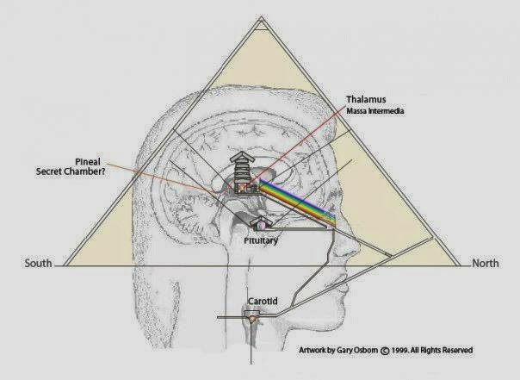In ancient Egypt, the harmonic ratio 2/3 was considered most sacred and it is the secret of the "yang qi" alchemy resonance. The ancient god/goddesses of Sumeria were based on harmonic ratios and accessed using inner sound yoga.

|  |
| --- |
|  |
| Hathor and Krishna are Blue because of the serotonin secret of lunar yin qi fertility |

The oldest farming city is older than Egypt and Sumeria, with [Harappan urban civilization starting around 5,000 BCE. But collapsed due to urban disease, climate change, increased](http://www.sci-news.com/archaeology/science-collapse-harappan-civilization-01705.html) [violence, etc. As I note in my 2012 free pdf book, "Alchemy of Rainbow Heart Music" - archaeology has traced the](https://www.google.com/url?sa=t&rct=j&q=&esrc=s&source=web&cd=1&cad=rja&uact=8&ved=0ahUKEwjdyomz0I7NAhVPU1IKHWK3AK4QFggdMAA&url=https%3A%2F%2Fwww.gearslutz.com%2Fboard%2Fattachments%2Fmoan-zone%2F279031d1330198691-retune-your-music-444-old-tuning-standard-alchemy-rainbow-heart-music.pdf&usg=AFQjCNHfPsV52pcAYbRCVTLkEboCjazrng&sig2=47tKfYISjjic7HKF59YLzg) ecological crisis of monocultural wheat farming back to at least 9000 BCE.

The original alchemy training uses gibberish words but the females sing and clap while the males dance around the fire and the original ritual trance dance music is the "Eland Bull" song from before 70,000 BCE based on female menstruation synchronization with the lunar cycle. Females are the original healers being "yang internally" and so the dopamine bliss converts to serotonin via the vagus nerve orgasm connection to the cervix. The orgasmic bliss deepens converting the serotonin to melatonin and oxytocin of the heart.

The love emotional energy then increases the oxytocin bliss to open up the heart but even that "over-excitement" bliss has to be transcended through the mental focus of internal listening to the origin of time-frequency itself. So we can never visualize the Emptiness itself yet the Emptiness expresses itself through light. The more we are able to store up the qi energy then the more the qi has the power to increase the shen spirit light energy to transform our jing energy which can then reverse time and see the future also. The Emptiness is then a spacetime transformation achieved with this unification of energy as alchemy. Ch'an Buddhism called this the "point of origination" (zero time light as 5th dimension formless awareness) and what the Vedic acoustic science calls "bindu." (secrets revealed on the Bindu chakra below).

So I was asked recently - do you need to be able to sit in full lotus to meditate? I said no but if you are meditating properly then you will be able to sit in full lotus. So sitting in full lotus shows that you are able to meditate properly. As Taoist master Wang Liping teaches only the full lotus is able to open up the nerve channels in the lower back to really sublimate the jing energy properly. Taoist Alchemy teaches us that the left leg should be on top as again due to the secrets of Taoism, the difference between the yin lower body and yang upper body, this left leg on top opens up the channels to store up the qi energy. It is medical doctor, Dao Qi alchemy Dr. Shuang Yan Guan Zhu who explains the psychophysiological details of [the complementary opposite secrets of padmasana](http://sygz2012.blogspot.com/2016/07/padmasana-lotus-position.html):

*The figure clearly shows the celiac plexus or solar plexus is much larger on the right side. The plexus associated with the kidneys, the liver, the pancreas, and the testicular or ovarian arteries or nerves. These organs, especially the liver, the head of the pancreas, and the stomach deviate to the right anatomically. Since the ancient adepts in Qi or Prana practice, they felt the Qi or Prana movement is related to the nerves and ganglia. The Qi accumulates more on the right and minimal on the left. On the right, the kidney (renal plexus), is associated with Qi (nerves connection with Mingmen) of the solar plexus and the Qi of Mingmen. Hence, the right kidney, QI communicates with Qi of Mingmen and solar plexus. The right kidney can rightfully call Mingmen (Qi). Whereas, the left kidney remain as a kidney. This phenomena can explain K. Pattabhi’s explanation that “the right side first and left leg on top purifies liver; and the left kidney remains passive.”*

|  |
| --- |
|  |
| Serotonin yin qi psychic lunar blue shen spirit light as throat chakra |

I explained to my family member asking me about full lotus - the key is that it stretches open the lower back. Or as Gurdjieff said: modern humans, Western civilization, is controlled by the Kundabuffer - the blockage of the lower back. Or as Taoist alchemy teaches - the Yuan Qi originates between the kidneys and how to activate it? Again through visualizing the shen below the jing or the fire below the water - to then boil the water into steam which is then qi energy. When the qi energy builds up through meditation you can then sit in full lotus. A real qigong master can then sit in full lotus for as long as needed in ease. So we can trace the Bronze Age alchemy of "fire under water" to create steam as qi in the lower tan tien - all the way back to the Bushmen, the original human culture doing trance dance alchemy from before human language had evolved!!

*In them [Bushmen], n/um was pictured as a covered fire at the base of the spine of the n/um kxau, ‘possessors of n/um’, which was believed to become alive and hot by the dance. This, the dance and the dissociation wrought mental and bodily changes in them.*

When we realize this basic foundation of practice it's called

|  |
| --- |
|  |
| Secret Reason why Left leg (yang) is on top (embraces) right leg, to store up the qi energy. |

"Laying the Foundation" for the first half of enlightenment - the lunar psychic Tai Chi is experienced to open up the Third Eye. This is what the San Bushmen, the original human culture, describe when they say they can see spirits and smell disease as rotting burning flesh and they then heal people in this "post-death" trance state. I achieved this state for a few weeks in 2000 and I specifically had that experience - I saw spirits and smelled cancer as rotting flesh and the original qigong master confirmed my enlightenment experience. The original qigong master said qigong masters can smell cancer as rotting flesh and as he healed the man who emanated this rotten flesh smell then the smell went away. Later that night the man had sex with a woman in the room next to me at the retreat center and I could barely stand the smell through the wall next to me, as the rotting flesh smell returned from his loss of energy through ejaculation! *The centers of my hands and feet and the top of my head all pulsated with qi!* If my legs went numb in full lotus I could just send qi out of my hands into my feet using the sword fingers. At this time in 2000 I had fasted for over 7 days taking only a half glass of water for the whole 7 days! But since I had not really studied Taoist Alchemy well enough I didn't understand the principles to maintaining this energy.

*In !kia [trance] your heart stops, you’re dead. […] You see ghosts killing; you smell burning, rotten flesh; then you heal, you pull sickness out. You heal, heal, heal, heal …, then you live. Then your eyeballs clear and then you see people clearly. R. Katz, Boiling Energy.*

So for example as Master Nan, Huai-chin states at this level the nerves are very sensitive and lust easily overtakes the mind. Also the healer gets heroic over-exuberance and so the energy gets overused easily. So then when I studied 1) Mantak Chia I discovered the secret - the diaphragm has to be flexed down at the same time that the [perineum is flexed up. 2) Check out this "secret" video by Dr. Newman K. Lin on "anal breathing" as the secret of vagus nerve stimulation.](https://www.youtube.com/watch?v=pRiChK0Q_FI&feature=youtu.be)

*There are two main areas you will always use. Pull up the perineum and press down the diaphragm. This will reduce the space in the Tan Tien and condense the Chi in the Tan Tien. Mantak Chia, p. 69*

The two biggest muscles in the body are the glutes and the diaphragm.

3) [The Power of Ki! Dr. Joo Bang Lee March 1988 Black Belt Magazine](https://books.google.com/books?id=PdYDAAAAMBAJ&pg=PA23&dq=ki&hl=en&sa=X&ved=0ahUKEwiw1Iylh9vOAhWGGB4KHaeGC-gQ6AEIHjAA#v=onepage&q=ki&f=false)

*While one is breathing the Dan Jun (diaphragm) and anus must be held tight.*

This secret keeps the small universe flowing in the proper direction and prevents the yin qi energy from going up the front of the body and out of the eyes with the shen. 4) [Neidan qigong, Dr. Yang, Jwing-Ming](http://ymaa.com/articles/2014/1/nei-dan-sitting-meditation)

*At this time you should start to coordinate your breathing and abdominal movement with the movement of your huiyin (Co-1) (literally "meet the yin") cavity and perineum to lead the qi to the tailbone (weilu cavity)....The trick of holding up and loosening the huiyin and perineum is extremely important in nei dan qigong.*

In his [Small Circulation Heavenly Orbit book](http://www.academia.edu/17769030/Qigong_Meditation_Small_Circulation) Dr. Yang, Jwing-Ming emphasizes the secret of the perineum again:

*Huiyin is the Pump and the Abdomen is the Bellows*

*The Huiyin cavity [perineum] is the crucial valve controlling Qi in the four yin vessels. When it [perineum] is pushed out, the stored Qi is released, and when it is held up, the valve is closed, holding Qi in and conserving it. So the Huiyin pumps Internal Qi (Nei Qi) and governs the manifestation and preservation of the body's Qi. Controlling Huiyin [perineum] in your practice makes a significant difference. Traditionally this was one tricky place which the master would keep secret until the student was trustworthy.*

So that is the main secret of how to store up the energy along with continued practice of "Moving of yin and yang" to reverse blockages and convert the jing back to qi energy. 5) [Chinese Medical Qigong textbook googlebook link -](https://books.google.com/books?id=idgnBQAAQBAJ&pg=PA108&lpg=PA108&dq=zhongpeng+lin+qigong&source=bl&ots=pJcZGJmJFh&sig=0WYaS-VtXqERpW7TX5IJUld5kLQ&hl=en&sa=X&ved=0ahUKEwiihYOmgoHSAhVK5mMKHTUgBxwQ6AEIHTAB#v=onepage&q=zhongpeng lin qigong&f=false)

*Anus-lifting breathing refers to the respiratory method that contracts the muscle of the perineum while inhaling and relaxes the perineum while exhaling. Generally speaking when one practices Xiao Zhou Tian (Small Heavenly Circulation Form), anus-lifting breathing is mandatory to coordinate the Qi.*

|  |
| --- |
|  |
| Flex the Diaphragm down and the perineum up at the same time - secret of storing up qi energy! |

6) Bagwa master Sun Luc-Tang lists as one of his eight essentials of Baguazhang:

*3: The rectum is lifted internally and the tongue touches the hard palate just above the top tooth line on the hard ridge, so as to join the Du Mei with the Ren* [*Mei. p. 76, Eric Montaigue internal Gong-fu pdf*](https://www.google.com/url?sa=t&rct=j&q=&esrc=s&source=web&cd=&cad=rja&uact=8&ved=0ahUKEwi8vMe7y93RAhVHjlQKHSGYC_oQFgguMAM&url=http%3A%2F%2Fgftaognosticaespiritual.com%2Fwp-content%2Fuploads%2F2015%2F03%2F12-Internal-Kung-Fu-Vol-1.pdf&usg=AFQjCNFAQTvHi54HZjdteHFCvjbNRSwQTA&bvm=bv.145063293,d.cGw)

So *seven different sources* (see below for the seventh source from kriya yoga) emphasizing the same essential secret to storing up and condensing the qi in the lower tan tien! Now the final secret is that Master Nan, Huai-chin teaches it's crucial to hold the breath only after exhale. So then we find Wim Hof teaching the same secret of holding the breath, only after exhale and, only after first charging up the body doing the Quick Fire breathing. Dr. Shin Lin at UC-Irvine, documented, using transcranial Photon Migration Spectroscopy, a great increase in brain oxygen from holding the breath after exhale and after the Quick Fire charge up breathing. So then we discover from science that holding the breath after exhale activates the parasympathetic nervous system. Marc Seifer described the results:

*"During normal breathing, the reverberations in the aorta arc out of phase with the heartbeat and the system is inharmonious. However, during meditation and when the breath is held, the echo off the bifurcation of the aorta (where the aorta forks at the pelvis to go into each leg) is in resonance with the heartbeat and the system becomes synchronized, thus utilizing a minimum amount of energy. This resonant beat is approximately seven cycles per second, which corresponds not only to the alpha rhythm of the brain but also to the low-level magnetic pulsations of the Earth." p.49, Transcending the Speed of Light.*

And from the Kriya Yoga tradition:

*The vajroli mudra [contracting the lecithin semen] has to be [7] practiced together with the moola bandha (flexing the perineum up) and uddiyana bandha [flexing the diaphragm down] in kumbhaka. Practice of kumbhaka [breath retention after exhale] is necessary while the ejaculation is being held. Retention of the breath and the bindu [amrita kundalini] go hand in hand. Loss of kumbhaka is loss of bindu, and loss of bindu is loss of kumbhaka.* [*"Kundalini Tantra" by Swami Satyananda Saraswati*](https://www.google.com/url?sa=t&rct=j&q=&esrc=s&source=web&cd=2&cad=rja&uact=8&ved=0ahUKEwjv67r61ebRAhVp6YMKHWIbDMUQFggiMAE&url=http%3A%2F%2Fthekingdomwithin.net%2Fwp-content%2Fuploads%2F2016%2F02%2FSwami-Satyananda-Saraswati-Kundalini-Tantra.pdf&usg=AFQjCNEVl_9279Ae8WxWJ5NrUTU7T-DCZg&sig2=bn-8ixIa7h5JBjw39G3yYg) *(google pdf link, more on the bindu chakra below).*

Kriya Yoga is older than Hindu religion, according to Satyananda Saraswati and the secret is that the Lunar Amrita normally flows down from the top of the brain to be "used up by the sun" as ejaculation, and instead the lunar and solar energy need to be united by retaining the lunar energy and purifying it. This is the same secret as Taoist yoga alchemy. Kriya yoga states that, at first the anal sphincter flexing is the key since a normal person can not "flex" their perineum on their own. But as the qi energy increases then you can isolate the perineum to stop loss of qi or prana energy out of the perineum. Swami Satyananda Saraswati states that most people operate with just their Moola or perineum chakra open (the Number 1 person as per Gurdjieff) and so this is the main vibration that can be "listened to" with the Yi or I as intention - to build up the qi energy, to activate the kundalini. So the key to putting the intention in the lower tan tien is by flexing the two largest muscles - the glutes up and diaphragm down, you begin to listen to or feel the vibration of the qi at the perineum to stop its loss, and to sublimate the jing energy up the spine, to the Bindu chakra (more on this below).

So in Pranayama training first you train so that the exhale is twice as long as the inhale - so exhale can be up to 60 seconds and [then you train in the retention after exhale](http://www.tirungopal.com/bahya-kumbhaka-retention-breath-end-exhalation/):

*the breath is held for several seconds after the exhalation is complete.*

More on this Bindu Chakra secret below as the "Water Path" as proper intention of the pancreas - the source of worry or too much thinking. [breath retraining:](http://www.rbphd.com/Docs/breathingretraining.htm)

*When stressed or worried, we tend to tense the muscles of the neck, throat, chest and abdomen. Especially when we tighten the abdominal muscles, we begin to breathe with rapid, shallow breaths primarily in the upper chest region. As the drop in CO2 causes distressing symptoms, we become afraid of the symptoms. Arousal remains high and a vicious cycle of worry and arousal occurs.*

So the tummo method of Wim Hof as the Quick Fire method of alchemy is to first do very deep reverse breathing which increases the carbon dioxide in the brain, the opposite of hyperventilation, or shallow overbreathing that lowers carbon dioxide levels. Or as [another breathing expert](http://www.breathing.com/articles/hyperventilation.htm) explains:

*But my research leads me to believe that a significant issue or way this is influenced is more about the way and depth the nervous system is stimulated, ie., whether parasympathic/abdominal, breathing, or sympathetic, high chest dominant (over approximately 45%) breathing is engaged. I have observed people breathing intensely for hours without any signs of distress, but rather with signs of bliss and joy. The key to "over-breathing" is more about balance between the high chest and abdominal breathing pattern.....*

*Optimal oxygen uptake is not possible without proper CO2 presence. Alkaline forming nutrition is also relevant....*

*I have observed -with the help of a pulse oxymeter, that quick [fire]-deep or quick [fire]-shallow breathing, if dominated by belly, back and side breathing, most often increases the level of oxygen in our blood. By gas exchange standards, this would seem to reduce the CO2 ratios, invite constriction and inhibit O2 transfer into the cells but this MAY or MAY NOT not occur depending upon how well the breather is able to relax and stay dominant parasympathetic. Key factors are how well they adapt, tolerate or become accustomed to the increase in physical energy (chi, prana, Qi, pneuma etc).*

The increased carbon dioxide from the deep strong reverse breathing, along with increased adrenaline, then enables the holding of breath after exhale for a longer time period, as it is the pH balance in the brain that triggers the breath reflex. [2014 study of tumo "heart-yoga" heat:](https://www.ncbi.nlm.nih.gov/pubmed/24156771)

*Tumo was associated with a hyperdynamic vasodilated state with increased biventricular performance. We postulate that tumo results in a massive increase in sympathetic activity with activation of brown adipose tissue and marked heat production. The increased heat production may explain the paradoxical vasodilatation in tumo practitioners exposed to subzero temperatures.*

So then as the breath is held after exhale you get the parasympathetic rebound which then increases the oxygen levels in the brain and stores up the qi or prana energy. As this technique of continued, with 30 deep breaths followed by breath retention after exhale, then with each cycle the oxygen in the brain increases and the parasympathetic nervous system stores up *more energy* as increased prana or qi, along with sublimating the lecithin that stores up the qi. As the brain qi energy increases it is the brain that controls breathing and body temperature and so as Wim Hof details, he can just use his brain to increase his body heat, as the Tibetan tummo monks also do, through deep relaxation and very slow breathing. Science tells us it is the right side vagus nerve that is the dorsal or back of the rear body as this "reptilian freeze" trance or samadhi energy which then goes up to the right side of the brain and then down to the right side of the heart.

Taoist Alchemy tells us that "Yuan qi" originates from the right side of the heart and Advaita Vedanta tells us, via Ramana Maharshi, that the right side of the heart is the secret pinhole to the formless awareness of the Universe. As the pdf explains, [All Disease Comes from the Heart](https://www.google.com/url?sa=t&rct=j&q=&esrc=s&source=web&cd=9&cad=rja&uact=8&ved=0ahUKEwiw5J-6nf_RAhVS2GMKHdb1Bh8QFghIMAg&url=https%3A%2F%2Fwww.jadeinstitute.com%2Fjade%2Fassets%2Ffiles%2FFruehauf-AllDiseaseComesFromTheHeart.pdf&usg=AFQjCNFf5Wrtp43LEwub2Y8YiGl7Zewk1A&sig2=_jjr-WyOgOB51MxsZ-1Anw&bvm=bv.146094739,d.cGc) in fact in the earlier Chinese dictionary, from 200 AD, the heart is the Earth organ, after it is able to contain the fire energy.

*This remarkable 2nd century statement makes reference to a little known fact: in the early stages of Chinese medicine the heart was alternately classified as the earth organ, not the fire organ that it is exclusively described as today. Prof. Heiner Fruehauf*

The Advaita nondualists will try to claim this is not accurate since Ramana Maharshi explained:

*"It must be the heart at the right side of the chest since every man, of whatever race and religion and in whatever language he may be saying 'I', points to the right side of the chest to indicate himself. This is so all over the world, so that must be the place. And by keenly watching the daily emergence of the 'I' thought on waking and its subsiding in sleep, one can see that it is in the heart on the right side.”*

|  |
| --- |
|  |
| Right side Vagus or Wanderer Nerve is secret of Kundalini - heart-right brain-reproductive connection |

In fact what Ramana Maharshi is referring to is that humans are right hand dominant and in actuality this is indicative of the inherent complementary opposites of [evolution! Only in *Taoist Yoga: Alchemy and Immortality pdf link*](https://www.google.com/url?sa=t&rct=j&q=&esrc=s&source=web&cd=1&cad=rja&uact=8&ved=0ahUKEwjtrsrFqKXNAhVBQFIKHZyHB_EQFggeMAA&url=http%3A%2F%2Fterebess.hu%2Fzen%2Fmesterek%2FTaoist-Yoga-Alchemy-and-Immortality.pdf&usg=AFQjCNGy4SrrA7UspVUt4BXCO5nDid_6UA&sig2=i4g4HzA-5kO3qPs9h1qCXw) do we find this secret confirmed - the right side of the heart is the origin of ["yuan qi." Even acupuncture gives the hint (pdf):](https://www.google.com/url?sa=t&rct=j&q=&esrc=s&source=web&cd=27&ved=0ahUKEwjQmt_Y9pLOAhWH0iYKHfBTDG84FBAWCEUwBg&url=http%3A%2F%2Fwww.point-to-point-acupuncture.com%2Ffiles%2F8-Extra_Teaser.pdf&usg=AFQjCNFsQ9xDf8t_6ltiYKGJr1bDlK_Fsg&sig2=a_vhSDwh4Wspg1DAjmipGg&bvm=bv.128153897,d.eWE&cad=rja)

*The first cry activates Qi-Ke – mouth of qi – to circulate Qi and Blood*

* *This is reflected by thepulses at Lu-9 and St-9 – Breathing into the Lungs*

*(for the first time) sets the*

*Heart-Blood in motion*

* *This also creates a pressure in the left atrium, which is greater than that of theright atrium, thereby creating the “Heart barrier,” or Pericardium*

The qigong master who befriended me actually demonstrated this truth to me - when he left his body and then activated the deep qi on the right side of my heart. He wanted to find out if I was speaking truly from my heart and he said that I was. Of course when I experienced this source of my spirit I stopped speaking as that was also the source of the truth and the end of the need for words. haha. And so as the San Bushmen describe their hearts really do stop when in deep meditation.

Harvard Professor Dr. Richard Katz, *Boiling Energy: Community Healing among the Kalahari Kung*  Richard Katz questioned Kau Dwa further on this topic:

*KATZ: Kow Dwa, you have told me that in kia you must die.*

*Does that mean really die?*

*KAU DWA: Yes.*

*KATZ: I mean really die?*

*KAU DWA: Yes.*

*KATZ: You mean die like when you are buried beneath the ground?*

*KAU DWA: [With enthusiasm]: Yes. Yes, just like that!*

*KATZ: They are the same?*

*KAU DWA: Yes, the same. It is death I speak of. KATZ: No difference?*

*KAU DWA: [Firm but soft]: It is death.*

*KATZ: The death where you never come back?*

*KAU DWA: Yes, it is that bad. It is the death that kills us all.*

*KATZ: But the healers get up, and a dead person doesn’t…? KAU DWA: That is true; healers may come alive again.*

In 2012 [the original qigong master](http://springforestqigong.com/) described his experience as well:

*My heart, the heart rate beating, shooting up so fast. I just couldn't count how fast it beat. Then to a point it completely stopped, the beating. I don't feel the pausing with my hand on the heart, and I'm still functioning well. For a second I was worried, what is going on? So I tried to breathe. Wow I feel more room in my lungs to breathe..... I continued to teach...For quite a while I feel nothing in my heart. Then I drove back to the center....May was there, saying hi, how's it going? Yeah it's going fine. But I still have no heart beat. I sit down. I look inside. I didn't call 9/11. To me, this is only my experience. When you get something like that, call 9/11 right away and go to the hospital. I sit down. Why I get this? I didn't get anything even in meditation. Gradually in 20 minutes. So for a good 2 hours I didn't feel anything in my heart. So gradually my heart beat slowly comes back.....Then after a few days I ask why I have this? Just a way to open your heart. I say...well this is not a good way! haha. But I experience that and I check myself and I read myself inside and I check out my organs. Everything looks pretty good. There's no damage or anything. Of course this is a very extreme situation. But I'm telling you everything has a reason. You go into your heart to find the answer and that will tell you on a bigger level.... No fear. In my life I experience so many --- people call it bizarre things. People say -- well that's a story, not necessarily real. I don't care. This is what I experienced. My life. And this is the way I get my heart more and more open and look at things from a different perspective.*

*Taoist Yoga*, p. 41 ( "The sun stands for the heart and the moon for the lower tan t'ien cavity (under the navel), respectively symbolized by the dragon (female or negative vitality) [yin qi] and the tiger (the male or positive vitality) [Yuan Qi]." *Taoist Yoga*, p. 67 "Therefore the secret lies in the prenatal positive vitality [Yuan Qi] that existed before heaven, earth, and all things came into being." *Taoist Yoga*, p. 75 "The channel carrying blood and vitality from the right ventricle of the heart is a vein which is linked with the duct of the testicles and the restraining nerve; hence the centre of the right palm is the tiger cavity." *Taoist Yoga*, p. 110.

As I posted above we now from science that is the parasympathetic nervous system that connects to the testicles and it is the right side vagus nerve of the parasympathetic nervous system that can stop the heart and restart it. *By putting the Yi or intention in the lower tan tien, we "listen" or feel the vibration of the perineum that connects to the pineal gland.*

"The tiger's roar heard in the left ear reveals the fullness of vitality." p. 116 This deep Tai Chi Emptiness is called "breathless ecstasy" by Sri Yukteswar, the nirvikalpi samadhi of the energy meridians fully charged up via the deep [reptilian "freeze" or "playing dead" vagus nerve activation, connecting the reproductive organs to the heart. *Waking the Tiger: Healing Trauma: The Innate Capacity to Transform Overwhelming Experiences* by Dr. Peter A. Levine](https://books.google.com/books/about/Waking_the_Tiger.html?id=3Y2t1oQEmcoC) gives the secret of this right side vagus nerve:

*I used to think the paralysis that occurs during extreme events was due to overloading of the sensorymotor cortex with kundalini energy. This may play a part in it, but now I think the paralysis is due to the brainstem stimulating an extreme parasympathetic response to meet the extreme sympathetic activity that is occurring...thus both on and off switches are at full bore. To prevent any further escalation of this duel between the on and off systems the body turns on a massive freeze response [samadhi trance] via the dorsal vagal complex. The dorsal vagus complex (DVC) is a cluster of connected neurons in the brainstem medulla that slows down the energy-expending processes. It is the primative unmyelinated vagus related to the conservation of metabolic resources.*

Similarly in the alchemy training we get this paradox of a strong sympathetic stress input creating a strong parasympathetic "freeze" reaction - in other words meditation trains us to suppress the sympathetic when normal people trigger the sympathetic.:

*These behaviors increase, further inhibiting the other system through tuning, and counter-intuitively not only is the opposite system fully suppressed, but stimuli that would normally evoke the opposite system (non-sensitized system) instead evoke a response in the sensitized system (termed reversal phenomena)..It is important to emphasize here, that under normal circumstances the nervous system cannot function this way; SNS and PNS are by nature alternating systems. Strange Bedfellows: Meditations on the Indispensable Virtues of Confusion, Mindfulness* [*and Humor in the Neuroscientific and Cognitive Study of Esoteric and Contemplative Traditions Sept. 2016 pdf*](https://www.google.com/url?sa=t&rct=j&q=&esrc=s&source=web&cd=16&cad=rja&uact=8&ved=0ahUKEwiNi-TdrojPAhUN7GMKHWG7CbM4ChAWCDIwBQ&url=http%3A%2F%2Fwww.mdpi.com%2F2077-1444%2F7%2F9%2F113%2Fpdf&usg=AFQjCNHBQZQbYp19Xoa-xC0XPij7wEVWcA&sig2=oMalJvHDpJFNIH3Y6AwWpQ&bvm=bv.132479545,d.cGc)

So the left ear is right brain dominant and so by emptying out the conceptual word left brain and developing Ting Jing (internal listening in Tai Chi) we build up the White Tiger yuan qi energy. The inner ear connects to the vagus nerve and cerebellum to sublimate the right side vagus jing energy and increase the pineal gland power.

As Ramana Maharshi states with his shen (right brain spirit visualization) focused on the right side of his heart then after 15 minutes he felt a strong shock as the qi of the right side of the heart re-started his stopped heart and reactivated his shen as his spiritual self-awareness. Before that he was in a state of pure yuan qi as formless awareness - like a black hole of bliss through the right side of the heart. This shows again how the individual jing is tied to the shen and qi and explains the mystery of how Ramana Maharshi could insist he maintained his individual self even while he was submerged in the impersonal Self of the universe. Ramana Maharshi emphasizes to focus on the conceptual logicial inference of the source of the I-thought in order to ground the energy. We find the same [discovery from Gopi Krishna - The focus on the left-side vagus nerve is the myelinated emotional energy to the heart. This is the focus on the "water path," see below.](http://www.kktanhp.com/kundalini.htm)

When a qigong master is able to go into the post-death samadhi state, called nirvikalpa samadhi or "breathless ecstasy" (Sri Yukteswar), then that means the spiritual ego is emptied out, the 7th level of awareness in Mahayana Buddhism, and true enlightenment is achieved. That is the sign of a real spiritual master. As the qigong master who befriended me explained: You can be a qigong master but not necessarily enlightened. That is what he was referring to. For example a qigong master can see out of the head in four directions at the same time! But that doesn't necessarily mean they are enlightened through a deep heart awakening. The shen as spirit moves in one direction while the qi moves in the other - and the body transcends its physical limitations as it merges with the qishen as the quantum formless awareness origin of time-frequency of the Universe.

But for Mahayana Buddhism even this level of spiritual formless awareness beyond the physical body and at one with the source of the Universe is not enough. The body itself as the jing energy also needs to be emptied out and harmonized - the first five levels of consciousness and indeed it is the jing energy, that alchemically, enables this creation of the yuan qi energy at one with the Universe. [2014](http://protein.bio.msu.ru/biokhimiya/contents/v79/full/79101316.html)

*the lunasensor hypothesis about the role of the pineal gland as a peculiar gravisensor...At the full moon, for example, the EEG delta activity in humans was reduced by 30% in the deeper stages of sleep, and evening melatonin secretion was also greatly suppressed [*[*11*](http://protein.bio.msu.ru/biokhimiya/contents/v79/full/79101316.html#Ref11)*].*

So as Master Nan, Huai-chin reveals in his Ch'an lectures - this is why the Buddha achieved enlightenment after 7 days of nonstop full lotus meditation under a tree. The key here is that the solar and lunar calendars do not line up exactly and instead there is an infinite transformation of energy, be it a person's physical body or the external world they are also harmonizing. This is the secret of the Bodhisattva and the secret of Chuang Tzu, the "yuan qi" is the superluminal phonons as the backwards wobble or precession, lined with the Earth to the pole star, or the protonelectron magnetic moment....(so the post-script sections below).

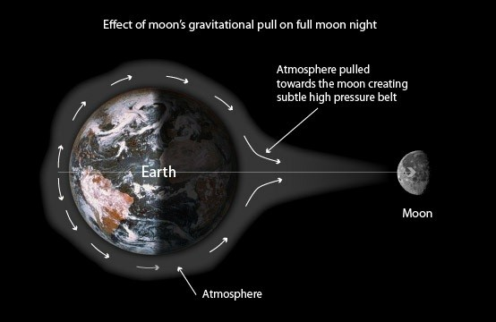This is what the original qigong master means when he says there is no center to the universe. I saw the original qigong master demonstrating this ability as in his full lotus meditation he created new "yuan shen" healing spirits out of his heart-mind oneness with the Emptiness - each "yuan shen" spirit was individualized and so it formed out of the top of his head - yellow light shaped like a human - and broke off from his head and then drifted out to the student to be healed. As the qigong master who befriended me explained, that is a "very profound level of healing" and he is not able to do that.

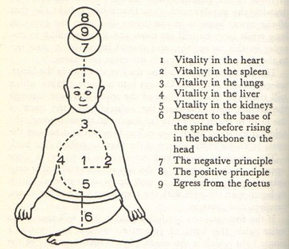As the original qigong master teaches meditation from the three days before and after the full moon is ten times stronger than normal. Why? Because the yin qi psychic energy is from the natural resonance of the moon in harmony with the earth, just as the same face of the Moon rotates in line with the earth. And so Buddhism, like Taoism, is based on the lunar calendar, just as the jing energy of the N/om from the San Bushmen originates from the female [exact synchronization with the lunar cycle. Journal *Nature* on](http://www.nature.com/mp/journal/vaop/ncurrent/full/mp2016263a.html?WT.feed_name=subjects_medical-research)

[Moon gravity affecting moods of humans. (Online 1/2017)](http://www.nature.com/mp/journal/vaop/ncurrent/full/mp2016263a.html?WT.feed_name=subjects_medical-research)

*Measurements of circadian rhythms in body temperature suggest a biological mechanism through which transits of one of the moon’s semi-diurnal gravimetric tides might have driven the patients’ bipolar cycles, by periodically entraining the circadian pacemaker to its 24.84-h rhythm and altering the pacemaker’s phase-relationship to sleep in a manner that is known to cause switches from depression to mania....This type of [pineal gland] shift in the timing of circadian rhythms relative to the timing of sleep has been shown to cause switches from depression to mania*

As Gurdjieff taught it is only when the dominant life on Earth resonates its energy in harmony with the moon's spiritual evolution will alchemy then succeed. Otherwise the moon destroys life on earth and the cycle of spiritual training on Earth starts over again.

As described by N/isa, female sexuality is to men, what male healing potency - *n/um* or *tsso* - is to humankind. [Tricksters and Trancers: Bushmen Religion and Society](https://books.google.com/books?id=TVMZ8Y2xwwcC&q=staying+#v=onepage&q=healing&f=false) For the Australian Aborigines, this is the male "yang jing" or "yin qi" energy - from the moon.

*Mowaljarlai): Thatʼs why! Moon is ʻheʼ for womanʼs cycle. male Moon, shot out into space from the female Earth (in Creation time), is in a kind of yang relationship with all the fluids of the yin Earth including women, governing their cycles – tidal, menstrual, diurnal.....*[*Two-Way Thinking*](http://www.hannahrachelbell.com/)

*Not surprisingly, this miwi or “power” is said to be present in all persons, though especially developed only by a few. It is said to be located in the pit of the stomach,* [*Australian aborigine pdf*](https://www.google.com/url?sa=t&rct=j&q=&esrc=s&source=web&cd=11&cad=rja&uact=8&ved=0ahUKEwjz6bqV08fOAhUFdx4KHYUvDxA4ChAWCBswAA&url=http%3A%2F%2Fwww.studiesincomparativereligion.com%2Fuploads%2FArticlePDFs%2F419.pdf&usg=AFQjCNG9hEhCfPr8mxE51uTcxKEY04nfdQ&sig2=xE58DzINThBoIhaWxH8PFg&bvm=bv.129759880,d.dmo)

|  |
| --- |
|  |
| The Way of Earth becomes Female as "yang internal" or yin qi sublimation through Tai Chi "shaking" medicine celibacy |

This is the secret of how to get to the Wu Chi, the lower body as Earth needs to become female like the lunar energy; as human females are yang internally.

*And in that full moon day the nectar, amrita, [ambrosia] ripens. Until lowering into the external mind from kundalini*

*heights, time stands still. Tamil alchemical Tirumantiram 875*

So 3 months is the typical minimum standard, a gong, based on the lunar cycle, a trimester, of no loss of "yin qi" energy for males in order to build up the lower tan tien for real Emptiness as the Tai Chi enlightenment experience to be achieved. On a deeper level the "yin shen" of "yin jing" emotional blockages need to be converted to the yuan qi of the yuan shen to create the "yang shen" physical immortal body transformations.

|  |
| --- |
|  |
| New Moon resonates Sun's gravity for menstruation and Full Moon resonates Sun's gravity for ovulation |

Postscript: Now that we're not Idiots any more! The Red Pill is that "no ONE" is behind the light of the universe.

When we get into the deeper cause and effects of Taoist alchemy then we again defer to the basic formula that time is the complementary opposite of frequency. So CIA mind control scientist Dr. Andrija Puharich wrote [his final book on his*ELF Magnetic Model of Mind and Matter pdf*](https://www.google.com/url?sa=t&rct=j&q=&esrc=s&source=web&cd=1&cad=rja&uact=8&ved=0ahUKEwjv-Zfjl5jOAhUFyT4KHVaBAesQFggeMAA&url=http%3A%2F%2Fwww.puharich.nl%2FBio%2FElf_Magnetic_model_of_matter_and_mind.pdf&usg=AFQjCNG81ZfA9IQiSJ1UnAlEOtCmb3qtmw&sig2=O-rd8m3SS7a0HyI8BLTsgQ) which argues that the ELF resonance is the backward wobble or spin precession of the electron-proton magnetic moment. This means there is a superconducting quantum nonlocal consciousness-energy (Yuan Qi) created, as Dr. Mae-Wan Ho discovered, from delocalized protons, activated by the imaginary mass of light, resonated from splitting [water. Tim Ventura in 2002 reviews the similar claim of Fran De Aquino, a professor of physics at Maranhao State, arguing that ELF waves can cancel gravity. pdf link. The claim of De Aquino that absorbing resonant energy will](https://www.google.com/url?sa=t&rct=j&q=&esrc=s&source=web&cd=1&cad=rja&uact=8&ved=0ahUKEwjWs-iQlJjOAhUEHD4KHbrcD7gQFggeMAA&url=http%3A%2F%2Fwww.americanantigravity.com%2Ffiles%2Farticles%2FDe-Aquino-Article.pdf&usg=AFQjCNE4wg0a23AzNwHUfUOzwETTzoLqHg&sig2=ybKovMrP63uGki-1fhULXQ) decrease mass (antigravity levitation and spacetime distortion) is corroborated by other physicists Dr Eugene Podkletnov, and Dr. Thomas Bearden, who independently, again cite the time-frequency complementary opposite resonance as the alchemical secret. Quantum physicist Jack Sarfatti has also made this ELF-quantum consciousness connection as has Michael Persinger of Laurentian University, Canada and the nonduality research of Matti Pitkanen.

*Researcher Alex Constantine has asserted that psychotronic devices using ELF (extremely low frequency) electromagnetic waves were being tested on RV [remote viewing] subjects at SRI*

*[Stanford Research Institute]....Constantine notes that ...Dr. Sam Koslov, assistant to the Secretary of the Navy, saw on the chart being projected on the screen, the words, "ELF and Mind Control."* [*Phenomenal World by Joan D'Arc 2000*](https://books.google.com/books?id=bgTG1dxoQ8kC&pg=PA40&lpg=PA40&dq=ELF+model+of+mind+and+matter+pdf&source=bl&ots=yVkiw09P-5&sig=wubI7zc4Ll5ZvgrPAY7AYgTBU80&hl=en&sa=X&ved=0ahUKEwjv-Zfjl5jOAhUFyT4KHVaBAesQ6AEIPDAF#v=snippet&q=ELF &f=false)

[We find corroboration of Dr. Puharich's ELF magnetic model in *Handbook of Biological Effects of Electromagnetic Fields, Third Edition*](https://books.google.com/books?id=PZd_2UJrwdwC&pg=PA187&lpg=PA187&dq=ELF+harmonic+proton+magnetic+moment&source=bl&ots=fVsOqM_lDc&sig=RqA9GtahYwLAEFivTISnE1-wH-g&hl=en&sa=X&ved=0ahUKEwiQ95bCjpnOAhWKdj4KHWe2A-kQ6AEIJjAB#v=onepage&q=ELF harmonic proton magnetic moment&f=false)

*Another model of ELF magnetic interactions that has received recent attention is the possible effect of these fields on the triplet state yield in radical-mediated charge transfer processes....phosphenes which have been shown to be induced by...ELF magnetic fields...coupled ELF electric fields applied to the head in the region of the eyes....the effect of ELF magnetic fields on nocturnal melatonin synthesis in the pineal gland is mediated by effects of these fields on visual pathways...*

So then cryptochrome, found in plants and animals, is being studied as a primary receptor of ELF resonance harmonics. Cryptochrome, a blue light photoreceptor in the human eye resonates via ELF waves. Just as birds are modeled to use quantum entanglement "beats" for migration via ELF cryptochrome resonance, so too are other [animals, including humans. The journal Nature 2015 has a study of cows and ELF fields showing a decrease in pineal gland melatonin in the winter. The result considers that serotonin is the most effected since the summer](http://www.nature.com/articles/srep14206) result was contrary to the winter, so that the ELF waves repress the conversion of serotonin to melatonin during the winter when serotonin is low due to short day length. This is why the winter is considered a good time for meditation, to increase the yuan qi from the increased darkness.

In *Taoist Yoga* Alchemy it is taught that only the eyes are yang in the body and the rest of the body is yin. So by rotating the eyes the "yuan qi" and "yuan shen" are united and activated by the eyes connection to the pineal gland to the lower tan tien, via the central thrusting channel. *Taoist Yoga: Alchemy and Immortality*: "after gathering and holding" the generative force - as previously explained (chapter 4) - then the eyes need to be rotated (chapter 6). This is how the small universe meditation is ended in SFQ - while visualizing the light in the lower tan tien, rotating the energy is to rotate the eyes. The six phases of fire alchemical purification of the small universe meditation are all based on the five elements as yin shen thinking mind energy lost out of the eyes while the Yuan Shen emanates [only when the Yuan Qi is activated, after the yin qi or generative force has been built up. Walther Sell gives an overview:](http://www.taoistiching.org/firing.html)

*The firing process refers to a six-step process, going from one yang to the pure wholeness of six yangs. During this process the influence of the human mind gradually decreases so that the Original Spirit (also called the Gold Elixir) can come into being.*

To quote *Taoist Yoga: Alchemy and Immortality*:

*"generative force is only immature vitality [yuan qi]."*

So the small universe is used to "stop the thinking process" so that the light can be turned around - to open up the cavity of original spirit in the middle of the brain. So then when you can see the light in front of you then the "only then can you lay the foundation of immortality." So that light can only be seen externally after the Tai Chi experience. But again to achieve deep serenity - the light has to be built up in strength by building up the yuan qi energy. That is the difference from a number 4 person to a number 5 person as Gurdjieff describes it. No I have not achieved that level of deep serenity. I had a minor enlightenment experience so that I am a Number 4 person. The qigong master who befriended me is a Number 6 person: Not only is his third eye fully open (a Number 5 person) but he achieved the deep serenity of going past physical death. The original qigong master is a Number 7 person - he has achieved the Yang Shen and now he does "miracle" healing as a living Buddha Boddhisattva.

As *Taoist Yoga: Alchemy and Immortality* states - if you are still not clear about the 18 different definitions of the six phases of alchemical fire regarding the small universe meditation then you can just practice "freezing the fire." I have more on the Hun shen of the liver yin qi going out of the eyes and what that means alchemically - in the final section of this article (blogbook). So the *Taoist Yoga* book states on p. 89

*" even if you are still not clear....you can gather the light...and drive it into the lower abdomen...until true vitality [yuan qi] vibrates..."*

*"This cultivation of (essential) nature and (eternal) life requires constant attention and the slightest carelessness can obscure the inner light and cause the drain of the elixir with the result that all previous efforts will be sterile." p. 97*

We now find science confirming this connection of Yuan Qi as ELF energy tied to quantum nonlocal consciousness through the eyes connecting to the pineal gland! Also just as with *Taoist Yoga* Alchemy we find a stronger seasonal variation in the energy - so that the melatonin is higher for deep body healing meditation during the winter while [during the summer dopamine and serotonin are higher for more physical activity. "A human source for ELF magnetic perturbations" byA. R. Liboff, in *ELECTROMAGNETIC BIOLOGY AND MEDICINE* May 2015 gives a scientific](https://www.researchgate.net/publication/304611257_A_human_source_for_ELF_magnetic_perturbations) model for this ability of humans to send external ELF energy to other humans.

I know as a qigong healer, the united shen-qi leaves out of the eye balls via the pineal gland - causing my eye balls to pulsate with ELF waves! I had one qigong student who read me work online then visit the qigong center and the qigong master informed me that I knew him already from online and o.k.'d him to visit me. As I sat next to him in full lotus he suddenly noticed that my eyeballs were pulsating! haha. I knew they were but I had never had someone [else comment about it! http://emmind.net/ the *Electromagnetic Mind* website gives links on the related science research exploring this alchemical reality.](http://emmind.net/)

*If “gravity” waves share a similar source of variance to Zero Point Vacuum*

*Potentials [37], then the “coincidental” similarities of the threshold Landauer value for information dissipation into entropy or its emergence from it and the amplitude fluctuations of the ~8 Hz subthreshold variations could reflect one intercept between human brain activity, the Schumann frequencies and “gravitational” phenomena.*

[*A Fugal Discourse on the Electromagnetic Coupling of Electromagnetic Processes in the Earth-Ionosphere and the*](http://zone.biblio.laurentian.ca/dspace/bitstream/10219/2557/1/SAROKADissertation%20Final.pdf)

[*Human Brain pdf* by Kevin S. Saroka 2016 Ph.D. for Michael Persinger and here Saroka and Persinger one mode of “information” exchange between the Schumann and cerebral fields will involve discrete and very small quantities of photons through non-local processes.](http://file.scirp.org/Html/11-3400403_56609.htm)

[Professor of Electrical Engineering at RMIT University in Melbourne, Australia Irena Cosic in 2006 finds](https://www.researchgate.net/publication/256374467_Human_Electrophysiological_Signal_Responses_to_ELF_Schumann_Resonance_and_Artificial_Electromagnetic_Fields) [electroacupuncture confirms ELF resonance with the meridian points as low resistance, resonance points. More details on this acupuncture research by Ken Renshaw](http://www.kenrenshaw.com/accupuncture/styled/)

*The adiabatic nature of the nerve pulse combined with the mechanical changes and the physical size of the pulse, indicates that the nerves pulses could be a type of sound wave. This deduction lead* [*to the proposal of the Soliton model by Heimburg and Jackson in 2005 [26]. 2014 Soliton Sound nerves Ph.D. thesis pdf .... The soliton is locally pushing the lipid membrane into its lipid melting*](https://www.google.com/url?sa=t&rct=j&q=&esrc=s&source=web&cd=4&ved=0ahUKEwiqsOKt9vnPAhWpwlQKHS4jDEAQFghCMAM&url=http%3A%2F%2Fwww.nbi.ku.dk%2Fenglish%2Fresearch%2Fphd_theses%2Fphd_theses_2015%2Flars_mosgaard%2FLars_Mosgaard.pdf&usg=AFQjCNE8ea43hdd_ttBKv-WuCP_9YUHO6g&cad=rja) *transition as it propagates....The propagation of the soliton will result in changes in thickness of the membrane and also have an electrical component, both observed during the propagation of nerve signals....Interestingly the inverse piezoelectrical e ffect means that an electrical change has a mechanical response, allowing for a coupling between electrical stimulation and the excitation of a soliton....This means that the dispersion and non-linearity of the speed of sound are tightly coupled through their dependency on the state of the lipid membrane....Timescales found for the dynamics of pores in lipid membranes are rather on the millisecond regime which predict solitons with a width of z [approx.]10 cm for L = 1:39 1012J K=(s mol). Nerve pulses in myelinated axons have a width of the order of z [approx.] 10 cm which seems within the predicted range....The Soliton model, unlike the Hodgkin and Huxley model, predicts that nerve signal propagating down the same axon can pass through one another without annihilation [42, 110]....We demonstrated that nerve pulses can penetrate each other in both myelinated*

*preparations (earthworms) and in non-myelinated preparations (lobster). Penetration is predicted by the Soliton model, whereas it seems contradictory with respect to the prediction of the Hodgkin and Huxley model....The typical timescale of a nerve pulse is 1 ms, corresponding to a characteristic frequency in the range up to 1 kHz....All previous attempts to explore sound propagation in lipid membranes have focused on the ultrasonic regime [9,14–16], and it has clearly been demonstrated that dispersion exists in this frequency regime....nerve fibers swell during the nerve pulse [37{39, 114, 115]....the Soliton model the mechanical changes are the one that cause the electrical signal and they represent two aspects of the same pulse....other membrane adhesive molecules with large dipoles can be used to create an asymmetric membrane, e.g., soluble proteins or lipid-associated molecules such*

*as long-chain sugars. Depending on the nature of the asymmetry, the system can display piezoelectric properties.*

For an overview of the deeper science analysis of unified yuan shen-yuan qi energy see my recently published article, [Death, Trance, and Cosmic Spirit Exorcism: Science of Spiritual Healing part 2](http://www.viewzone.com/spirithealing-part2.html)

[Also my recent blog post states this metaphorical insight: The Alchemical Secret of De Broglie's Law of Phase Harmony:](https://voidisyinyang.blogspot.com/2016/06/the-alchemical-secret-of-de-broglies.html)

*So we can say from the perspective of alchemy that Time is the Emptiness and Frequency is the Shen while Wavelength is the Jing and Momentum is the Qi. The "yuan qi" is then the momentum as phase velocity that is the speed of light squared. The complementary opposites of time and frequency then reverse the entropy of jing and qi. If the light as shen or frequency is turned around then time is also turned around and you get negentropy instead of entropy. Jing is time as entropy but it can be turned around to change fate. This is the secret of putting the shen or frequency as the reverse direction to wavelength or jing as physical time. The result is the infinite quantum entanglement as the speed of light squared - the light turning itself around to create the phase velocity of speed of light squared as the "pilot wave."*

Post-Post-Script:

As I was investigating the historical connection between Hun spirit and Mayahana Buddhism then I discovered a new blog to me, by a retired Chinese medical doctor, Western-trained, with over 20 years experience in Dao Qi [alchemy training. This led me to more "new" information that directly changed my meditation focus. First of all let's review the basic foundation of the alchemy training.](https://www.researchgate.net/publication/257635748_Spirituality_in_Traditional_Chinese_Medicine)

[Pastoral Psychology](https://www.researchgate.net/journal/0031-2789_Pastoral_Psychology) 61(5-6) · December 2012 by Zhang Chenguang, Lin Shi give us good information:

*Practitioners believe that the heart controls the mind and that shen stays in the five organs of the human body. Shen is divided into five aspects and is affiliated with the five organs. “Shen stays in heart, po (soul) stays in lungs, hun (spirit) stays in liver, mind stays in the spleen, and zhi (will) stays in kidneys”(The Medical Classic of the Yellow Emperor,p.*

*62). Although cognitive activities belong to the five organs, they mainly are the physical functions of the heart. “Heart is the matter of the mind, where spirits come from”(The Medical Classic of the Yellow Emperor, p. 27).*

*Meng Zi believed: “Will, is the master of Qi;Qi, is the content of a body. Where the will goes, Qi will go with it”(Zhang 2010a,b, p. 66).*

[But in my last mention of Hun and Po, I revealed that in fact Hun and Po are more closely connected to qi - So then I discovered this pdf by a Tai Chi teacher - Dennis Willmont - Ritual, Sacrifice and Alchemy](https://www.google.com/url?sa=t&rct=j&q=&esrc=s&source=web&cd=&cad=rja&uact=8&ved=0ahUKEwimo5a51uHRAhWF4IMKHeiRB7UQFghCMAc&url=http%3A%2F%2Fwww.willmountain.com%2Fv%2FTaijiquan%2FRIT-TCC.pdf&usg=AFQjCNHJ59c1y2IR7J6AYCD7j7HmwBqoWg&sig2=n-K3Nf7jq2R_bykRJ21wGA&bvm=bv.145063293,d.amc)

*Alchemy reiterates the earlier idea of external sacrifice found in Chinese ancestor worship, but does so internally within the body and mind by the conversion of jing to shen via the intermediary level of ch'i and I/Intention.*

So that exactly encapsulates the basic principle of alchemy training that I focus on in my "Idiot's Guide" article - to put the shen below the jing via the yi as intention, that then governs and guides and creates the qi.

*Between Heaven and Earth, the central harmonizing principle of Man is associated with the phase Soil (tu), the Spleen/Pancreas, worry, Intention (I), and Trustworthiness (xin).*

And so Trustworthiness of the pancreas intention is actually the proper balance of the kidney water will power, with the emotional heart of fire, to create good soil. And we know from permaculture, that it is the liver as wood that provides the fuel, to create the biochar, to hold the nutrients properly. The pancreas then feeds the lung energy first.

*The ancients thought that the loss of jing and shen through this progression was automatic unless there was some conscious intention to rectify it.*

So again it is the pancreas intention that is the key balancing factor between the fire (shen) and water (jing), as the secret of alchemy.

*Therefore the exoteric alchemists came up with the idea of a closed container in which they would bury alchemical ingredients under the ground so they could not leak away, and therefore be completely transformed in their interactions with one another. The internal alchemists followed the same idea but used their I/Intention to contain the alchemical process in the human body.*

So this goes back to my original question about Hun. I discovered another historical analysis of Hun, stating that in fact the word is connected to a Thai word also relating to ancestor worship. So as Hun is the light of the moon, which originates from the Sun, so then is Hun the male principle that is passed on to the child at birth. So if the male is considered to be powerful on Earth, then the Hun energy is stronger and then after death, the Hun energy goes into heaven while the Po energy also remains strong with the body. So that is the secret of why then food must be brought to the grave - or else a "hungry ghost" will arise, from the anger of the Po qi energy still attached to the body as a ghost. Traditionally it was 3 years required to feed the spirit connected to the dead body - but for the powerful Hun spirits of rulers, then ancestor worship could even last 1000 years! And this is why in Tibet - they cut up the bones of the body, and feed them to the birds - to ensure that the qi energy empowering the spirit can not return to the body to create a vampire-zombie.

*We can also find this idea of containing the jing and shen in the Taijiquan Classics where the I (psychic counterpart of the "Power" Man, the phase Soil, and the organ Spleen/Pancreas) takes on the function of a container:*

*Up and down, forward and backward, left and right, it's all the same. All of this is done with the Yi....*

citing Chang-San-Feng.

*Elsewhere the Classics build on this same idea:*

*(Throughout your) entire body, your mind (I) is on the Spirit of the Valley (jing-shen) ["concentrated awareness" is the translation I prefer], not on the Chi (qi).*

So now we know the secret of why the Spirit of the Valley has no one precise location and yet does have a specific alchemical secret of process. And we are just beginning to reveal some fascinating new secrets! To quote again this teacher who understands how putting shen under jing creates qi - through intention as the key secret of Hun!

*In Taijiquan it is easier to understand how I/Intention, as a closed container, can preserve and develop the jing and shen through the "Standing Postures" where movement is reduced to its extreme slowness.....The process of "condensing" jing into the bones in the standing postures is like storing more and more energy in a battery. At a certain point the jing and bones resonate with the ch'i of the Earth and one's deep root is established.*

*In the Standing Postures, at the same time one sinks the I and ch'i into the bones in order to concentrate the jing, one's conscious awareness (the most basic definition of shen) is lowered automatically into its associated realm (Water).*

So then he explains that there are two burials in ancestor worship - after two years the bones are dug up and reburied, so that the jing of the bones attracts the shen, the bones now called *huang-jin* (yellow-gold) as alchemy. So now we know the secret of why in Egypt (and spreading into the West) the body is to be buried with gold - the actual alchemical process is much more detailed! And now in our materialistic fallen times people just worship the actual gold instead!!

O.K. so now I want to introduce [the medical doctor Chinese alchemist](http://sygz2012.blogspot.com/2012/05/illustrated-yellow-court-classic-huang.html) - through intense study he figured out the secret of the Yellow Emperor Classic text to alchemy training:

*pancreas-spleen = earth = 5 kidney (water) 1 plus lung (metal) 4 = 5 heart (fire) 2 plus liver (wood) 3 = 5*

*Earth governs four of the five elements.*

Dr. Shuang Yan Guan Zhu, physician, says how in his qi training experience, the pancreas directly connects to the spine sympathetic nervous system, in contrast to the other organs. He too made the alchemical ancestor worship connection!

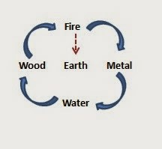[So based on his qi experience of the sympathetic nervous system of the spine - he realized that Earth was in the middle, thereby governing fire and water:](http://sygz2012.blogspot.com/2014/10/tsan-tun-chi-songs-of-cauldron-ding-qi.html)

He also makes the astrological connection:

*REMARKS: Merger of East Green Dragon Qi with the West White Tiger Qi: In ancient times, astronomers divided the sky near the ecliptic and the equator into 28 regions, each of which was called one xiu (constellation). These were put into four group subjects to different four directions with seven constellations for each group. The*

*seven constellations in the East are called Canglang (Green Dragon). Those in the North are named Xuanwu (Dark Tortoise), the West, Baiha (White Tiger), and the South, Zhuque (Red Bird).*

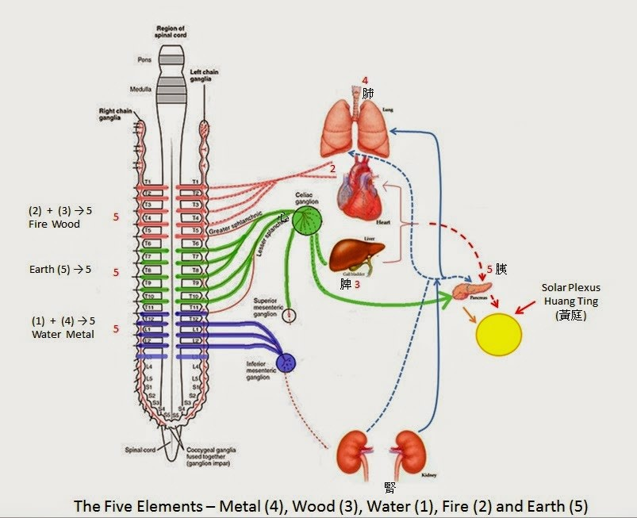And so now we get to the details of the connection between the Hun and the Po via the pancreas:

*v Davis translation*

*The taking of so small a quantity of it as would cover the edge of a knife or spatula will be enough to confer tranquility on the hun p’o (man’s animal spirit), give him immortality, and enable him to live in the village of the immortals. Those who love the Tao (Way) trace things to their roots. They decide on the proper quantities (to use) in connection with the preparation of their medicine on the basis of the Wu-hsing.*

*v Pregadio's Version*

*Moisten one knife-point,**and it will cleanse the hun and the po;**you will obtain a long life and find a home in the town of the Immortals.*

*v Our interpretation*

*If the panacea is activated, the spirit and the soul will be purified.*

*REMARKS: Dao Gui (* 刀圭 *) - in ancient times.*

*Dao Gui was an instrument for measuring powdered medicine (Figure 9).*

|  |
| --- |
|  |
| Western-trained medical doctor figures out ancient Chinese alchemy secret! |

*Remark: The Pancreas also consider as*

*“Earth” – “Tu”(*土*).*

*CONCLUSION: The Dao Gui in Figure 9 resembles the shape of the pancreas (Figure 9 and 10). Gui is a sceptre used by nobility in ancient China. The word Gui (*圭*) is two Chinese earth (*土*) staggered together . We propose that Dao (knife) represents the pancreas, and Gui with two Tu (* 土 *)’s represents the left and right celiac ganglions. The Daoist use it as code words for the whole celiac plexus. This is the area where different kinds (five elements) of Qi are converted to spiritual nectar for further Dao pathway to enlightenment.*

So now we have more medical details of how the pancreas directly goes to the spine as sympathetic nervous system energy - but what about the parasympathetic? Indeed [the dropbox pdf book compiled from his blog gives further confirmation of my claim as well!](https://www.dropbox.com/s/atz86fxlb56unsj/%E7%82%81%E9%81%93FINAL.pdf?dl=0)

*Route II: Micro-Cosmic Circulation*

*This route is the same as above, except when the Qi passes through the foramen magnum. The Qi enters into the brain through the Cingular Gyrus. The Qi travels along the Cingular Gyrus and enters into the third ventricle. At the chamber near the pineal gland, the Qi turns around and down the brain stem into the Vagus nerve and back to the lower Dan Tian. This is called the micro cosmic circulation.*

*In Dao meditation, the micro-cosmic... the meridian of Ren, in our opinion, equivalent to the Vagus nerve in the abdomen*

And so the question is what is the connection between the spleen/pancreas and the vagus nerve - and fortunately I had provided the answer in my earlier blog posts and so by returning to that research we get further crucial details. [So amazingly the pancreas-spleen is considered a crucial key to regulating chronic disease in the body.](http://onlinelibrary.wiley.com/doi/10.1111/j.1365-2796.2010.02321.x/full#js-feedback)

*Termed 'the inflammatory reflex', this neurological mechanism involves the vagus nerve,* ***which can sense peripheral inflammation*** *and transmit action potentials from the periphery to the brain stem. This in turn leads to the generation of action potentials in the descending vagus nerve that are relayed to the spleen, where pro-inflammatory cytokine production is inhibited.*

[*the spleen is the major organ source of systemic TNF that accumulates in blood [7, 25]. TNF production in spleen accounts for >90% of the total TNF burden that reach*](http://onlinelibrary.wiley.com/doi/10.1111/j.1365-2796.2010.02321.x/full#b7)*es the circulation,*

*either the common coeliac branch of the abdominal vagus nerve, or the splenic nerve, indicating that cholinergic anti-inflammatory pathway control of TNF culminates in spleen [*[*7, 26, 27*](http://onlinelibrary.wiley.com/doi/10.1111/j.1365-2796.2010.02321.x/full#b7)*].*

*For example, cardio-inhibitory vagus nerve fibres in mammals are B and C fibre types, which require significantly higher stimulation intensities to fire as compared with myelinated A-type fibres, which do not participate in heart rate regulation.*

And so what we find - is that our conscious intention as the myelinated vagus nerve going down to the pancreas/spleen then activates the vagus nerve which lowers inflammation and causes the metabolism to run more efficiently - and on a deeper level of the unmyelinated vagus nerve (the right side) - we then get the slowing down of the heart. So that exactly corroborates the "yuan qi" connection to the right side of the heart but now we see the pancreas/spleen connection.

So with further digging into the Western medical research we can find more corroboration that is quite fascinating about the connection between intention and the pancreas! [Overstimulation of the nerves causes pancreatitis.](https://www.ncbi.nlm.nih.gov/pmc/articles/PMC4644889/)

Fascinatingly - it's been verified then that electroacupuncture and TENS electrical stimulation of the spine - if done on a minor level then heals the pancreas but if done too much then damages the pancreas. And relatedly - it is discovered that nonwestern spices like ginger and cayenne also treat the pancreas by reducing the inflammation but at the same time increasing the digestion powers of the pancreas.

*More recently, in a neonatal model of pancreatitis, administration of the neuron-denervating agent capsaicin [active ingredient of cayenne] significantly reduced histological severity scores and abolished plasma extravasation associated with pancreatitis[*[*30*](https://www.ncbi.nlm.nih.gov/pmc/articles/PMC4644889/#B30)*], findings which support the notion that primary sensory neurons constitute a common final pathway for pancreatitis.*

So now we can corroborate the traditional Chinese medicine claim that the pancreas then sends energy to the lungs:

*The lungs are heated by yi, often translated "righteousness," in the sense of integrity and dignity.*

or to establish communication with the emotional mind under control as direct translation of Chinese Mandarin of "Yi"

Dr. Yang, Jwing-ming, "*Qigong Meditation: Embryonic Breathing*."

*To lead an ape (emotional mind) into a cage you need a banana (breathing), so concentrate the mind on the breathing.*

When you regulate the breathing you should not have an intention (Yi). Should you have an intention your mind will cause tension in the breathing. Simply pay attention to the breathing.

*Once your mind is away from this center [the real lower tan tien], your Qi will be lead away from it and consumed. Therefore the Qi will never build up and store in the body to a higher level. That is why it is said, "Keep your Yi at the Dan Tien. Yi Shou Dan Tien.*

So this brings up the fascinating point that is made by the Mantak Chia student and qigong teacher, Michael Winn, [that Yi as intention is not the same as visualization - and yet can include visualization. We find more details elsewhere.](http://richardleirer.org/mind-intent-or-imagination-in-qigong-and-tai-chi/)

*The Chinese word for mind intent is Yi Nian (*意念 *). Yi meaning thought / to think / intention and Nian meaning to study. Yi Nian in Qigong and Tai Chi means to think and study the qi movement in your body, through your channels.*

*Over time, this phrase Yi Nian has been mis translated into Imagine or Visualize. Imagination and visualization are different mental concepts then to think and study, and they use different parts of the brain and human consciousness.“The visual information from real events that the eyes see flows “up” from the brain’s occipital lobe to the parietal lobe, but imagined images flow “down” from the parietal to the occipital.” 1. Says researchers in a study published in journal NeuroImage.*

So this got me interested in the parietal lobe - a part of the brain I really had not given much "attention" or "intention" to!!

[Sure enough the parietal lobe controls conscious attention.](https://www.ncbi.nlm.nih.gov/pmc/articles/PMC3683564/)

*Interoception may arise from anatomically distinct, evolutionarily older limbic regions that provide a present-centered context for sensations originating from the inside of the body (*[*Farb et al. 2007*](https://www.blogger.com/null)*;* [*Craig 2009). But the back parietal lobe controls internal attention, while the front part of the parietal is for external attention.*](https://academic.oup.com/cercor/article/23/1/114/330585/Attentional-Modulation-of-Primary-Interoceptive)

Now this is truly fascinating to me - because as I looked at the images of the parietal lobe - immediately I focused my intention on that part of the brain. I realized that I really could feel the parietal lobe very clearly - and not only that - I realized that indeed that was the origin of my "intention" to "flex my pineal gland"!!!

Now here's were things get even more trippy. Suddenly I discovered that the Bindu chakra is actually at the connection of the parietal lobe to the occipital lobe - and as I just quoted - this parietal lobe attention is the source of imagining visualization and now we corroborate it truly is the source of "flexing" the pineal gland!!

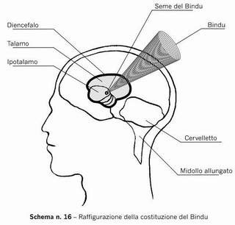*The Bindu Chakra lies beneath the cowlick that most people have at the back of their head. Anatomically it is located where the bones of the back and sides of the skull meet (the occiput and the parietal).*

*On the physical level this means that with the awakening of the Bindu Chakra the Pineal Gland, which is connected to this centre, becomes active.* [*here*](https://www.chakras.net/energy-centers/bindu)

Now things get even trippier - because as I reported, the qigong master who befriended me saw my energy blockage at a distance - he made me hang up the phone with him, so he could go deeper into the Emptiness - and he detailed that my problem was that *my energy was going up the front of my body, and out of my skull. Whereas I just confirmed above that the pancreas/spleen is controlled by the vagus nerve going down the front of the body and in fact the Taoist alchemy training is the vagus nerve going down the front of the body.*

Now check this out:

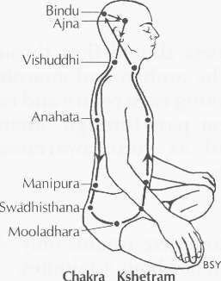So based on the Bindu chakra - sure enough the direction of the "small universe" is reversed!!!

Now people have mentioned to me - and even claimed - that you can have this "reverse" small universe and it's o.k. But clearly I have just detailed that to create the qi energy - you want the energy to go down the front of the body. But if you are in fact taking in energy from the Bindu chakra - then you can just recharge the energy and it appears the direction does not matter as much.

The point being again that the parietal lobe is the secret of "flexing" the pineal gland - and not only that it is the secret connection to the Cosmic qi.

So then when I re-examine this insight via Taoist alchemy I find corroboration!

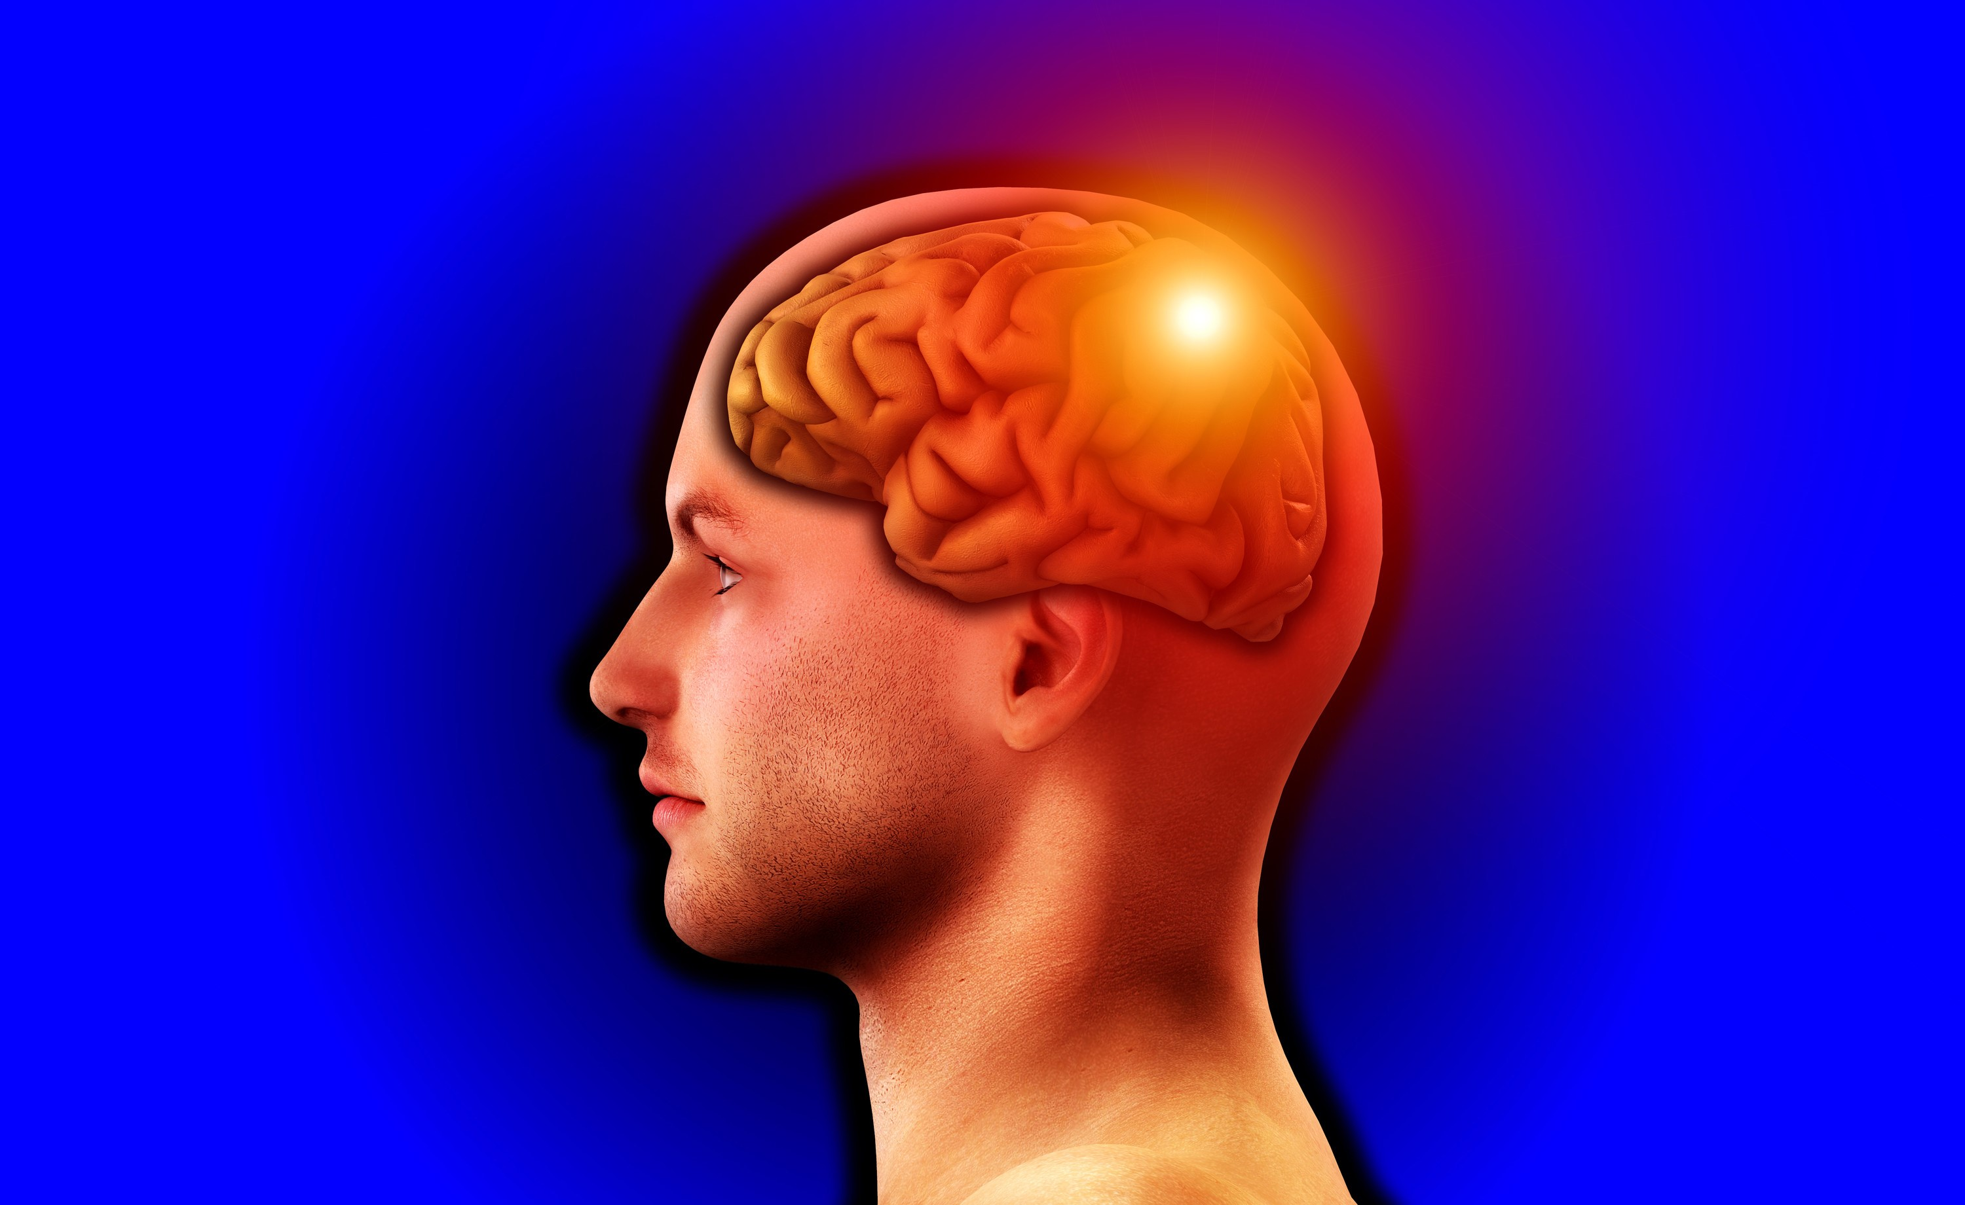Now keep in mind - I can "flex" this point as the source of my "attention" - very easily - and yet I had never known about this point before!!

And yet through the Enlightenment experience as the Tai Chi [- this point is opened up: Alchemy: Science of Enlightenment scribd](https://www.scribd.com/doc/9272251/Alchemy-The-Science-of-Enlightenment)

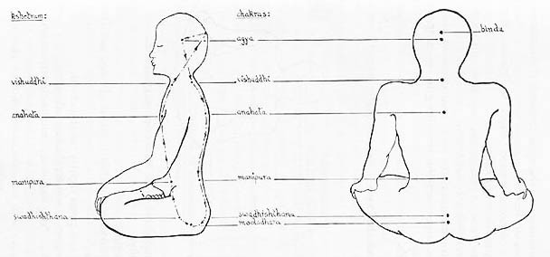*Internally, Soma is associated with the Bindu point of transcendence located in the head center. The symbolism of the Bindu and Soma are both associated with the Moon. The Bindu point and crescent Moon are seen at the top of the Sanskrit Om symbol of infinity.*

*Through advanced meditation, Soma nectar is said to drop from the Bindu down to the throat or Vishuddhi chakra where one drinks the internal nectar.*

And amazingly in terms of the cosmic qi connection the Bindu Chakra is considered then the North Star - the backwards precession or the secret of the "yuan qi" - of the Earth-Sun-Moon resonance as the alchemical creation of the Holy Grail Soma. The pole star has been documented as of key alchemical importance going back to the Shang Dynasty, 1200 BCE China.

|  |
| --- |
|  |
| [The Bindu Chakra is the secret of the Last Kriya!](http://goldenagejourney.blogspot.com/2011/02/nada-sanchalana-kriya-3.html) |

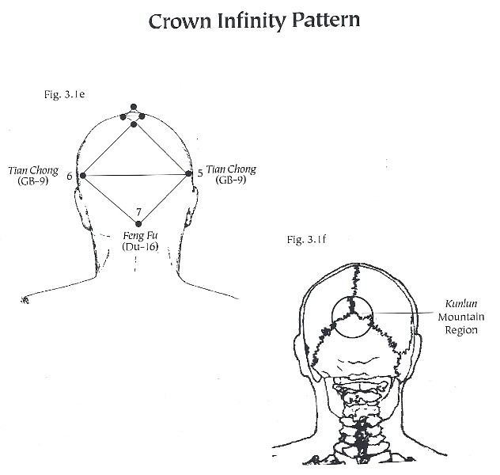

|  |
| --- |
|  |
| [Jerry Alan Johnson gives a slightly different location.](http://www.ichikung.com/html/dantians.php) |

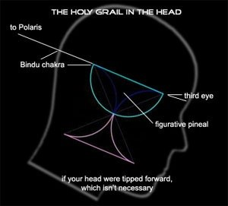

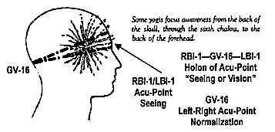

[Wing Y. Pon, Taoist physicist-engineer Acu-Brain model](http://holon137.com/Matter-BeingProject/?cat=5)

|  |
| --- |
|  |
| Left Eye is Yuan Shen, the Right Eye is Yuan Qi |

So [in part one](https://voidisyinyang.blogspot.com/2017/01/bindu-chakra-as-yi-or-i-intention.html) I mentioned that I started out my investigation based on the clue of the historical connection between Mahayana

Buddhism and

the Hun Spirit of Taoism. What is fascinating about the Hun

Spirit is that it is from the father and it enters the baby at birth post-Heaven and yet, the Hun spirit is the connection to the pre-heaven energy. This has recently been a

"sticking point"

(Ming) or

"selling point" of

Neidan "marketing" on the interwebs whether someone's teaching is really a true pre-Heaven teaching (whatever that means).

*From beginning to end, the great medicine depends on one thing: the metal in the midst of the water, that is,* [*the lead*](http://thesecretofthegoldenflower.com/ch8.html) *in the water-region. ... Then with both eyes one illumines the Palace of Kan (Water) ☵. Wherever the Golden Flower goes, true Yang comes forth in response. ... Thus the yang energy of the trigram Kan (Water) ☵ leaps upward.*

So "such and such" a school will deride another school stating oh they are just "qigong" and not real alchemy. haha. But there are paradoxes involved - for example the Water Path that is the focus of Kunlun alchemy has the secret that in Level 3 Water teaching - the energy goes *down* from the top but down through the central channel, to the heart, as "water" energy, and this prevents the Fire energy going up the spine from being too out of balanced.

***5. Water promotes Youthfulness and Longevity***

*There are methods to open the “downward flow” of celestial water, from the crown of the head down. The energy travels through the Sushumna, or central channel of the body and is stored between the navel and kidneys (called the lower dan tien).* [*http://hiddenradiance.com/water-path/*](http://hiddenradiance.com/water-path/)

So then we learn from [my "Part 1" Bindu Chakra investigation](https://voidisyinyang.blogspot.com/2017/01/bindu-chakra-as-yi-or-i-intention.html) that the secret of the "mystic female" or "the valley pass" is not one location per se but rather having the shen underneath the jing. And so teacher Yang, Jwing-Ming emphasizes that the Water Path is the pre-heaven qi as the yuan qi sexual energy. [***The Root of Chinese Qigong: Secrets of Health, Longevity, & ..***](https://books.google.com/books?id=024lDAAAQBAJ&pg=PT53&lpg=PT53&dq=jing+qi+pre+birth+qi+or+water+qi&source=bl&ots=b-xEQJ1-Qd&sig=3afFK6lHFa1LkiddAKCUztH_z9s&hl=en&sa=X&ved=0ahUKEwjyz66KtpLQAhUEsFQKHbL0CWEQ6AEILzAD)***.***

*https://books.google.com/books?isbn=1594391378*

[*Jwing-Ming Yang*](https://www.google.com/search?tbm=bks&q=inauthor:%22Jwing-Ming+Yang%22&sa=X&ved=0ahUKEwjyz66KtpLQAhUEsFQKHbL0CWEQ9AgIMDAD) *- 2016 - Health & Fitness*

*The first type is called Prebirth Qi or Original Qi (Yuan Qi, ). ... This Qi is drawn from the Jing (i.e. essence) of the food and air we take in. ... Prebirth Qi is commonly called “Water Qi” (Shui Qi, ) because it is able to cool down the Postbirth Qi, ..*

And it is best to do the Water Path based on the yuan qi sexual energy, instead of the Fire path based on the postheaven qi from food and air. And in alchemy we learn this energy peaks when a person is 16 years old. But it is only when the intention is pure then that the shen stays below the jing, and then the qi energy develops to open up the third eye. But again the Water Path is a "downward" path of the Yuan Qi....

*The Lower Dantian is often called "the Sea of Chi (Qi)." It is the place where Chi (Qi) is housed, the*

*Mingmen Fire is aroused, the Kidney Yin and Yang Chi (Qi) are gathered, and the Yuan Qi is stored. Also called Source Chi (Qi) or Original Chi (Qi), the Yuan Qi is the foundation of all the other types of Chi (Qi) in the body. The Yuan Qi is closely linked with the Prenatal Essence (Yuan Jing).*

So then the Hun Spirit we learned in "part 1" is actually the Liver jing-shen which is closely tied to the pancreasspleen jing-shen that as Earth then builds up the Lung po spirit as Water. The Liver spirit frequency as intention is green color - which is the color of the "universe" as the secret of the SFQ symbol, as I have analyzed before.

So the basic teaching of proper alchemical intention is to "put your consciousness (spirit or shen) into the

Emptiness" by focusing on the lower tan tien - to create the qi energy. Or as the original qigong master states - first you build up your kidney energy, then your liver energy and then your heart. Or in terms of the elements - you build up water, then wood, then fire. But what gets left out of that formula is that the proper water will power is from the Lungs as po metal passion intention with the deep breathing from the Earth pancreas-spleen intention as the real origin of the Water path. *It is the lungs as the bellows* that alchemically harmonizes heaven and earth.

*Practice with postcelestial kan (water) and postcelestial li (fire) is a postcelestial practice (fire path).*

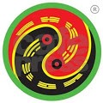

Alchemical Secret of the SFQ symbol revealed: Use your consciousness to go into the Emptiness

*Practice with precelestial kun (earth) and precelestial qian (heaven) is a precelestial practice (water*

*path).*

In alchemy this is called "converting jing to qi" which is dangerous since it means to do fasting - spiritual "energy feast" training and it's best done with the life force jing energy is strongest at 16 years old. But, for example, Taoist Master Zhang - of [http://qigongmaster.com](http://qigongmaster.com/) began his Taoist cave fasting full lotus meditation when he was very young - I think three years old? The same with Taoist master Yan Xin who began his teaching from his grandfather when he was three years old - in the mountains. And so then the original qigong master remembers when he healed a schoolmate in elementary school! The qigong master who befriended me remembers when he would leave his body when he was in the crib - so he could watch his mom in the house as she moved around.

And so the "pre-heaven" energy as the Water path is the secret of the White Tiger lung metal energy connection to the Universe as the Green Dragon liver wood energy via the kidney water and pancreas-spleen Earth intention. And we know that it is when the breathing is held after exhale that then the oxygen to the brain increases via the deep parasympathetic right side unmylineated kundalini energy as the proper intention - that opens up the brain channels. So the example given by the original qigong master is that a baby can cry for hours without getting tired whereas an adult will have the voice get weak easily - and so it is the voice that indicates the power of the White Tiger lung metal energy that is the hidden yang within the kidney water dragon energy. But it is only when the Green wood dragon energy is properly sublimated from anger into wisdom that then the dragon of the heart as shen gets below the dragon in the kidney water energy - to properly bring out the White Tiger intention as the alchemical pre-heaven Water path.

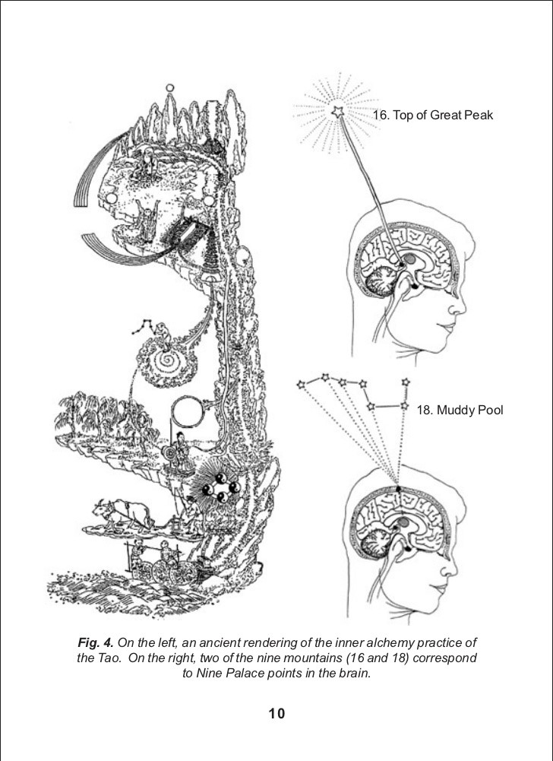So for this part 2 of the Bindu Chakra - what first initiated my investigation was my actual experience of implementing this new technique. The qigong master who befriended me called it "turning your perspective to meet your awareness in the back of the brain." Later he told me how he was practicing this new technique - so that any question he had to the Universe, he could simply turn his perspective around to his awareness - he called it reversing his thoughts - and he would get the answer from the Universe. I personally experienced how the qigong master who befriended me could leave his body at will and then go to where he focused his intention - as a shen-qi immortal, an Earth immortal. I would say that the original qigong master is an even higher type of immortal that does the "yuan shen" healing as an Emptiness spacetime vortex.

And so for this "part 2" of the Bindu Chakra investigation - I started out with the empirical clue in Part 1 - of the image of the back of the skull as Kunlun - and was this a direct connection to the "water path" secret of Kunlun qigong alchemy training of Max Christensen? Was this the secret of the proper intention of the pre-heaven Water Yuan Qi White Tiger energy?

So the alchemical secret is that when we rotate the eyes we are then unifying and activating the jing and shen energy - with the left eye as the right brain or yuan qi energy yang - and the right eye as the left brain as the yuan shen energy - both channels originate in the heart, with the right side of the heart as the yuan qi source. In the deepest formless awareness state, the left side of the heart as yuan shen goes into silence and stops, the right side of the heart as the formless universe "yuan qi" pulsating at ELF waves then restarts the heart, with it, bringing back the spiritual ego of the yuan shen. So we can surmise again - this refers to the right side vagus nerve and we also know that in Taoist alchemy it is the vagus nerve that is the "water" path that goes down the front of the spine - as the secret of the central channel via the left side vagus nerve. I made this claim, and then the Santiago school of Glen Morris made this claim, and then I discovered in "part one" of the Bindu Chakra blogpost - another Taoist alchemy Qi Dao researcher, as a Western trained medical doctor, making the same claim, that the "real" alchemy down path, down the front, is actually the vagus nerve.

So the idea of the proper "intention" or "awareness" or "attention" of Yi or I that governs the Qi - or guides the qi - is actually the intention or awareness that is formless and the secret of this intention is listening - to the formless. It turns out that science actually corroborates the alchemy claims! So to further my investigation - since I wasn't finding the Kunlun source at first - I realized that the Bindu chakra is at the juncture or fissure of the parietal and occipital lobes and so must have a name (and therefore a function) in Western science. [Bingo](https://www.ncbi.nlm.nih.gov/pubmed/26484830):

*/parieto-occipital sulcus or RSC/POS) were involved in encoding and retrieving target location from different perspectives and were modulated by the amount of viewpoint rotation, the RSC/POS was the only area showing decreased activity in the primed as compared to the unprimed condition, suggesting that this region anticipates the upcoming perspective change. The retrosplenial cortex/parieto-occipital sulcus appears to play a special role in the allocentric coding of heading directions.*

Now what does the alchemy teaching emphasize? The Yi or intention always has to be "ahead" or anticipate the qi. Now what clues did I just give from alchemy? It is the subconscious intention that determines whether Yuan Qi is lost from the heart, via the pineal gland via going out the eyes with the shen (subconsciously as holographic speed of light messages), and more importantly, as the loss down the spine, triggering ejaculation.

|  |
| --- |
|  |
| [Figure 4-13 Supranuclear control of eye movements. The pontine horizontal gaze center (blue) and the vertical gaze center in the midbrain (yellow) receive input from the frontal eye fields to initiate saccades, and from the parietal occipital temporal junction to control pursuit. These gaze centers control ocular motility by synapsing upon the ocular motor nerve nuclei (III, IV, and VI).](https://www.blogger.com/null)  (From Lavin PJM, Donahue SP: Disorders of supranuclear control of ocular motility. In: Yanoff M, Duker JS (eds) Ophthalmology, 2nd edn. St Louis, Mosby  2004.) |

,

Like I said - Boom! (or in my generation Bingo!). haha. In other words by "turning the light around" you are focusing your *intention* on the Bindu Chakra which then unifies the shen underneath the jing - at its source - in the brain - to prevent the separation of shen and jing going out the eyes, and more importantly, the separation of jing via ejaculation, down the spine, as triggered by the attention of the eyes.

Now guess what is crucial for maintaing this what did it say? This...UNPRIMED CONDITION.

See those objects that spiral around - that's the inner ear connection to the pineal gland as I have emphasized for a long time in the alchemy training! We will find further alchemical corroboration of this inner ear connection to the gaze of intention or attention of the parietal lobe....

*The alpha level was higher after non-objects*

So now we have a [new factor](http://www.jneurosci.org/content/17/18/7141.short) - the increased alpha brain waves from attention to "non-objects" - again more science corroboration of the Unprimed condition of formless awareness intention!

|  |
| --- |
|  |
| [Vestibular proprioception input for the g](https://www.youtube.com/watch?v=mPVPrYUEXHY)aze. |

*The non-objects were systematically followed by a higher level of alpha than the objects....*

*suggesting that the alpha level is inversely related to saliency or familiarity of the object and does not directly reflect visual awareness. The reactive alpha rhythm was generated in the parietooccipital sulcus, [the Bindu Chakra] which in several primate species includes areas belonging to the dorsal visual pathway*

[So when we turn back to alchemy training - like this](https://www.youtube.com/watch?v=mPVPrYUEXHY)

[Secret of Everlasting Life book - translation of the first book focused on internal alchemy in China...](https://www.youtube.com/watch?v=mPVPrYUEXHY)

[We finally discover that indeed that Kunlun image I had posted in "part one" really is the Bindu Chakra....googlebook link - water flows down from the Kunlun pass in the back of the brain.](https://books.google.com/books?id=01QOqLpZbfEC&pg=PA212&lpg=PA212&dq=kunlun+water+crown&source=bl&ots=GX8yP6H5NN&sig=j0imzEOQtDVnnTRPUp-UYn4cRpI&hl=en&sa=X&ved=0ahUKEwiqhby3yObRAhUn34MKHQ2LAFIQ6AEIJzAC#v=onepage&q=kunlun water crown&f=false)

So that indicates that the secret of the Max Christensen Kunlun alchemy training of the water flowing down is from the Bindu Chakra - for real! But wait - there will be further corroboration!

|  |
| --- |
|  |
| EEG in meditation. Theta rhythm is found mainly in central, temporal and frontal areas. Its episodes (encircled by double line) may appear at the same time when alpha rhythm dominate in occipital and parietal areas. |

[From Moscow University Brain Research Group - spiritual matters !](http://brain.bio.msu.ru/kapl_photo/bci_album5.htm)

Now then - what did I just post - about the parietal-occiptal fissure or sulcus - the Bindu Chakra - it is highest in alpha waves when focused on a non-object as the UNPRIMED CONDITION and now another brain research group documents the same thing from meditation yogis that focus on the formless awareness!!

But wait it gets better because as I was doing my research, keep in mind, I was "flexing" or "sucking" on my Bindu Chakra - putting my qi intention there, creating pressure on the skull fissue or sulcus....and amazingly generating great Tummo heat in the lower tan tien. I know from my qigong experience that the tummo heat is best generated when the overflowing cerebrospinal fluid is swallowed, after it overflows out of the nasal cavity. I even quoted alchemy texts confirming that truth - as the "front" path of restoring yuan jing energy via yuan quan energy restoration. I did a blog post making that argument after a certain "school" of Neidan claimed you could not restore Yuan Qi.... using fear tactics while at the same time claiming that celibacy was not necessary for their alchemy training! Hilarious.

*Alpha-band activity is significantly greater when subjects have been cued to attend selectively to impending auditory stimulation.*

|  |
| --- |
|  |
| [So now we have more corroboration that proper intention is UNPRIMES, a non-object, and on listening to formless awareness.](https://www.researchgate.net/figure/261290123_fig1_Figure-3-Anticipatory-alpha-band-suppression-effect-Alpha-band-oscillatory-activity-is) |

That is what increases the alpha brain waves to be strongest in the back, thereby causing increased theta brain waves in the front - which causes the energy to resonate with the heart theta REM waves. Science has just discovered that contrary to

previous claims, it is the REM dream state that are the most coherent brain waves! So now it's time to go back to alchemy training to [dig out further details](http://xtrememind.com/phpbb/viewtopic.php?p=73945):

*In simple terms, Kunlun is described as the Downward Water Flow and Kundalini as the Upward Rising Fire. The path of Kunlun is one where the Water or Kunlun energy is brought down to the heart, automatically causing the fire from the root to rise, resulting in the merge of the two to result in alchemy at the level of the Inner Heart. This results in the generation of what one calls the ‘steam’ or a third magnetic potential, eventually leading to the Great Void (or the Great One – whatever you choose to call), initiated by a magnetic expansion. In terms of Chi, if you would describe Chi as electric, Kunlun energy can be termed magnetic. The other key difference between Kundalini [fire approach I mean; I am yet to find popularly available water approach to Kundalini except in Kashmiri Shaivite schools] and Kunlun is also their doing – burning in the first case, dissolving in the latter. Also, Fire is all about ascension, becoming the heaven; whereas water is all about bringing heaven down to earth, to the human. Are they eventually the same, may be, may be not, assuming there is indeed an eventuality and a common one lol*

Why magnetic? Well science calls it gravitomagnetic - because the magnetic field is the precession as magnetic moment - it is the secret of "yuan qi" as the "hidden momentum" of turning the light around!

*I have occasionally heard of a connection mentioned in yoga between the bindu chakra (top back of head) and the vishuddhi chakra. The relationship is connected with the transformation of amrita which is produced in the bindu chakra and transformed in the vishuddhi chakra before descending lower down in the body. When the process is not working properly because of obstructions in the nadis or chakras, then, it is said, the process results in a contracted state of consciousness (the creation of persons), but when it is functioning in it's pure state it results in divine consciousness.*

[So contrary to the "general" meaning of bindu as point - we begin to discover the secret meaning of the Bindu Chakra - as the secret of the Water path as Kunlun Pass in Taoist alchemy!](http://www.aypsite.org/forum/topic.asp?whichpage=2.88&TOPIC_ID=7097&)

*Bindu holds our life force within. It is the center of where our life nectar, AMRITA, is produced. Amrita* [*is said to help the yogi obtain enlightenment. From there, this nectar drops down toward the third chakra, Manipura.*](http://www.sunnyray.org/Solar-plexus.htm)

*In the Manipura chakra, the life nectar from the Bindu chakra is being used up for various activities of our body. In other words, the fire of Manipura (the name Solar Plexus Chakra is not given by chance) is responsible for burning up and gradually using the nourishing powers of the AMRITA nectar.*

[So far we have these general declarations without much corroboration.](http://www.sunnyray.org/Bindu-chakra.htm)

It's difficult to believe - how could focusing on that Bindu Chakra restore your energy? Well I found out....

[So finally we get "official" corroboration that bindu really does mean drop of liquid originally.](http://www.wisdomlib.org/definition/bindu)

*Bindu, (cp. Vedic bindu & vindu) 1. a drop, usually a drop of water Sn. 392, 812 (uda°); J. I, 100; Vism. 531 (madhu°); ThA. 281; PvA. 98 (udaka°).—2. a spot (cp. SBE XVII. 155) Vism. 222 (°vicitvā gāvī a spotted cow). ‹-› 3*

So then in the above forum discussion the only reference I could find was this:

["Kundalini Tantra" by Swami Satyananda Saraswati. google pdf link](https://www.google.com/url?sa=t&rct=j&q=&esrc=s&source=web&cd=2&cad=rja&uact=8&ved=0ahUKEwjv67r61ebRAhVp6YMKHWIbDMUQFggiMAE&url=http%3A%2F%2Fthekingdomwithin.net%2Fwp-content%2Fuploads%2F2016%2F02%2FSwami-Satyananda-Saraswati-Kundalini-Tantra.pdf&usg=AFQjCNEVl_9279Ae8WxWJ5NrUTU7T-DCZg&sig2=bn-8ixIa7h5JBjw39G3yYg)

Amazingly this book gives great focus and attention to the Bindu Chakra - it discusses the Bindu Chakra as one of the key - if not the central secret of the alchemy training. Just word search Bindu.

What's fascinating about that book is the Bindu Chakra is considered to be focused on by *listening* as the source of the OHM sound - and you listen to high frequency sounds. Guess what? when I was earlier doing the science research I discovered another "hypersonic effect" study and the alpha brain waves that are increased by the ultrasound hypersonic effect? They emanate out of the parietal-occipital area of the brain!

*Indeed, the natural environment, such as tropical rain forests, usually contains sounds that are extremely rich in HFCs [high frequency components] over 100 kHz [3] [ultrasound]. From an anthropogenetic point of view, the sensory system of human beings exposed to a natural environment would stand a good chance of developing some physiological sensitivity to HFCs. We also found that some musical instruments, such as a gamelan of Bali, Indonesia, produce a significant number of HFCs over 100 kHz [3]. Deep Brain Activation*

So that book points out how then the Brahmins have a knot of hair tied at that Bindu Chakra in order to increase pressure on the skull as a meditation focus. There is 2016 research confirming that alpha wave binaural beats are strongest in the rear parietal lobe, and based on attention. Also that when there are competing thoughts as beta brain waves, it is the alpha brain wave the "suppresses" one thought, over another. Finally it is proven that an electrical current applied to the brain at alpha hertz increases creativity, similar to meditation.

So I began searching this source for more details....and bingo or Boom! The science and alchemy of Taoist and Vedic traditions merged together:

|  |
| --- |
|  |
| Secret of how the cerebrospinal fluid gets pulled down into the central channel via the Bindu Chakra |

*There is a connection between the Arohan and Awarohan psychic passageways in Tantric Kriya Yoga, and the Conception vessel (CV) and Governor vessel (GV) of traditional Chinese Medicine, and the segmented dermatomes (distribution of spinal nerves to the front and back of the body).*

*In the Bihar School of Yoga publication Moola Bandha the Master Key (1978, Page 122) by Chela Buddhananda, there are correlations drawn between the Arohan (frontal / anterior) psychic passageway and the Conception vessel & the Awarohan (back/posterior) psychic passageway and the Governor vessel.*

*Chela Buddhananda states, that the ancient Chinese must have known about Kriya Yoga, because in one of the ancient Chinese scriptures called the “Tai Chin Hua Tzang Chih (The Secret of the Golden Flower) there is as meditation technique very similar to that used in the Tantric Kriya Yoga.*

[Finally someone from the Kriya yoga tradition - is making the connection to the Small Universe meditation! haha.](http://www.kundaliniresearchproject.net/resources/articles/kriya-yoga)

[Unfortunately the Australian ashram of that Bihar school was doing evil sex abuse on youth.](http://yogadork.com/2014/12/16/satyananda-yoga-reeling-from-horrific-details-of-sex-abuse-rape-allegations-and-accountability/)

So having the proper intention of the Bindu Chakra is all the more important for doing the proper yoga training! What we have discovered is the Bindu Chakra over-rides - it's a short cut - and focuses the intention or perspective back on the "awareness" to hold the qi back to restore the Yuan Jing as the Water path going down the front of the spine....and as Master Nan, Huai-chin points out when the jing is converted to qi then a loud OHM sound emanates from the heart. In fact I discovered a new brain study of ayahuasca users and found they have highly increased alpha brain waves in the parietal-occipital region! I mention this since when I did a strong ayahuasca test while in full lotus - I heard this loud OHM sound from the heart.... Another interesting point from science is that hallucinations say seen in the left eye are caused by brain damage in the right side of the parietal-occipital region - so again we see how the cross over works for the energy.

So by focusing or "sucking" the cosmic Yuan Qi energy through the Bindu Chakra - then the cerebrospinal fluid bypasses the eyes and prevents the qi-shen from being lost out of the eyes - instead the alchemical amrita flows down as the Water Path -down the nasal sinus cavity via the pineal gland and swallowed down to the stomach.

*9. The method used by the ancients for escaping from the world consisted in refining away the dregs of yin in order to return to the pure Qian (Heaven ☰). It is just a matter of dissolving the lower self and completing the higher self. Turning the light around is the method of dissolving yin and controlling the lower self. Except for the secret of turning the light around,* ***there is no other exercise to return to Qian (Heaven ☰). The light itself is Qian****; to turn it around is to return to it.* ***Just persist in this method****, and naturally vitality-water will be sufficient, spirit-fire will ignite, intent-earth will stabilize* ***and thus the holy embryo gestates****.*

And so turning the light around really does mean focusing the shen below the jing - but starting to do that in the brain by focusing on the Bindu Chakra or Kunlun Pass but this is only understood by properly understanding the psychophysiological secret of the small universe meditation, detailed in the book *Taoist Yoga: Alchemy and Immortality*. It's only by doing a comparative study that this research is revealed.

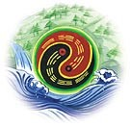So as I recommended to read what for me is the most important book of my life, *Taoist Yoga: Alchemy and Immortality*, I then returned to review it, after having not read the book in many months. I was also given a good comment that was discussed on thetaobums also. Just as I have recently focused on the Bindu Chakra, the book *Taoist Yoga* states to first focus meditation on the "original cavity of spirit" until you see light and then feel heat in the lower tan tien, strong heat for one day. But this is very difficult on its own and the secret is the "squinting" the eyes on the nose or the rotating of the eyes - called "gathering" the energy:

*"the cultivation of heart to preserve (essential) nature....If you can not set your heart at rest in order to fix spirit in its original cavity (in the centre of the brain between and behind the eyes)....." p. 84*

*"...for if spirit wanders outside, vitality will scatter to become generative fluid the exhaustion of which leads to death." p. 83*

*"While sitting in meditation the practiser should never...3, look at external objects, for there the spirit wanders thereby harming the incorporeal soul (hun)" p. 117*

*"However if he can unite the element of metal (male) with that of wood (female) and the sun and the moon in one place....he will see the light of true vitality in front of his original cavity of spirit which will then hold it to prevent it from running away; the longer it is held the brighter it will be. When it becomes stable it reveals the successful union of the dragon and tiger (i.e. the female and male vital breaths)." p. 72*

So at first you see light inside the brain but only when the qi energy is built up is the light seen "in front of" (meaning outside the body) the third eye.

*"which manifests when your body is full of prenatal generative force and disappears when the latter is lacking." p. 80*

*"driving the first two [generative force and vitality] into the third [shen or spirit] to invigorate it." p. 78*

But the key point the book makes is that successful focus on the "original cavity of spirit" that is the third eye in the center of the brain, the pineal gland, that *emanates "true" or "prenatal vitality" (Yuan Qi), thereby creating the spirit shen light*, requires that the heart by empty of passion and over-excitement and anger. If this is not possible then the small universe meditation is needed.

*Hence the method of correct breathing is to circulate quick [strong] fire up and down (in the microcosmic orbit) and so immobilise the generative force causing the genital organ to retract (thus stopping the draining of vitality). After it has shrunk, the practiser should breath in to drive the generative force into the base of the spine and thence up the backbone into the brain; p. 34*

The book *Taoist Yoga: Alchemy and Immortality* quickly (pg. 3) points out that there are two psychic channels that run up from each side of the body to the top of the medulla oblongata - so again that is to the pineal gland, the physical source of the third eye; but those two psychic channels then run to the eyes.

*"...west of the sun (the left eye)...." p. 4*

*"The left eye stands for the East whose element is wood and the right eye for the West whose element is metal." p. 65*

*True nature is prenatal vitality is prenatal vitality [yuan qi] in its cell [pineal gland] on top of the medulla oblongata. p. 66*

*"left and right sides [of the third eye] are linked with the pupils of the eyes by (two) psychic channels; and it is also connected with the heart. Hence it is said that essential nature is in the heart and manifests through the two eyes."*

*"The sun and the moon, when turning round, unite the positive yang with the negative yin so that a glorious light emerges in the centre of the brain." 64*

*footnote: the left and right eyes stand respectively for the sun and moon; i.e. the positive and negative yin."*

We can see from my Bindu Chakra research, this most likely is referring to the vagus nerve and the arteries and veins - as the Taoist Body uses the terminology of artery and vein - as the dragon and tiger channels. But the *Taoist Yoga* book is very clear that "only the two eyes are positive" and the rest of the body is yin qi energy - meaning only the two eyes emanate the prenatal vitality, as the book explains that the two eyes have "one source."

*"The left eye stands for the East whose element is wood...." p. 65 "...the female element of moon is the wood...." p. 85*

So it's very important to understand the eye energy and what these two eye channels are and we learn soon in the book, page 3, that the left eye is solar and the right eye is lunar. But here is where the mystery begins because it is not until the very end of the book that the left eye is revealed to be the "positive spirit" energy channel - the yang shen - immortal man - channel that is combined with the negative vitality of the body that creates the golden light.

*p. 156 "the left eye stands for the positive spirit"*

The mystery is this - the left eye is solar but it is also the liver hun incorporeal soul or dragon energy and yet the liver is also detailed as *lunar* and wood energy! *A serious contradiction*! But notice above the quote says to "unite" the sun with the wood and the moon with the metal, a serious clue:

*unite the element of metal (male) with that of wood (female) and the sun and the moon in one place*

Again this contradiction is not solved until the very end of the book when we learn that the "solar" of the left eye is actually the "positive spirit" as the "yang shen" or immortal man. The golden light immortal man, at the very end of the training, once finally all the yin shen negative vitality of the body is transformed into yang shen, then vaporizes the whole physical body into pure formless qi that is boundless with the whole universe. When the yang shen wants to be in once location it then condenses back into the golden immortal body as positive spirit.

*The Hun soul controls our essential nature [xing], and hence, our congenital [yuan qi] meridians.* [*http://www.scholarsage.com/the-hun-and-symbolism/*](http://www.scholarsage.com/the-hun-and-symbolism/)

*."..the spiritual [body] is prenatal vitality [yuan qi] ...and is our essential nature." p. 74*

So the original qigong master shared at the Level 3 retreat in 2000 that he knows meditation masters in the mountains of China who are developing their golden light aura as the yang shen. And once I had this book with me in class - but hidden in my back pack, I never brought it out, and yet the original qigong master shared how his meditation energy had been very deep lately and he had seen the falling snow in the sky as flowers falling in the winter. This is a direct reference to the end of the training as the golden light of the yang shen is developing. What the book states is that if you don't open the top center of the head then you just end up with the yin shen - the white light - that others can not see and has less abilities and in the end is not immortal. And the original qigong master even described how the top of the head really does open up and some masters will have something stuck through the opening - like a reed or some thin plant like that.

So in the very end of the Taoist Yoga book it states that the "four elements" are vaporized and then refers the reader back to page 31 - and those four elements are the body itself, the breath (post-natal or yin qi), and the Hun soul and the Po soul. Again the Hun soul is from the liver and the Po soul is from the lung and both then go to the eyes - the Po soul is the whites of the eyes and the Hun soul is the irises of the eyes. *Taoist Yoga: Alchemy and Immortality*: The Hun spirit is negative - meaning still yin shen - and so is from the consciousness of the heart - not the true original spirit of the heart. The hun spirit is then

powered by the yin qi of the liver but is moved by the heart - it "obeys the heart's impulses." The po spirit is then powered by the yin qi of the lungs - metal - passion - it also is moved by the heart's impulses.

*"Liver qi communicates with the eyes," states the* ***Neijing****, "and if the liver functions harmoniously, the eyes can differentiate the five essential colors....If the liver receives blood, we can see. The liver channel branches out to the eyes. Both liver qi and liver blood flood the eyes to maintain proper eyesight. A person's eyesight may therefore also serve as an indicator for liver function.*

And so to go back to how to open up the Original Cavity of Spirit - it is crucial to understand this secret:

*"...the element of fire in the eyes which are above scorches that of the water in the belly which is below, to produce positive vitality whose light manifests in front of him....the white light of vitality." p.*

*122*

So if a person is not able to manifest this white light - seen externally outside the person as auras - then the white light seen just internally is the "relative void" that is "useless."

*For the cultivation of nature alone ensures only the descent of the positive fire without the ascent of the (vital) breath from below;" p. 56*

Why? The microcosmic orbit training describes the energy going down the front of the body as "negative fire" or yin qi energy - whereas the energy going up the back of the body is "positive fire" or "quick fire" - that is the prenatal vitality, as it is stronger then the yin qi blockages and yin jing blockages of the generative force - so the quick fire is what activates and creates the yuan qi or prenatal vitality that then expands the energy channels.

*"the light of the eyes directed downward is positive" p. 123*

So the reason that the light of the eyes directed downward are positive is because that is the light seen externally also - the light that manifests when the original cavity of spirit is open as the light of yuan qi or prenatal vitality that later manifests as the "positive spirit" when creating the immortal man, but only after the liver lunar qi energy is build up from the negative vitality! Chapter 11: "the object of [alchemy] which is to realise the full development of positive vitality [yuan qi]."

And so not until the generative force is full does the positive vitality manifest to open up the cavity of original spirit with white light seen externally. That means the energy has to be restored to that of a 16 year old!! That is why it is much easier to do this training, the younger a person is. I achieved this "enlightenment experience" when I was 29 years old and I maintained it only for a few weeks!! Since I did not understand the training - the energy "drained" away and then I overused the energy from the "evil fire" of the heart - as the book details.

*If (essential) nature is still, the incorporeal (soul) lies hidden to let the element of wood return to its source. p. 31-2*

So there we finally get the direct connection between Xing as essential nature and the Hun - and the Xing then is the prenatal vitality or yuan qi that emanates out of the eyes via the pineal gland but when is "still" and not lost out of the eyes, then returns to the liver. So this can be used as the reference source for the Neidan entry on Wiki!! haha. I've never submitted anything to Wiki and don't plan to - but nice to solve this secret of alchemy!!

*The home of qi is said to be centered around the liver*[*[citation needed*](https://en.wikipedia.org/wiki/Wikipedia:Citation_needed)*].*

[*https://en.wikipedia.org/wiki/Neidan*](https://en.wikipedia.org/wiki/Neidan)

And this:

*The* ***Neijing*** *comments in its typical terse code: "Hun is that what follows shen going in and out."*

So that makes sense when we consider the prenatal vitality or yuan qi is necessary to be built up to enable the shen to go in and out of the body.

So then now we get the crucial secret of Xing meditation - the focus on essential nature in the center of the brain, the original cavity of Spirit, as the beginning of the meditation:

*"When the eyes cease seeing, the incorporeal soul is in the liver" Hsing-ming kueichih [“Balanced Instructions about Inner Nature and Life-Realities”] of 1615,....If essential nature is still, the incorporeal (soul) lies hidden...."*

*"Hence it is said that essential nature is (in) the heart which manifests through the two eyes....It is only when true vitality develops and united with essential nature to become one whole that the latter is called the precious cauldron [the third eye opened]." p. 10*

So as the original qigong master states only after the liver energy is built up does the heart open up - as the third eye manifesting. Use your consciousness to go into the Emptiness - the universe is the green liver energy and now we know why!

*The Hun moves upwards towards the Shen and its movement gives the Shen the capacity to extend and project outwards. The movement of the Hun towards the Shen is a psychic equivalent of the physiological ascending movement of Liver-Qi.*

<http://maciociaonline.blogspot.com/2012/11/shen-and-hun-psyche-in-chinese-medicine.html>

And yet the only way to build up the qi energy is by first building up the lower tan tien energy!

*My master said: When the generative and vital forces in the lower tan t'ien cavity move away they become liquid but when they return to that cavity they are prenatal vitality [yuan qi]." p. 59*

And so how is this connection to the lower tan tien made! With the eyes closed!!

*"When he wakes up, and opens his eyes, spirit returns to his organ of sight, thereby disengaging the heart from the lower abdomen which will not reunite even if he starves for a week." p. 82*

So the "true vitality" or yuan qi of the lower tan tien then unites with "essential nature" as the liver qi that powers the heart shen in the third eye.

*essential nature is "negative breath in the heart."*

Yin qi of the liver.

*"This spirit's fire derives from the spiritual power in the eyes, and if supported by postnatal breathing*

*[quick fire breathing], can sublimate the generative force and sustain the inner vital breath." p. 55*

So we are beginning to see how crucial the liver qi is - as the Hun and essential nature yuan qi source....

The lower tan tien has the main source of Yuan Qi - but the liver is the source of yuan qi for the spirit that guides the practice - and so you have proper intention of the spleen/pancreas that then through deep quick fire breathing builds up the lung qi energy which then builds up the kidney energy - which is then sublimated up into the brain, to then go back down and increase the yuan qi energy in the lower tan tien.

*"The male element of metal is the sun and the female element of wood is the moon" in the post-natal state, the sun and the moon do not unite....*

*"...the sun (the left eye or male principle) with the moon (the right eye or female principle);" p. 90*

So again the mystery here is that the left eye is the sun as the Liver Hun which is Lunar Wood energy - yin qi - but the Po as yuan qi is the Sun as metal but is the right eye lunar energy!

So not until the eyes are properly rotated which truly means the alchemical inversion of dragon and tiger - sun and moon within each other - as I go into the "Idiot's Guide" article - and this process truly ends in the immortal golden body, thereby finalizing the connection of the negative vitality as the source of the positive spirit of the sun of the left eye. From the glossary:

*"negative fire in the stove" [lower tan tien]*

*fire derived from prenatal vitality is "negative fire" in the house of water....*

*"spirit in li" the house of fire (the heart) is essential nature. Nature-vitality is negative*

*golden light reveals the fullness of the "negative vitality within the generative force."*

So that is all from the Hun liver Xing qi - this is the "purification" into yuan qi - down the front channel of the generative force as it builds up through the small universe meditation! But the light from that yuan qi is then called "positive fire" or "positive spirit" when it is built up even further as the golden light!

[This academic book details how there's been a long debate about the relationship of Hun to Xing.](https://books.google.com/books?id=hppjAwAAQBAJ&pg=PT32&lpg=PT32&dq=hun+soul+xing&source=bl&ots=lgfVtqa8Gu&sig=WUH778wzQ7X212syVcZ66D8oR_s&hl=en&sa=X&ved=0ahUKEwjbuKX4u_DRAhWGjFQKHcpfAiwQ6AEIIDAB#v=onepage&q=hun soul xing&f=false)

So my interest in that topic has serious standing but as we can see it is crucial to the alchemy training!

*The Liji (11, tr. Legge 1885:444) compounds hun and po with* [*qi*](https://en.wikipedia.org/wiki/Qi) *"breath; life force" and xing "form; shape; body" in hunqi* 魂氣 *and xingpo* 形魄*.*

We can now understand the specific alchemical secret of that combination - the solar-lunar-metal-wood alchemy!